Eldrine Albert Sr.
April 5, 1942 – October 30, 2013

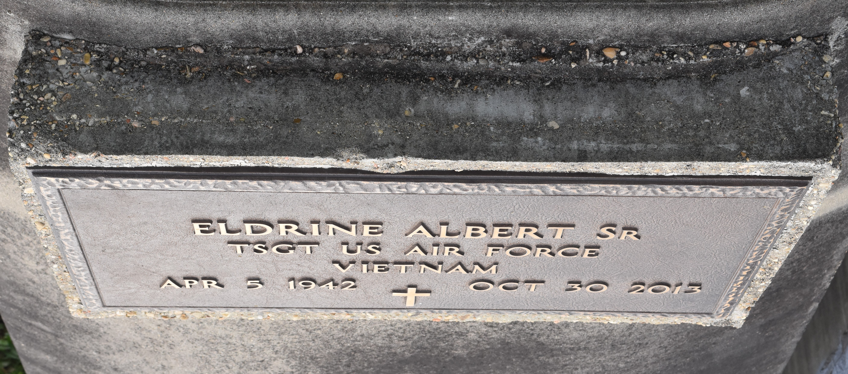
Eldrine "Steep" Albert a retired air force for 20 years passed away on October 30, 2013, age 71, husband of Bennie Faye Albert, Father of Eldrine Jr., Arnold and Shequitta Albert, Anita Albert Bardell, Rhonda Weston, Donta Miles, and Lance Davis.
Funeral Services will be held on Saturday at Evergreen Baptist Church 3399 Hwy 3125 Paulina, La 70763 at 11:00am Visitation will begin at 9:00am interment in Antioch Cemetery Paulina, La Services Entrusted to Hobson Brown Funeral home 985-535-2516
The Times-Picayune, New Orleans, Louisiana
Nov. 6 to Nov. 8, 2013

