Mary Lee (Johnson) Albert
February 23, 1935 – March 19, 2019

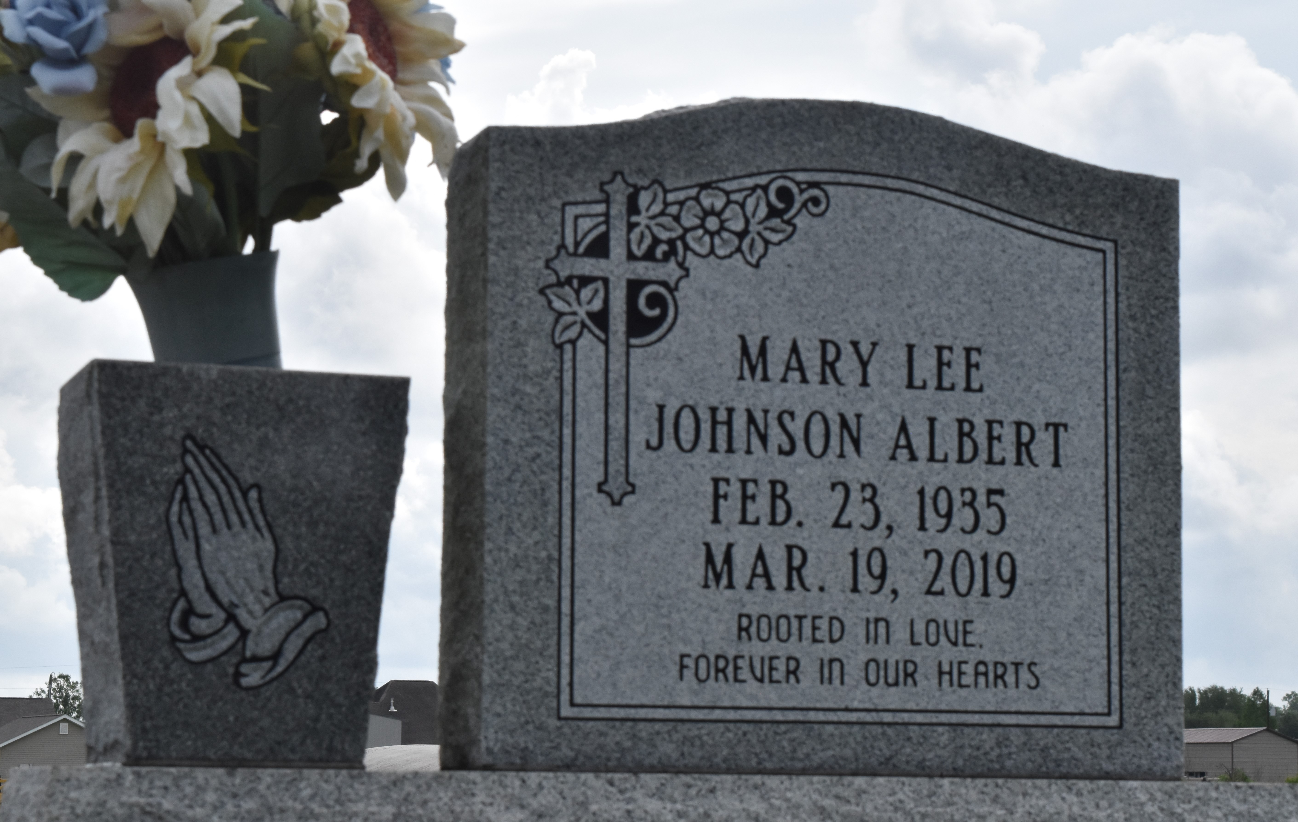

Mary passed March 19, 2019, age 84. Born to the late Albert Johnson and Leola B. Bowser. Wife of the late Ernest Albert, Jr. Beloved mother of Carolyn (Gregory), Marilyn (Barry), and Czedra (Dwight). Sister of Morris Bowser, Jr. (Doris) and Patricia B. Carr. She leaves 5 grandchildren to cherish her memory: Darnelle Holland, Kai Fleming, Erin Scott-Stewart, Blair Scott, and Mikhi Dalencourt, 7 great-grandchildren: Raven Emery, Zaria and Zykia Gordon, Ariel Scott, Kaleigh and Ethan Fleming, and Lathan Stewart.
A 1953 graduate of Cypress Grove H.S., and was employed at Charity Hospital in NOLA for 20 years. Mary was a faithful church member of Greater King Triumph B.C., for 73 years serving in various ministries including the Deaconess Board; in 2009 she was appointed Mother of the Church. She leaves a wealth of memories, legacy of love, and a message of unity that will forever be embedded in the hearts of the many loved ones that are left to celebrate her life.
Services will be held at Greater King Triumph B.C., 2572 Lionel Washington St., Lutcher, LA 70071, Friday, 03/29/19 at 10:00am. Visitation prior to the service at 9:00am. Arrangements entrusted to Braizer-Watson F.H. Donaldsonville, LA.

The Times-Picayune, New Orleans, Louisiana
March 25 to March 29, 2019

