Mildred (Washington) Albert
January 29, 1942 – April 8, 2004

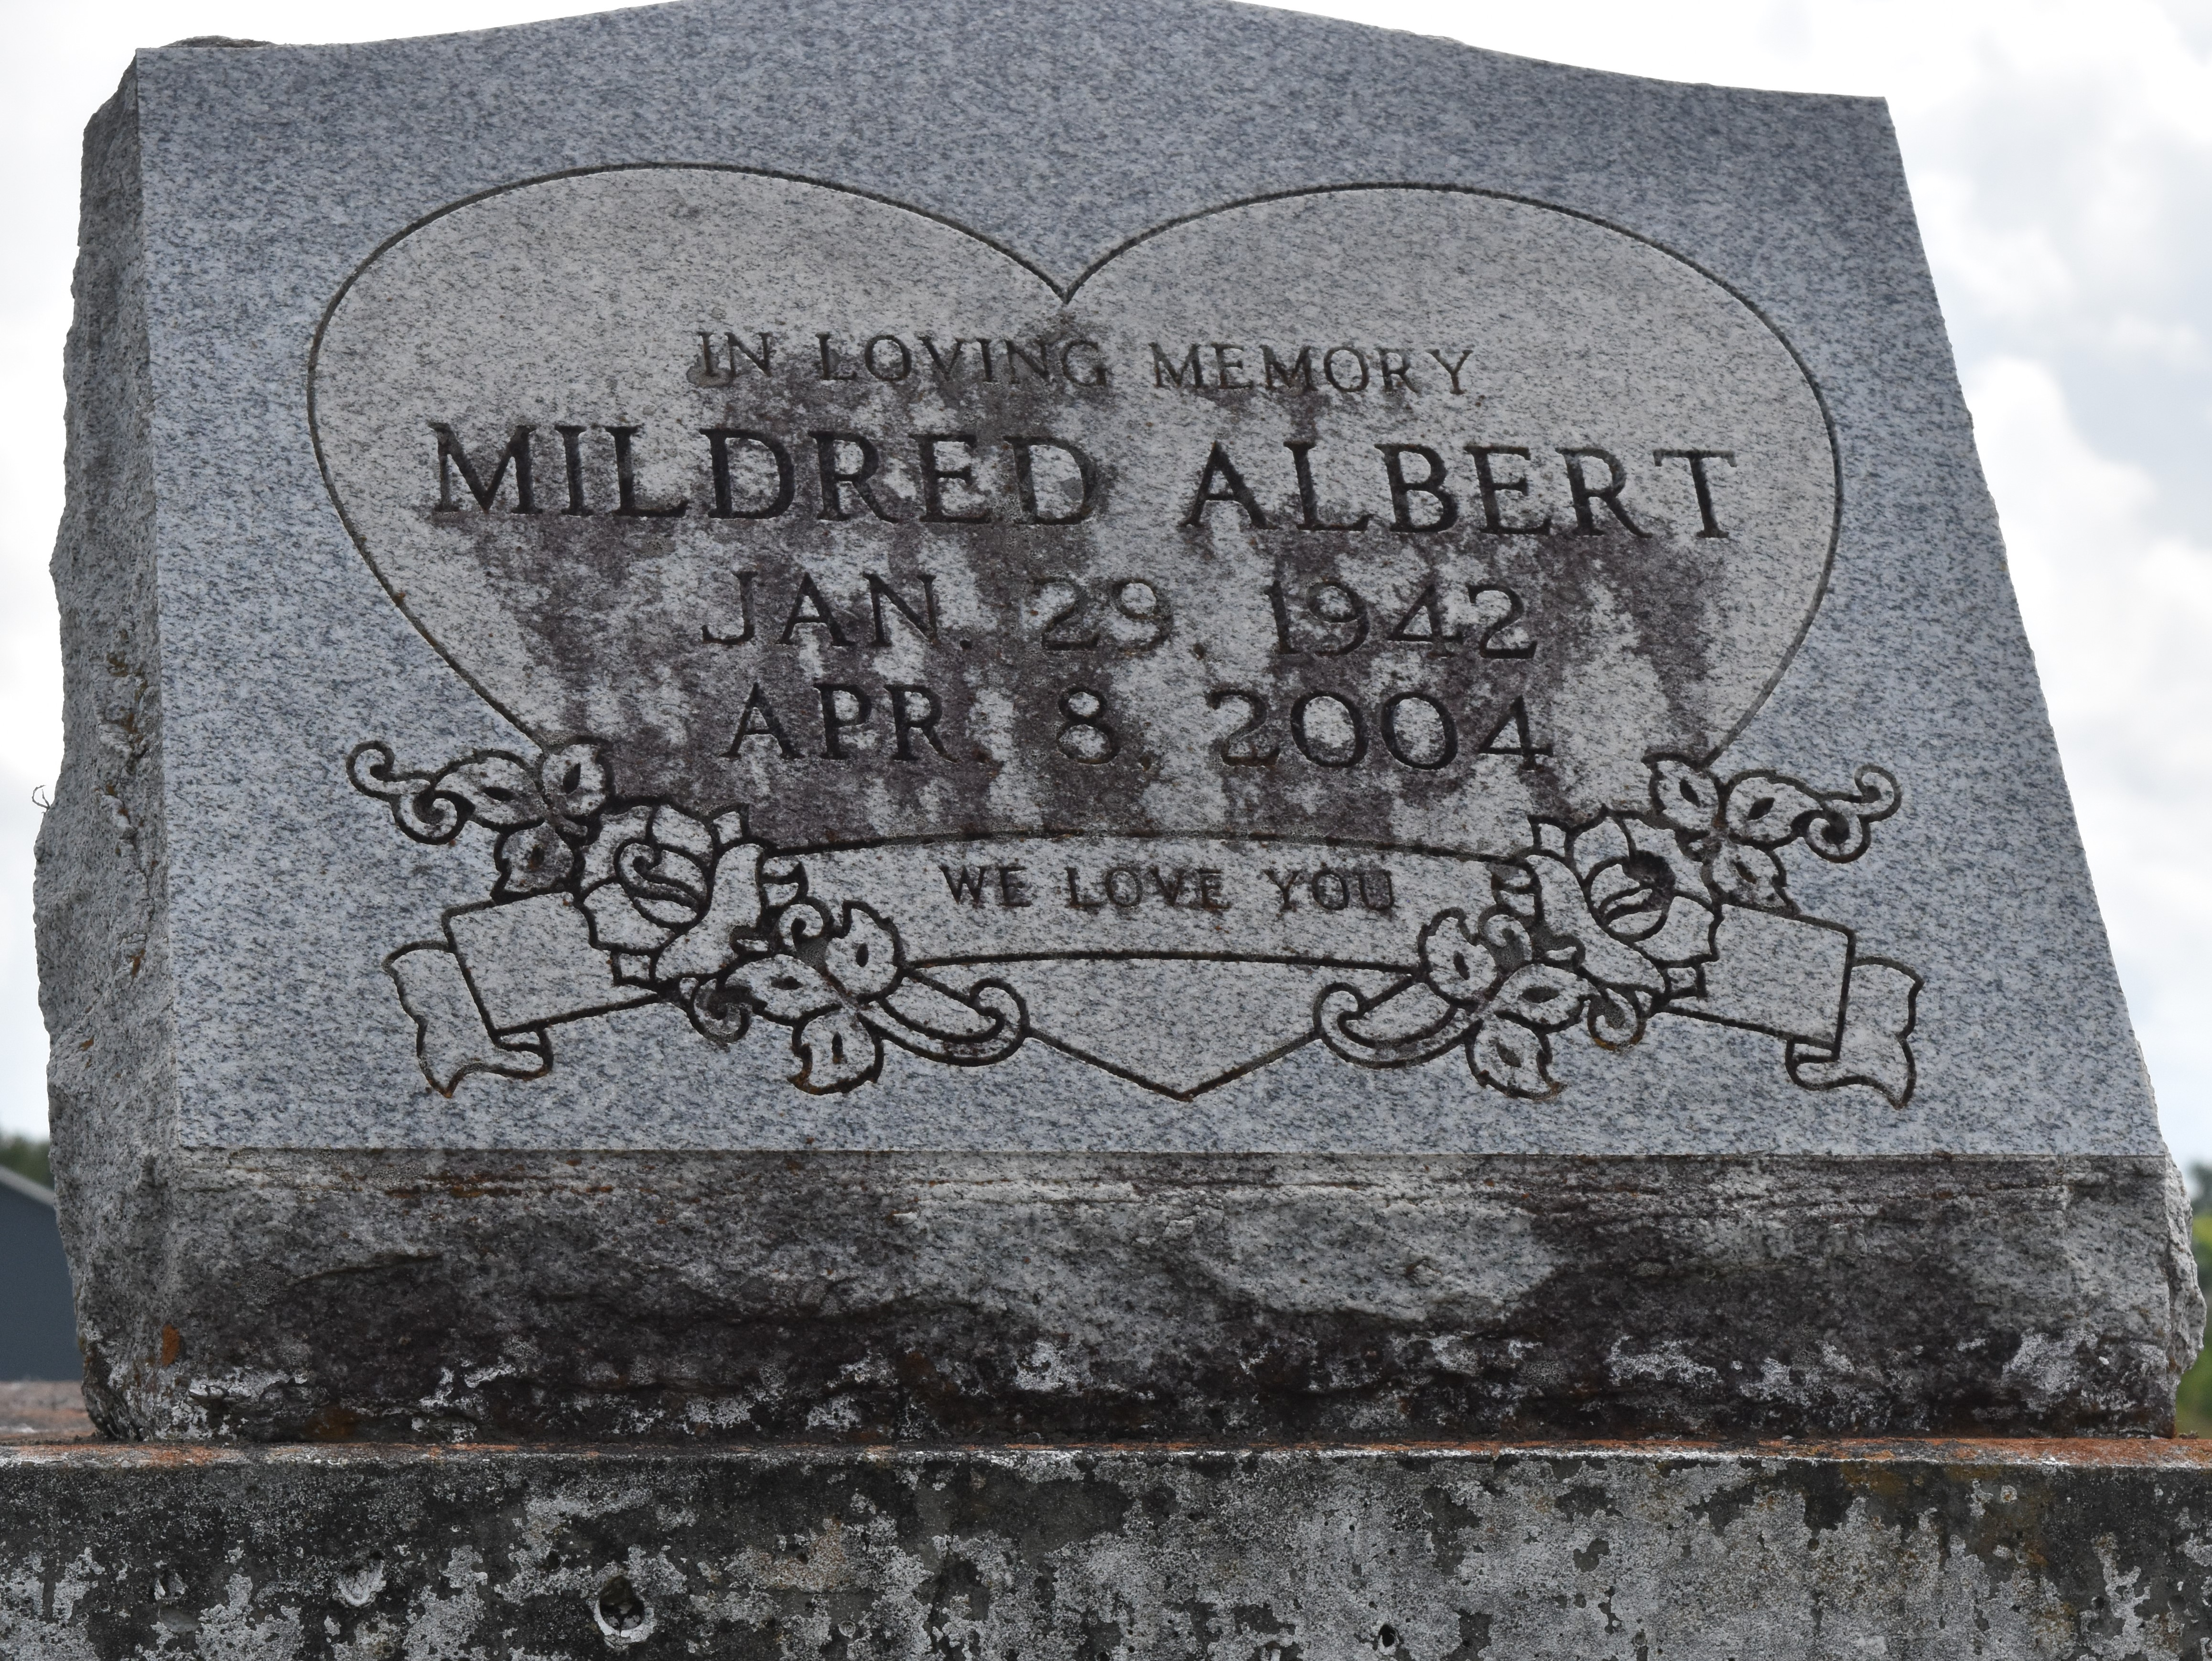

Mildred Washington Albert at her residence, Lutcher, LA., at 4:10 A.M., Thursday, April 8, 2004. Daughter of the late Henry Washington and Pearley Peters Washington. Wife of the late Freddie Albert, Sr. Beloved mother and mother-in-law of Trina and Jeffery Pearley of Gramercy, LA. Step-mother of Freddie Albert, Jr. Sister and Sister-in-law of Charles and Catherine Bowser, Dennis and Deborah Washington, Onetta Washington and the late Anthony Johnson, Ethel Mae Skinner, Willie Bowser, Bernice and Dorothy Washington, Josie Mae Wallace, Mary Lee Thomas and Irma Jean Goff. Grandmother of Ashaunta Gross and Trinesha Pearley. Great-Grandmother of Ceqwan Durst. Also survived by a number of aunts, uncles, neices, nephews, sisters and brothers-in-law, other relatives and friends. Age 62.
Visiting at Greater King Triumph Baptist Church, 2572 Lionel Washington Street, Lutcher, LA., Saturday, April 17, 2004 from 9:30 A.M. until Religious Services at 11:00 A.M. Conducted by the Rev. Reginald Joseph. Interment in Antioch Cemetery, Paulina, LA. Brazier-Watson Funeral Home in charge of arrangements.
The Times-Picayune, New Orleans, Louisiana
April 16, 2004

