Raymond Albert Sr.
September 15, 1938 – August 22, 2002

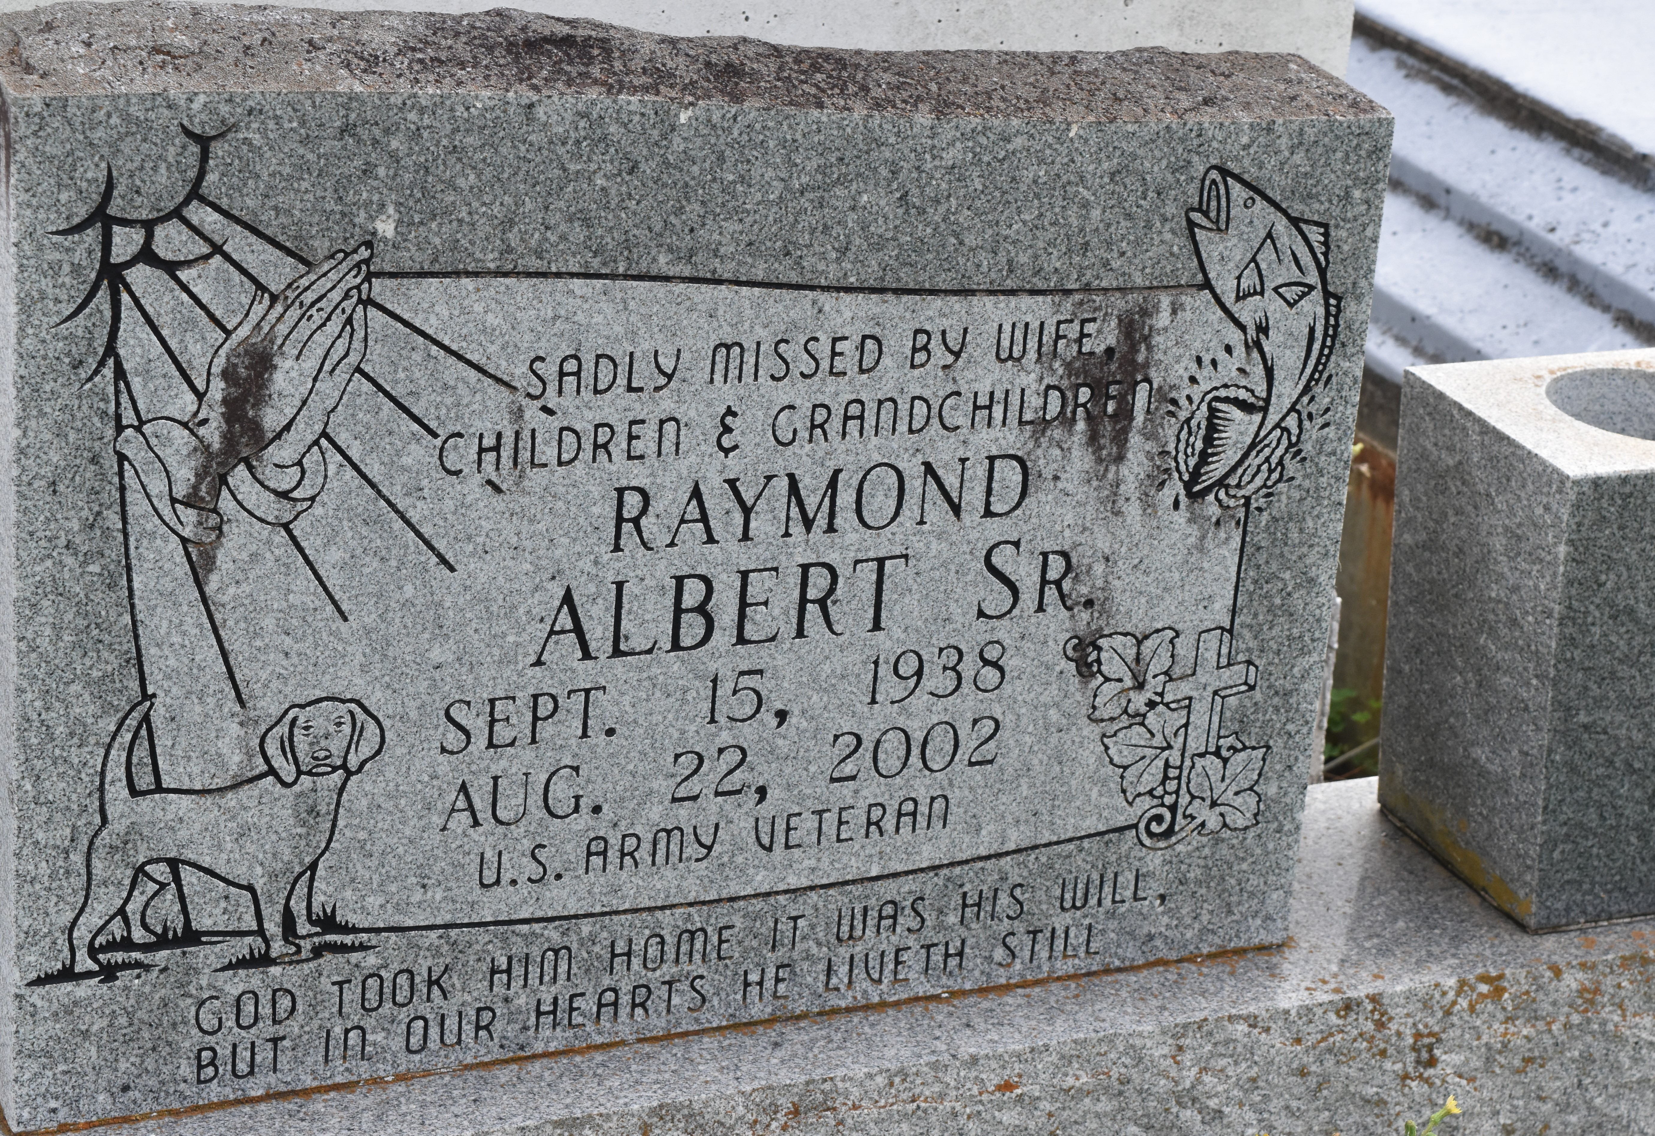

Raymond Albert, Sr. at Our Lady of the Lake Hospital, Baton Rouge, LA at 2:15 a.m., Thursday, August 22, 2002. Son of the late Ernest Albert Sr. and Velma Buckner Albert. Beloved husband of Gertrude Brown Albert of Lutcher, LA. Father and father-in-law of Angela Taylor and husband, Paul, Benita and Donald Albert all of Lutcher, LA, Raymond Albert, Jr. of Port Allen, LA, Daphne Carr and husband, Gino of Virginia and Kendell and Dewayne Winfield, also of Lutcher, LA. Brother of Ethel Jenkins, Annie Mae Davis, Diane Cannon, Elaine Foster, Eldrin Sr., Gary, Bernard, Lionel and Rev. Nolan Albert, Sr., the late Freddie Sr., Ernest Jr. and Larry Albert, Sr. Also survived by 13 grandchildren, a number of nieces, nephews, cousins, sisters and brothers-in-law, other relatives and friends. Age 63 years.
Relatives and friends of the family are invited to attend the Funeral Services on Monday, August 26, 2002 at 10:30 a.m. at Evergreen Baptist Church, Paulina, LA. Rev. Nolan Albert, Sr., Pastor. Interment in Antioch Cemetery, Paulina, LA. Visiting at the Church on Monday from 9:30 a.m. until time of services. NO WAKE. BRAZIER-WATSON FUNERAL HOME in charge of arrangements.

The Times-Picayune, New Orleans, Louisiana
August 25, 2002

