Geraldine (Banks) Allen
October 6, 1946 – April 23, 2018

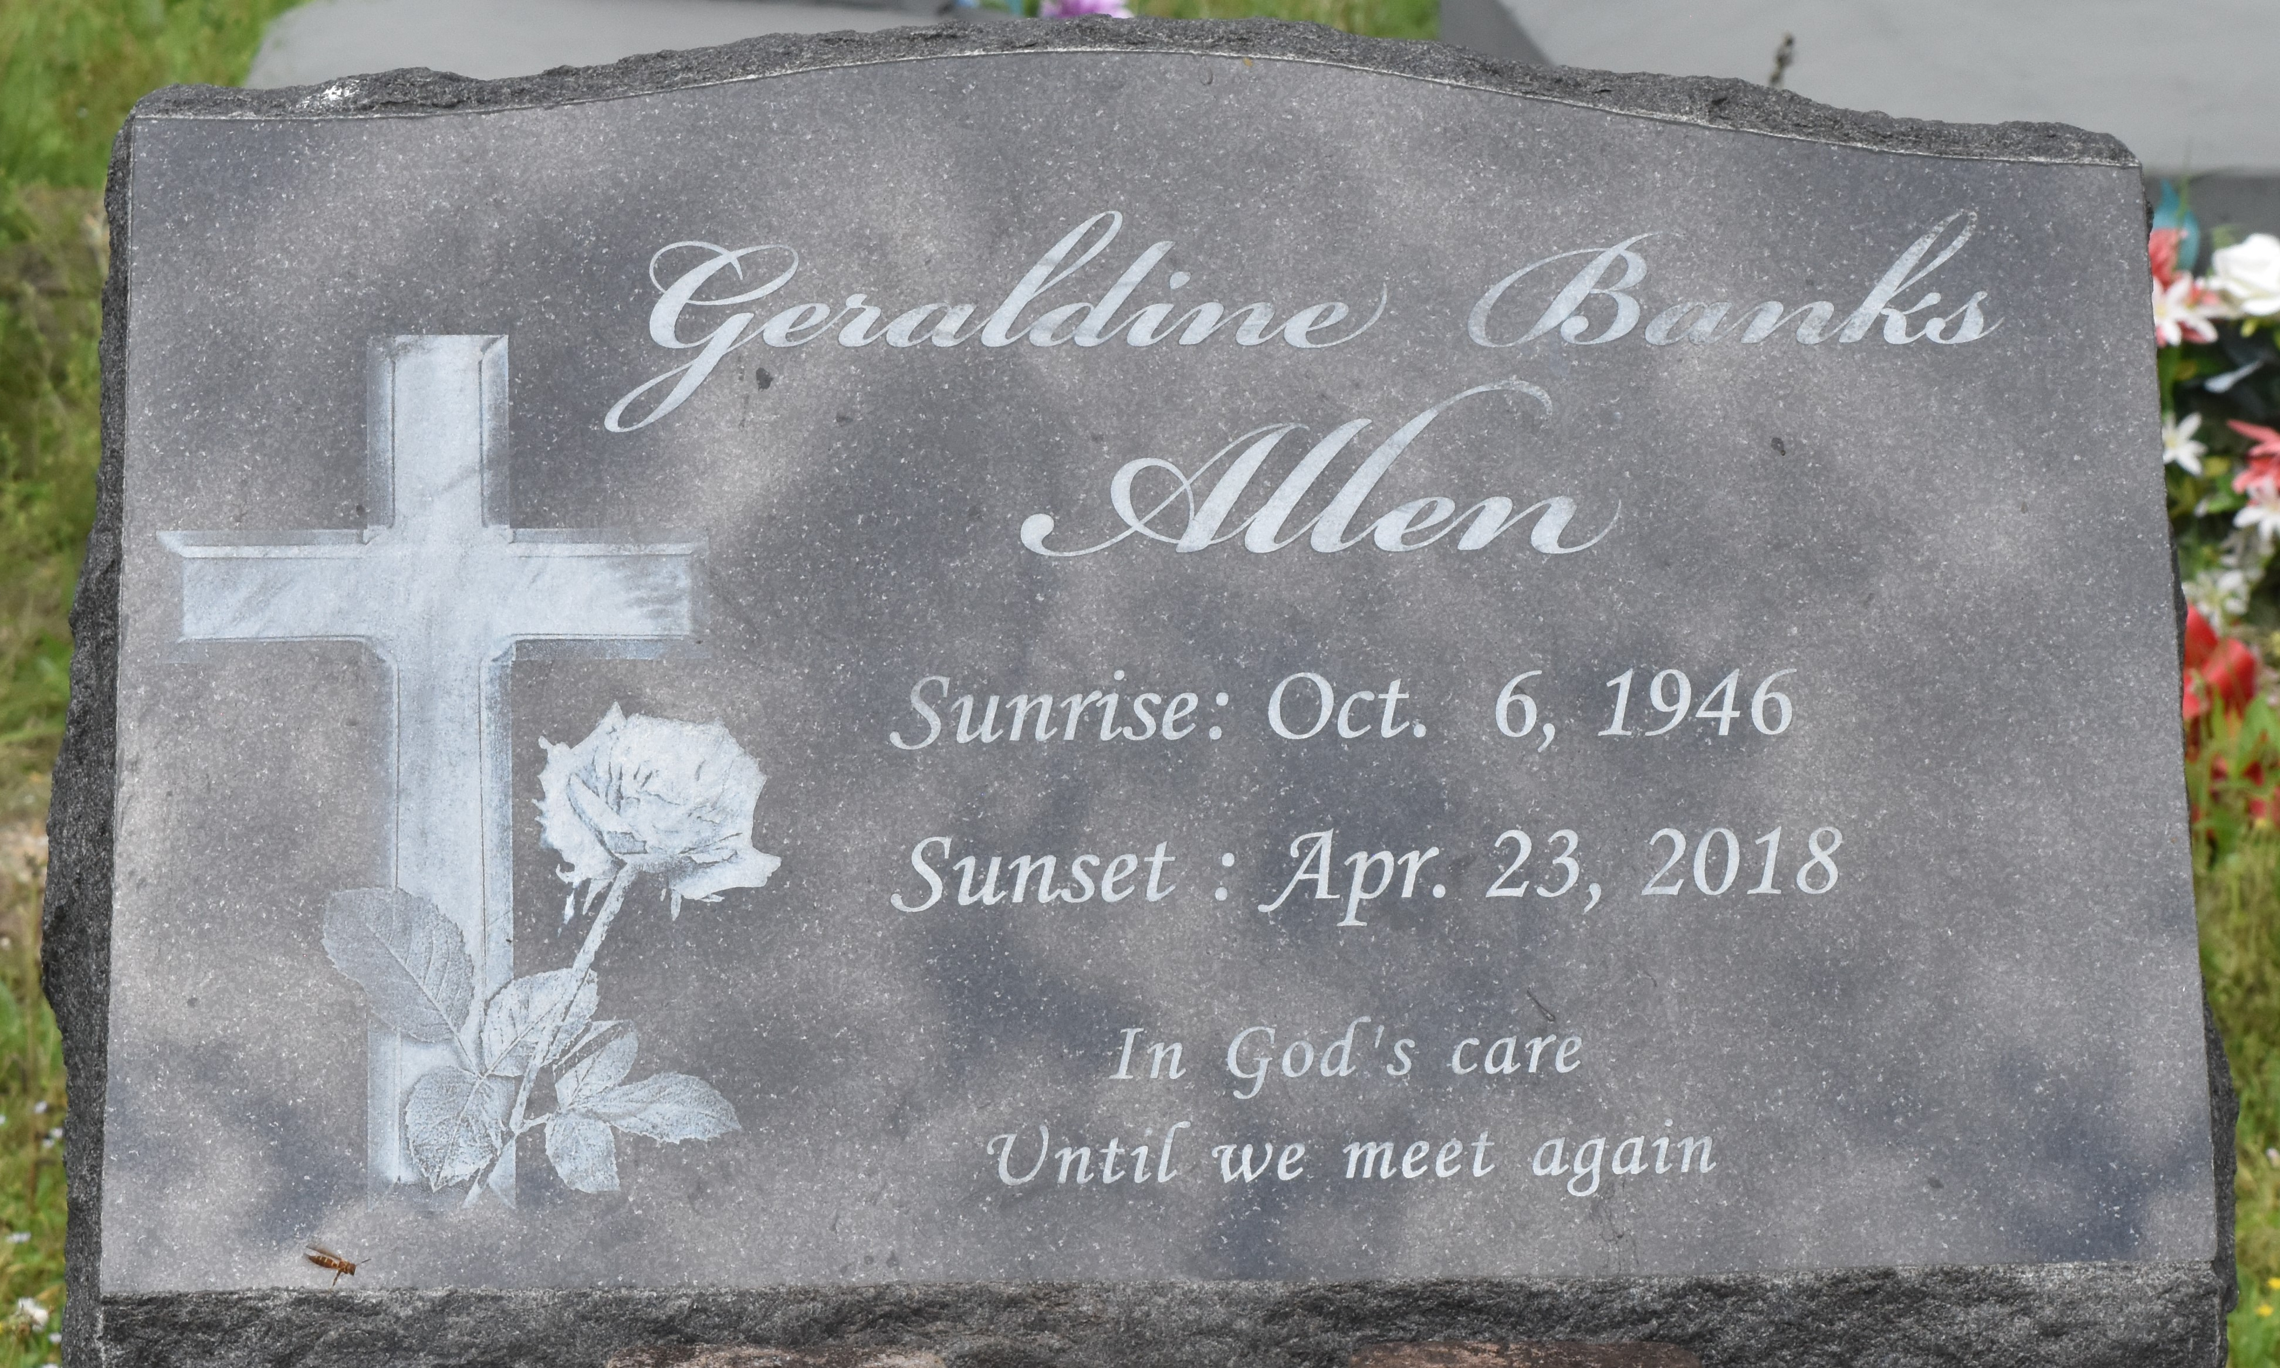

ALLEN, GERALDINE BANKS "GERI"
October 6, 1946 - April 23, 2018
A NATIVE OF PAULINA AND A RESIDENT OF MABLETON, GA. SHE PASSED AWAY AT KENNESTONE HOSPITAL IN ATLANTA, GA ON MONDAY, APRIL 23, 2018. SHE WAS 71.
VISITING AT KING SOLOMON BAPTIST CHURCH, NORTH COURSEAULT STREET, LUTCHER, SATURDAY, MAY 5, 2018 FROM 9:00 A.M. UNTIL RELIGIOUS SERVICES AT 10:00 A.M., CONDUCTED BY THE REV. KENNARD ROWDY SCOTT. VIEWING PRIOR TO SERVICES ONLY.. INTERMENT IN ANTIOCH CEMETERY IN PAULINA.
SURVIVED BY HER SON, BRIAN (OCTAVIA) TURNER. SISTERS: MERCEDES MITCHELL, ETHEL STRIGGS AND DELMA URSIN. BROTHERS: JOHN (ANITA) STRIGGS, ROGER AND THOMAS STRIGGS AND MOLEN (JOANN) URSIN. SISTER-IN-LAW: DANA BANKS. HER BEST FRIEND, CYNTHIA RAMBO; NUMEROUS GRANDCHILDREN, GREAT-GRANDCHILDREN, NIECES, NEPHEWS, COUSINS, GODCHILDREN, OTHER RELATIVES AND FRIENDS.
PRECEDED IN DEATH BY HER PARENTS: JOSEPH BANKS, SR., AND DELMA URSIN BANKS. STEPFATHER, JOHN STRIGGS. BROTHERS: JOSEPH BANKS, JR., REGINALD STRIGGS AND NATHANIEL BANKS. Visit us at www.brazierwatson.com to sign our guest book.

BRAZIER-WATSON FUNERAL HOME, Donaldsonville, Louisiana

