Johnnie Mae (Perkins) Armont
December 3, 1948 – April 15, 2012

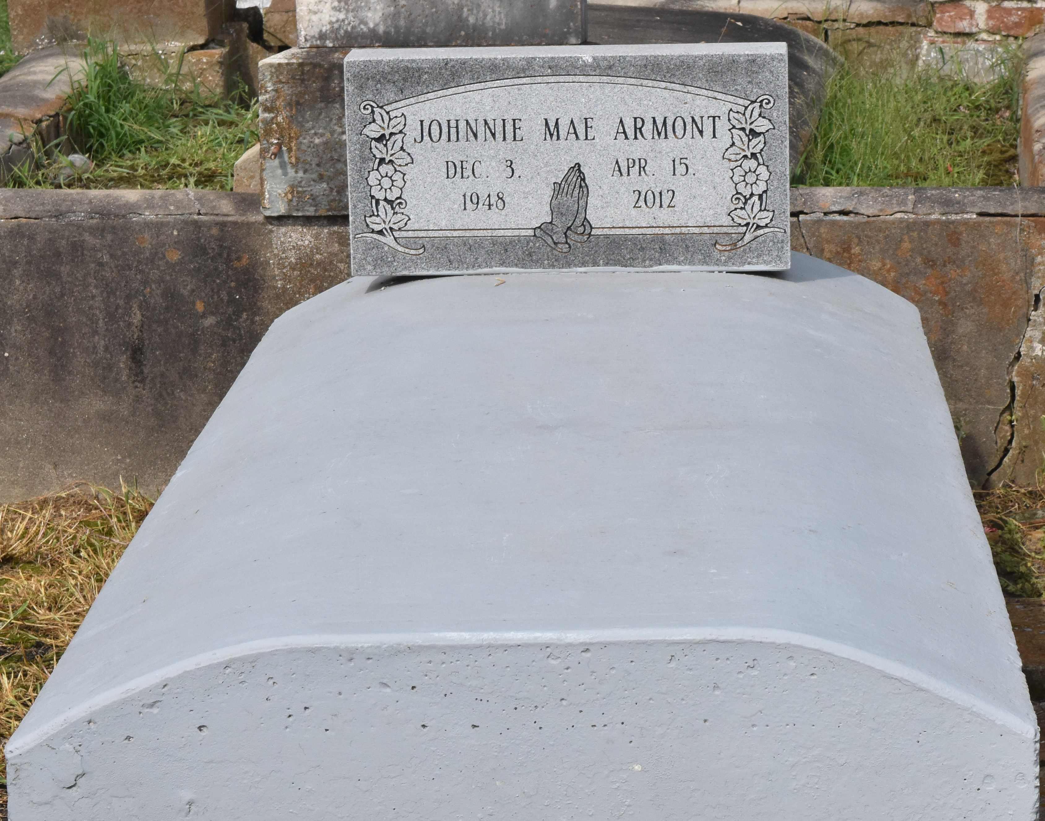

Johnnie Mae Perkins Armont was called home to be with the Lord on Sunday April 15, 2012. She was the daughter of the late Johnny & Beatrice Perkins. Wife of the late Kirby Armont, Mother of Vernadette (Lisa) Thomas and Crystal (Cha Boo) Beraud. Sister of Beatrice P. Mitchell, Alice P. Johnson, Jerry Perkins Sr., and George Weber Sr. Also survived by 2 grandchildren, 1 great-grandchild, aunts, uncles, nieces, nephews, in-laws, cousins, other relatives and friends. Recognized as daughters: Chantrell Burl and Mary K. Young.
Pastor, officers, and members of the New Zion Christian Center, Israelite Baptist Church, and all neighboring churches are invited to attend the Funeral Services on Saturday, April 21, 2012 at 10:00am at New Zion Christian Center, 216 West Main St., Gramercy, LA. Elder Emil D. Mitchell, Sr. Pastor, officiating. Visitation at the Church from 8:00 a.m. until service time. Burial in Antioch Cemetery, Paulina, LA. Service Entrusted to Hobson Brown Funeral Home 134 Daisy St. Garyville, La. 70051 (985) 535-2516
The Times-Picayune, New Orleans, Louisiana
Apr. 19 to Apr. 20, 2012

