Kirby Armont Sr.
October 15, 1939 – October 27, 2007

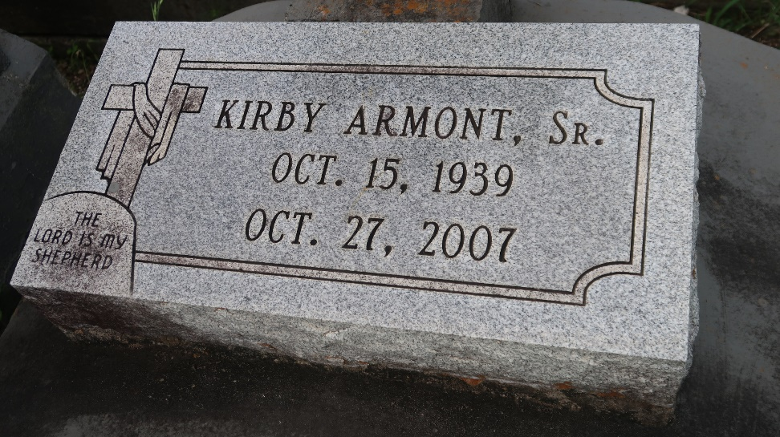

Kirby Armont, Sr., Age 68 departed this life on Saturday October 27, 2007, in Lutcher La., Son of the late Whelmon and Augustine (Kennard) Armont, Husband of Johnnie Mae Perkins Armont, Father of Karla Parks, Kevin, Kyle, and Kirby Armont Jr., and the late Keith Armont, Stepfather of Lisa Thomas and Crystal Beraud, Brother of Edna Clayton, Carrie, Roosevelt, and Clarence Armont, Naomi Morris, Donna Foley and the late Justina Watkins and Archie Armont also survived by 8 Grandchildren, 2 Great Grandchildren, Sons and daughter in law, brothers and sisters in law, and a host of nieces, nephews, other relatives. A native and resident of Lutcher, La.
Relatives and Friends of the family, Members of King Solomon B.C., New Zion Full Gospel, B.C., and all Neighboring Churches, employees Colonial Sugars are invited to attend the funeral service on Saturday November 3, 2007 at 11:00a.m. From the First Community Antioch B.C. 10860 Hwy 3125 Lutcher, La., Rev. Ferdinand Gaines, Jr Hosting Pastor , Rev Benjamin Scott, Pastor Officiating, Interment in Antioch Cem. Paulina, La., Visitation at the church from 9a.m. until Service Time. Service Entrusted to Hobson Brown Funeral Home Garyville, La.

The Times-Picayune, New Orleans, Louisiana
November 2, 2007

