Dorothy Mae (Miller) Banks
September 13, 1935 – October 13, 2019

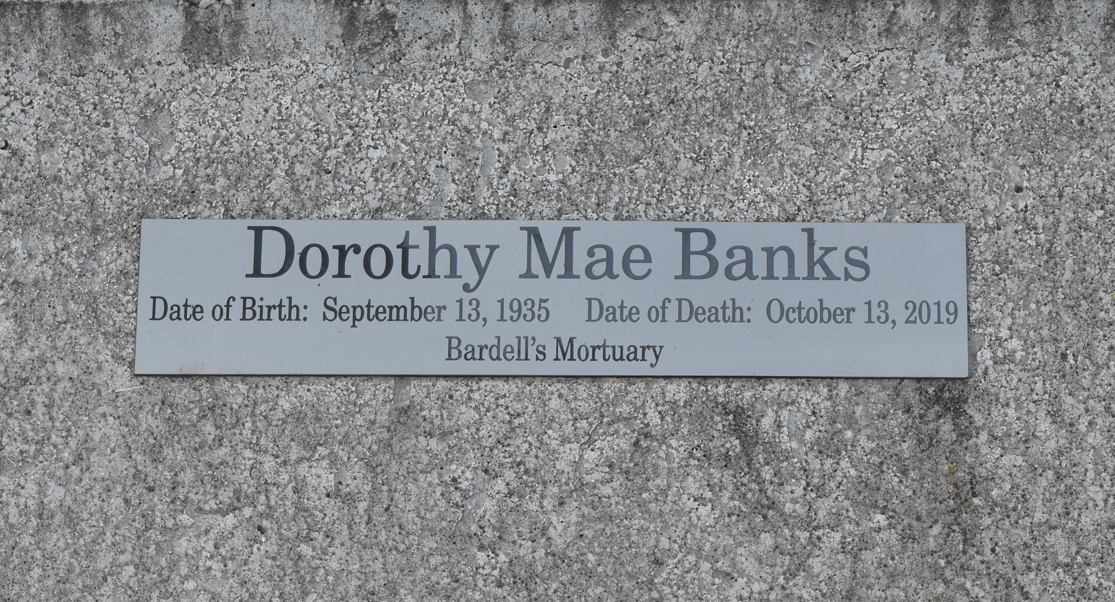

Dorothy Mae Banks was born on September 13, 1935 to the late Freddie and Viola Riley Miller in Hester, Louisiana. On Sunday, October 13, 2019, at the glorious age of 84 at her sister's home, Dorothy entered into rest knowing that to be absent from the body is to present with the Lord. Dorothy, affectionately known as Boo and Dor, was the wife of the late Willie Banks. She is stepmother of Joann (Andrew Carr, Jr.) Carr and Wilfred Banks. Dorothy has four step grandchildren, Willie II, Lydell, and Brian Banks and Sharda Chapman. Dorothy was reared in a loving, God fearing family. She is the sister of Frederick Miller, Louise Miller Washington, and Mary Joseph, and the late Edward Miller and Doretha Miller Armant. Sister-in-law of Alice Gaines Banks. Dorothy reared as her own Nancy Cantrelle Laiche, Karen Lynn Bovie, and Carl and Eric Cantrelle. One godchild, Elaine Johnson, a devoted cousin Ruby Johnson and a devoted friend of Ruth Washington, Ethel Mae Jenkins, Annie Mae Davis, Stacy Whittington, and Rose Howard, and numerous nieces, nephews, relatives, and friends.
Religious services will begin 11:00 am at Evergreen Baptist Church, 339 LA-3125, Paulina, Louisiana, 70763, Pastor Nolan Albert, officiating. Viewing from 9:00 am until service time. All neighboring churches are invited to attend the celebration of life for Dorothy Mae Banks. Interment at Antioch Cemetery, Paulina, Louisiana. Bardell's Mortuary of Mt. Airy, LA in charge. Information: (985)535-6837

The Advocate, Baton Rouge, Louisiana
Oct. 24 to Oct. 26, 2019

