Debra A. (Selders) Barney
April 5, 1954 – June 5, 2010

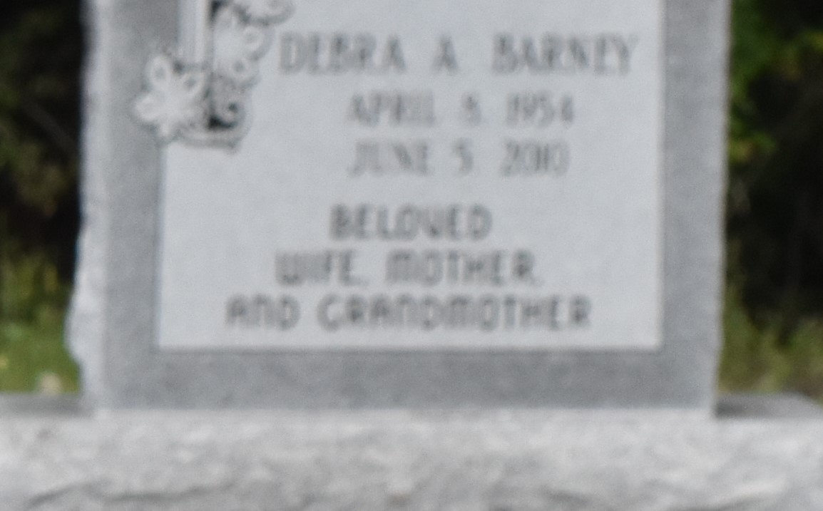

Debra Selders Barney at her residence in Cypress, TX, at 9:30 A.M., Saturday, June 5, 2010. Daughter of Margaret Crain Selders and the late Woodrow Selders, Sr. Beloved wife of Gary James Barney of Cypress, TX. Mother and mother-in-law of Michael, Jr., and Danielle Lewis, Tabyron Lewis, and LaShonda and LaTonya Lewis. Sister and sister-in-law of Barbara and Edward Alexander, Betry Alexander, Margarite Blair, Deloris Taylor, Aline and Fred Bellard, Bobbie and Gerald Selders, and the late Cheryl Lynn, Emmitt and Woodrow Selders, Jr. Step-mother of Keri (Aaron) Bovie and Kylan (Juanika) Barney. Daughter-in-law of Dorothy Barney and the late James Barney. Sister in law of Barbara Lagrange. Also survived by 10 grandchildren, 3 great-grandchildren, aunts, uncles, nieces, nephews, cousins, godchildren, other relatives and friends. Age 56.
Visiting at Greater Evergreen Baptist Church, Highway 44, Paulina, LA, Saturday, June 12, 2010 from 9:30 A.M. until Religious Services at 11:00 A.M., conducted by the Rev. Nolan Albert. Interment in Antioch B.C. Cemetery in Paulina, LA. Brazier-Watson Funeral Home in charge of arrangements.

The Times-Picayune, New Orleans, Louisiana
June 11, 2010

