Dorothy (Kirklin) Barney
September 11, 1930 – December 5, 2014

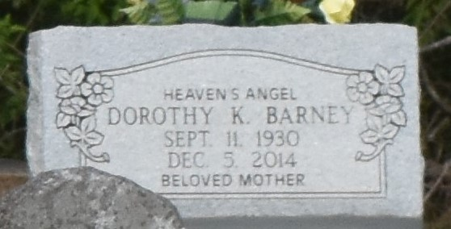

A native of New Orleans and a resident of Paulina. She passed away at St. James Parish Hospital in Lutcher on Friday, December 5, 2014 at 1:45 p.m. She was 84. Viewing at Evergreen Baptist Church, Highway 3125, in Paulina on Wednesday, December 10, 2014 from 9:30 a.m. until religious services at 11:00 a.m. ONLY, conducted by the Rev. Nolan Albert. Interment in Antioch Church Cemetery.
Survived by a daughter: Barbara Barney LaGrange and a son, Gary James Barney; Brothers: Lionel, Murphy, Melvin and Ronald Kirklin; Sisters: Melba Jean Gaines and Patricia (Joe) Long; Her grandchildren: Konetha and Kashane LaGrange, Kylan Barney and Keri Barney Bovie. Step-grandchildren: Michael, Lasonda, Lytonya and Tabyron Lewis; great grandchildren: Kerrien Banks, Kylah Barney and Amyri and Kenli Bovie; Sisters in law: Elaine, Lucille and Cathy Kirklin, numerous nieces, nephews, cousins, other relatives and friends. Preceded in death by her parents: Isadore Kirklin, Sr. and Evelina Jackson Kirklin. Her husband, James Barney; Her son, Ray Barney; A sister: Ethel Mae Kirklin; Brothers: Isadore, Jr., Percy, Oscar and Stanley Kirklin; Daughter in law, Debra Barney and Son in law, Kerry LaGrange and a sister in law, Sarah Kirklin. Brazier-Watson Funeral Home in charge of arrangements. Visit us at www.brazierwatson.com to sign our guest book.

The Advocate, Baton Rouge, Louisiana
Dec. 8 to Dec. 9, 2014

