Gloria Mae Barney
1998 – December 29, 2011

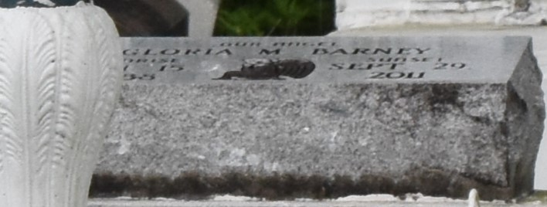

Gloria Mae Barney passed away on Thursday, September 29, 20011 in Baton Rouge, LA. She is survived by 4 daughters, 5 sons, 4 sisters, 2 brothers, and a host of grandchildren, and great-grandchildren.
Service will be held on Saturday October 8, 2011 at St. Matthew B.C., Hwy 44, Paulina, La. at 12:00 noon. Rev. Herman Clayton, Pastor. Burial in Antioch Cemetery, Paulina, La. Service Entrusted to Hobson Brown Funeral Home 134 Daisy St. Garyville, La., 70051 (985) 535-2516

The Times-Picayune, New Orleans, Louisiana
Oct. 6 to Oct. 7, 2011

