Manuel Bourgeois Sr.
April 24, 1934 – November 22, 2017

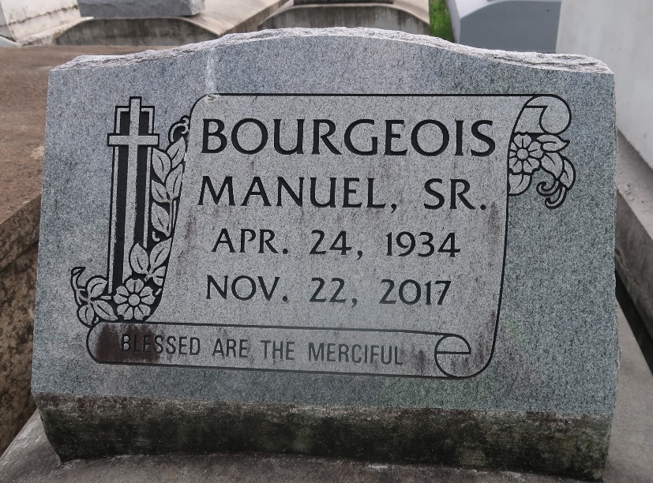

Manuel Bourgeois, Sr. on Wednesday, November 22, 2017 at Ochsner Medical Center, Kenner, LA. Son of the late Edna McCormick and Isaac Bourgeois, Sr. Father of Linnie Bourgeois Harris (Lenix), Manuel Bourgeois, Jr., Burnell Bourgeois and the late Lydia Rose Bourgeois. Brother of Wilmer Bourgeois, Sr. (Audry), Dorothy B. Thomas, the late Rosetta Jordan, Elnora McGuffey, Edna Ennis, Louvina Robertson, Eunice Rixner and Isaac Bourgeois, Jr. Also survived by 9 grandchildren, 2 great grandchildren, and a host of nieces, nephews, cousins, other relatives and friends. Age 83 years. A native and resident of Paulina, LA.
Relatives and friends of the family, also pastors, officers and members of Evergreen Baptist Church and all neighboring churches are invited to attend the funeral service at Evergreen Baptist Church, 3399 LA 3125, Paulina, LA on Saturday, December 2, 2017 at 1:30 pm. Rev Nolan Albert, Pastor, Officiating. Interment Antioch Cemetery, Paulina, LA. Visitation at the above named church from 1:00 PM until service time SERVICED BY ROBOTTOM

The Times-Picayune, New Orleans, Louisiana
Nov. 28 to Dec. 1, 2017

