Fayona V. (Marcell) Brown
June 20, 1960 – February 15, 2019

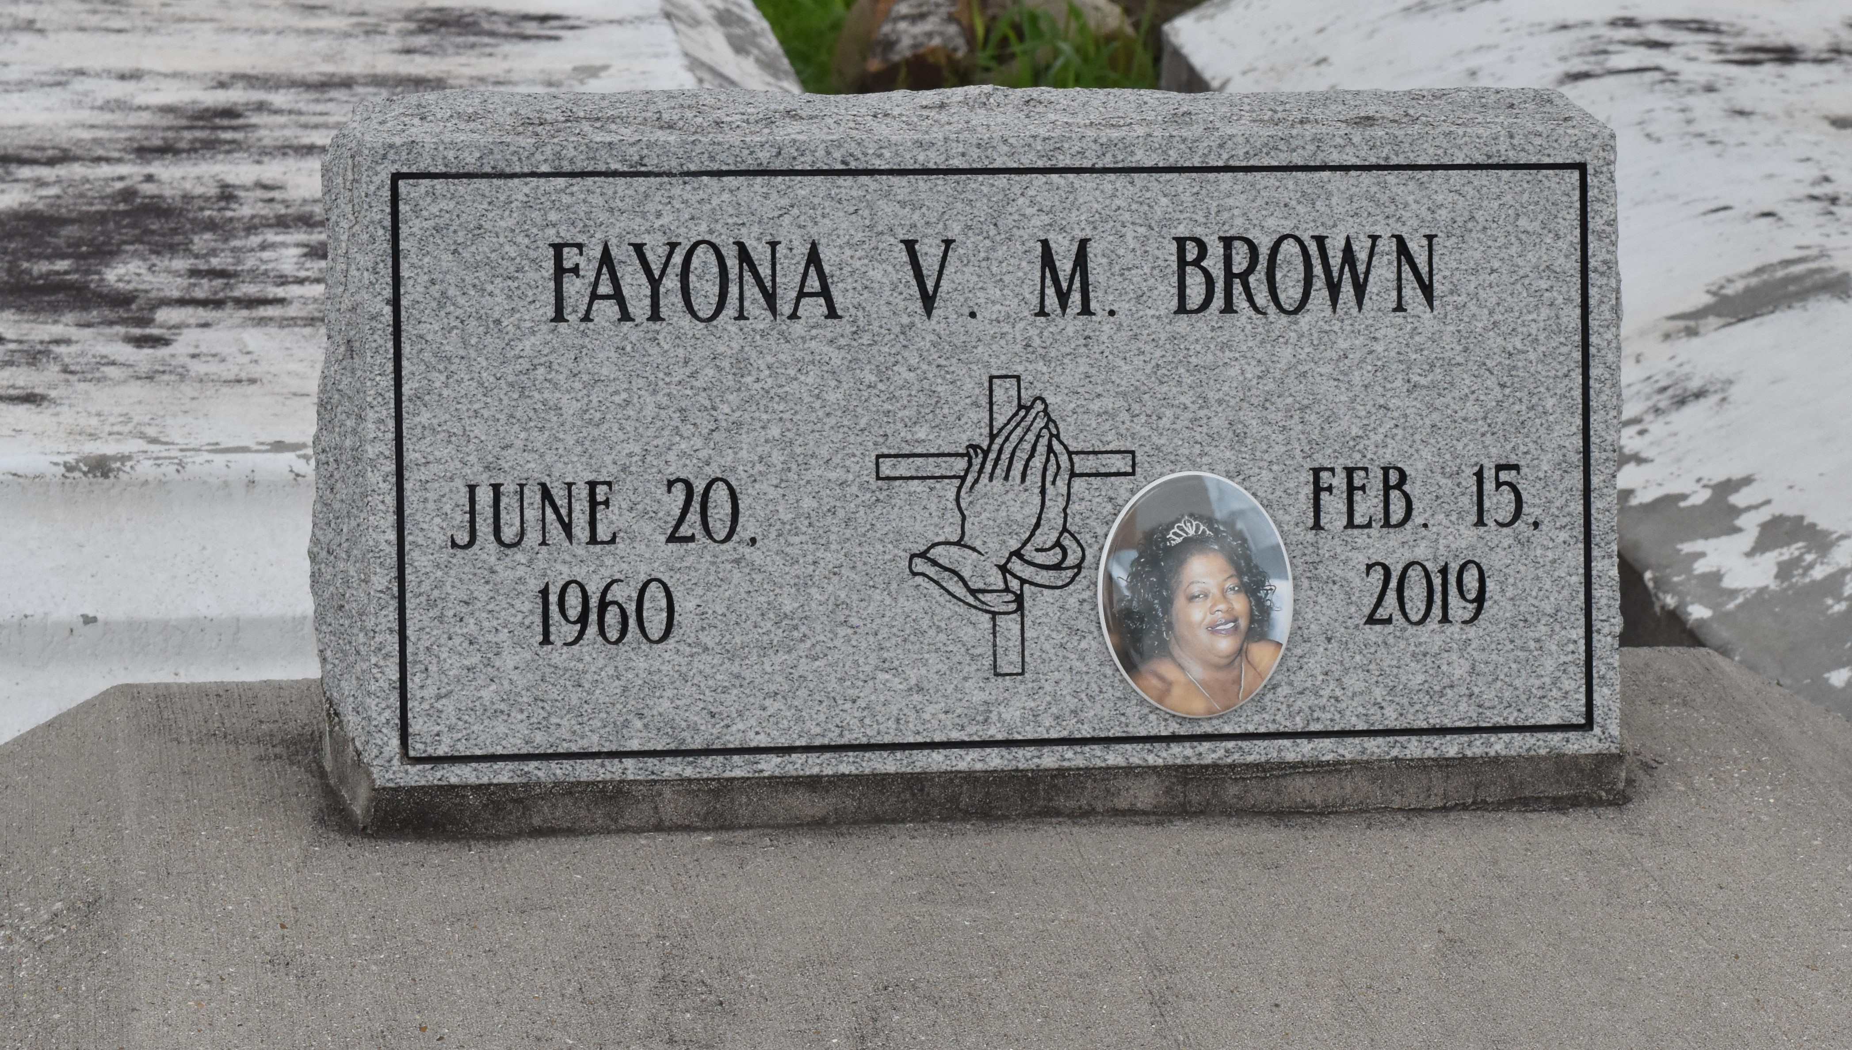

A native of Paulina and a resident of Lutcher. She passed away at Ochsner Medical Center in New Orleans at 7:23 P.m.., February 15, 2019. She was 58.
Visiting at King Solomon Baptist Church, Lutcher on Friday, February 22, 2019 from 9:00 am. until Religious services at 10:00 am., Conducted by the Rev. Rowdy Scott. Internment in Antioch B.C. Cemetery in Paulina.
Survived by her husband, Allen Brown. Her daughters: Allyneika and Allyneisha Brown and her son, Allen Brown. Her sister: Sonja Marcell. Brothers: Michael (Jennifer) Marcell, Dwayne Marcell and fiancé, Darlene Mayo, numerous nieces, nephews, cousins other relatives and friends.
Preceded in death by her parents: Freeman Marcell, Sr. and Georgia Noel Marcell. Her brother, Freeman Marcell, Jr
Visit us at www.brazierwatson.com to sign our guest book.

Brazier-Watson Funeral Home, Donaldsonville, Louisiana

