Jamarla M. Brown
November 18, 1979 – May 20, 2019

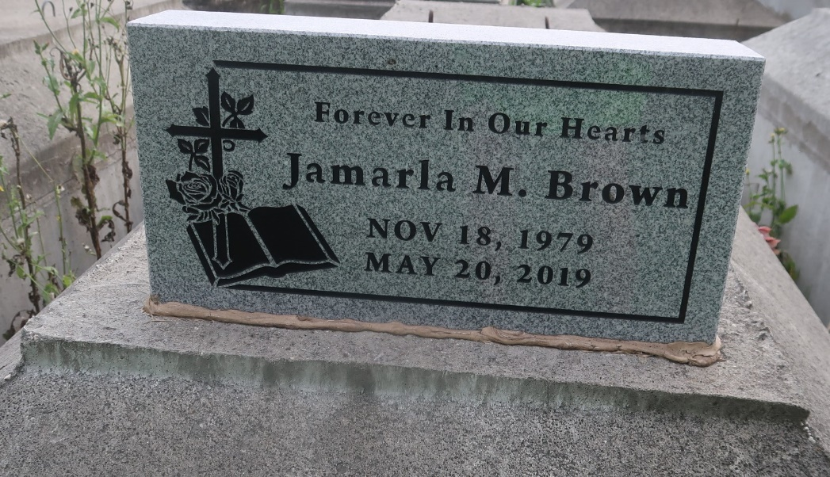

JaMarla "Huck" Brown, age 39, departed this life on May 20, 2019, Son of Michael and Gwendolyn Brown, Brother Ebony Brown and Michael Jones.
Celebration service will be held on June 1, 2019 at Golden Grove B.C. 127 Mulberry St Gramercy, LA 70052 at 10:00 am. Viewing from 8:00 am until service time. (ONLY), Rev. Ulysses Jarrow Pastor, officiating.
Internment Antioch cemetery Paulina, LA. Professional Services entrusted to the caring staff of Hobson Brown Funeral Home, 134 Daisy St., Garyville, LA 70051. 985-535-2516.
The New Orleans Advocate (LA)
May 29 to Jun. 1, 2019

