Michael J. Brown
March 3, 1956 – January 31, 2022

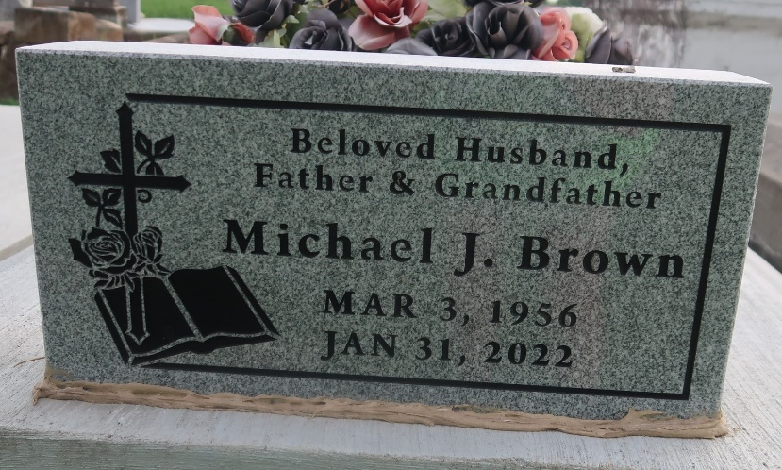

On January 31, 2022, heaven opened its gates for a true servant to enter the kingdom and take advantage of the better life. Michael Brown, a native of Gramercy, LA departed this earth in Kenner, LA at 65 years of age. Michael is the son of the late Mary Bujol Brown and Moss Brown, III. Beloved husband of Gwendolyn Jones Brown, father of Michael Jones, and Ebony B. (Terence) white, and the late JaMarla Brown. Brother of Tammy Jackson, Steven, Osmund Brown, the late Charles Brown, Sr., and Deborah Shorty. Michael is also survived by grandchildren, nieces, nephew, and a host of other relatives and friends.
Funeral Service will be held on Saturday, January 5, 2022, at 12:00 noon at Greater Golden Grove B.C. 127 Mulberry St. Gramercy, LA., Rev. Ulysses Jarrow officiating. Visitation at 11:00am. Interment Antioch Cemetery Paulina, La. Due to cdc (covid19) restrictions seating may be limited, mask and social distancing are required. Professional Services entrusted to the Caring Staff of Hobson Brown Funeral Home, 134 Daisy St., Garyville, La 70051, 985-535-2516.
The Times-Picayune, New Orleans, Louisiana
Feb. 3 to Feb. 5, 2022

