Alfred Bujoile
November 7, 1943 – November 5, 2018

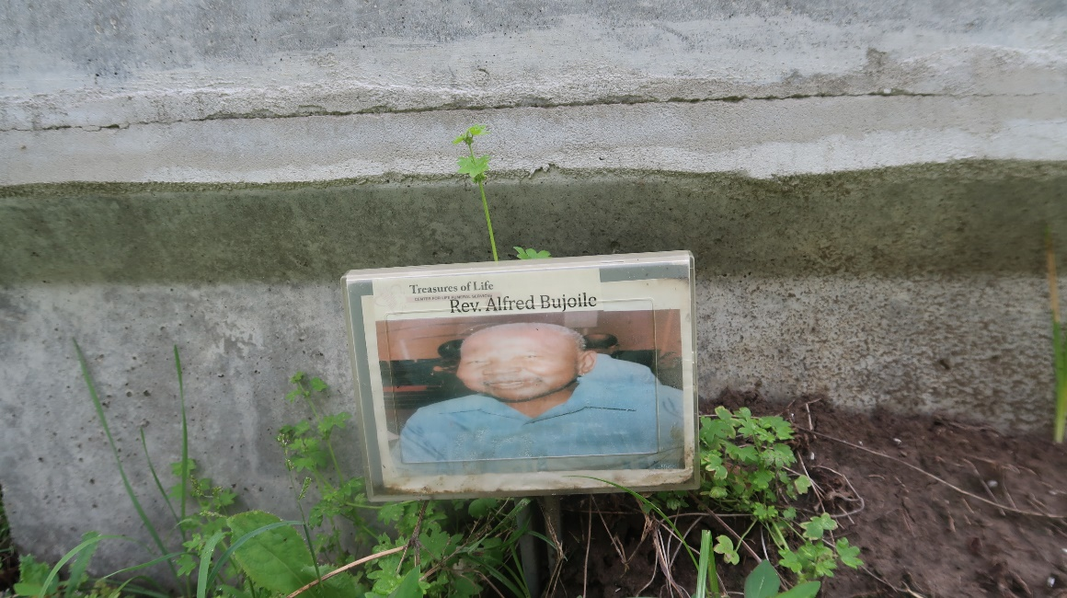

Rev. Alfred Bujoile transitioned to his eternal home on, November 5, 2018. The Reverend's life journey began on November 7, 1943 in Lutcher, LA. His parents were the late Freddie Bujol, Sr. and the late Rosa Lee Coates Bujol. Alfred was the fifth of thirteen children; Della Jury, Marlene Morris, Katy Hayes, Wanda Wharton, Dolores Morris, Margret Webster, Kathaleen Shorty, Rayne Robinson, and Charles Mitchell. His siblings; Mary, Freddie Jr., Rene and Shelia preceded him in death. He was married to Mary Jane Turner for fifty-two years. This union produced two offsprings, Charlotte Butler and Trenell Bujoile. Rev. Bujoile had one son-in-law, Joseph Butler; one aunt, Zerlie Aubert of Riverside, CA; eight grandchildren, fifteen great grand-children and three Godchildren, a host of nieces and nephews; four sister-in laws, eleven brother- in-laws and a devoted best friend, Earnest Smith, Sr.
Rev. Bujoile was educated in St. James Paris public school system and received a master of divinity from A.P. Clay Christian Bible College in Kenner, LA. He was an Associate Minister at King David Baptist Church in Lutcher, LA and Pastor at St. Matthews Baptist Church in Paulina, LA. He was employed at Lutcher Wholesale Food Store and retired from C.T. Boudreaux Lumber Co. after 28 years.
A Celebration of Rev. Alfred Bujoile. life will be held on November 17, 2018 at First Community Antioch Baptist Church, Hwy. 3125 Lutcher, LA. Rev. Ferdinand Gains, Jr., Officiating. Visitation, 9:00 am to 11:00 am. Services will begin at 11:00 a.m. Friends, family and neighboring churches of Lutcher, Gramercy and Paulina, LA and the First Free Mission Baptist Church, New Orleans, LA. Burial will be at Antioch Cemetery, Paulina, LA. Arrangements by Treasures of Life Center for Life Funeral Service, 315 East Airline Hwy., Gramercy, LA 70052.

Treasure of Life Funeral Services, Gramercy, Louisiana

