Ronald James Burden
August 19, 1950 – October 28, 2006

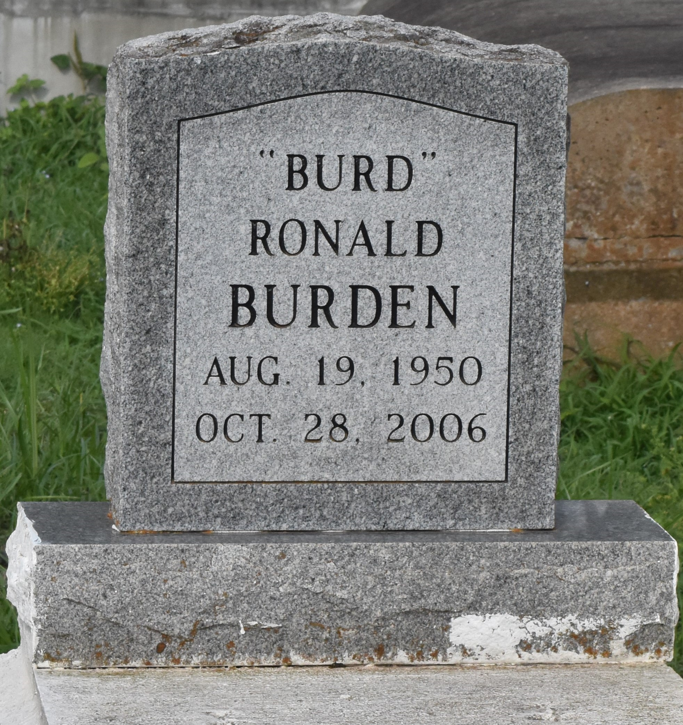

Burden, Ronald James "Burd" A native of Lutcher and a resident of Thibodaux, he died at 4:57 a.m. Saturday, Oct. 28, 2006, at Thibodaux General Hospital in Thibodaux. He was 56. Visiting at King David Baptist Church, Lutcher, on Tuesday from 10 a.m. until religious service at 11 a.m., conducted by the Rev. Dr. Herbert Gordon. Burial in Antioch Cemetery in Paulina. Survived by his mother, Roseanna Williams of Lutcher; uncle, Joseph Williams Sr.; cousins, including Rosalind Langford, Paulette Butler, Alvin, Cornell and Anita Faye Traveler, Adam Cooper Jr., Olivia and Joseph Williams Jr., and Joann White; and other relatives and friends. Preceded in death by his father, James Burden Jr.; and brother, Alex Burden. Brazier-Watson Funeral Home is in charge of arrangements.
The Advocate, Baton Rouge, Louisiana
November 6, 2006

