Roseanna (Williams) Burden
July 15, 1922 – May 29, 2009

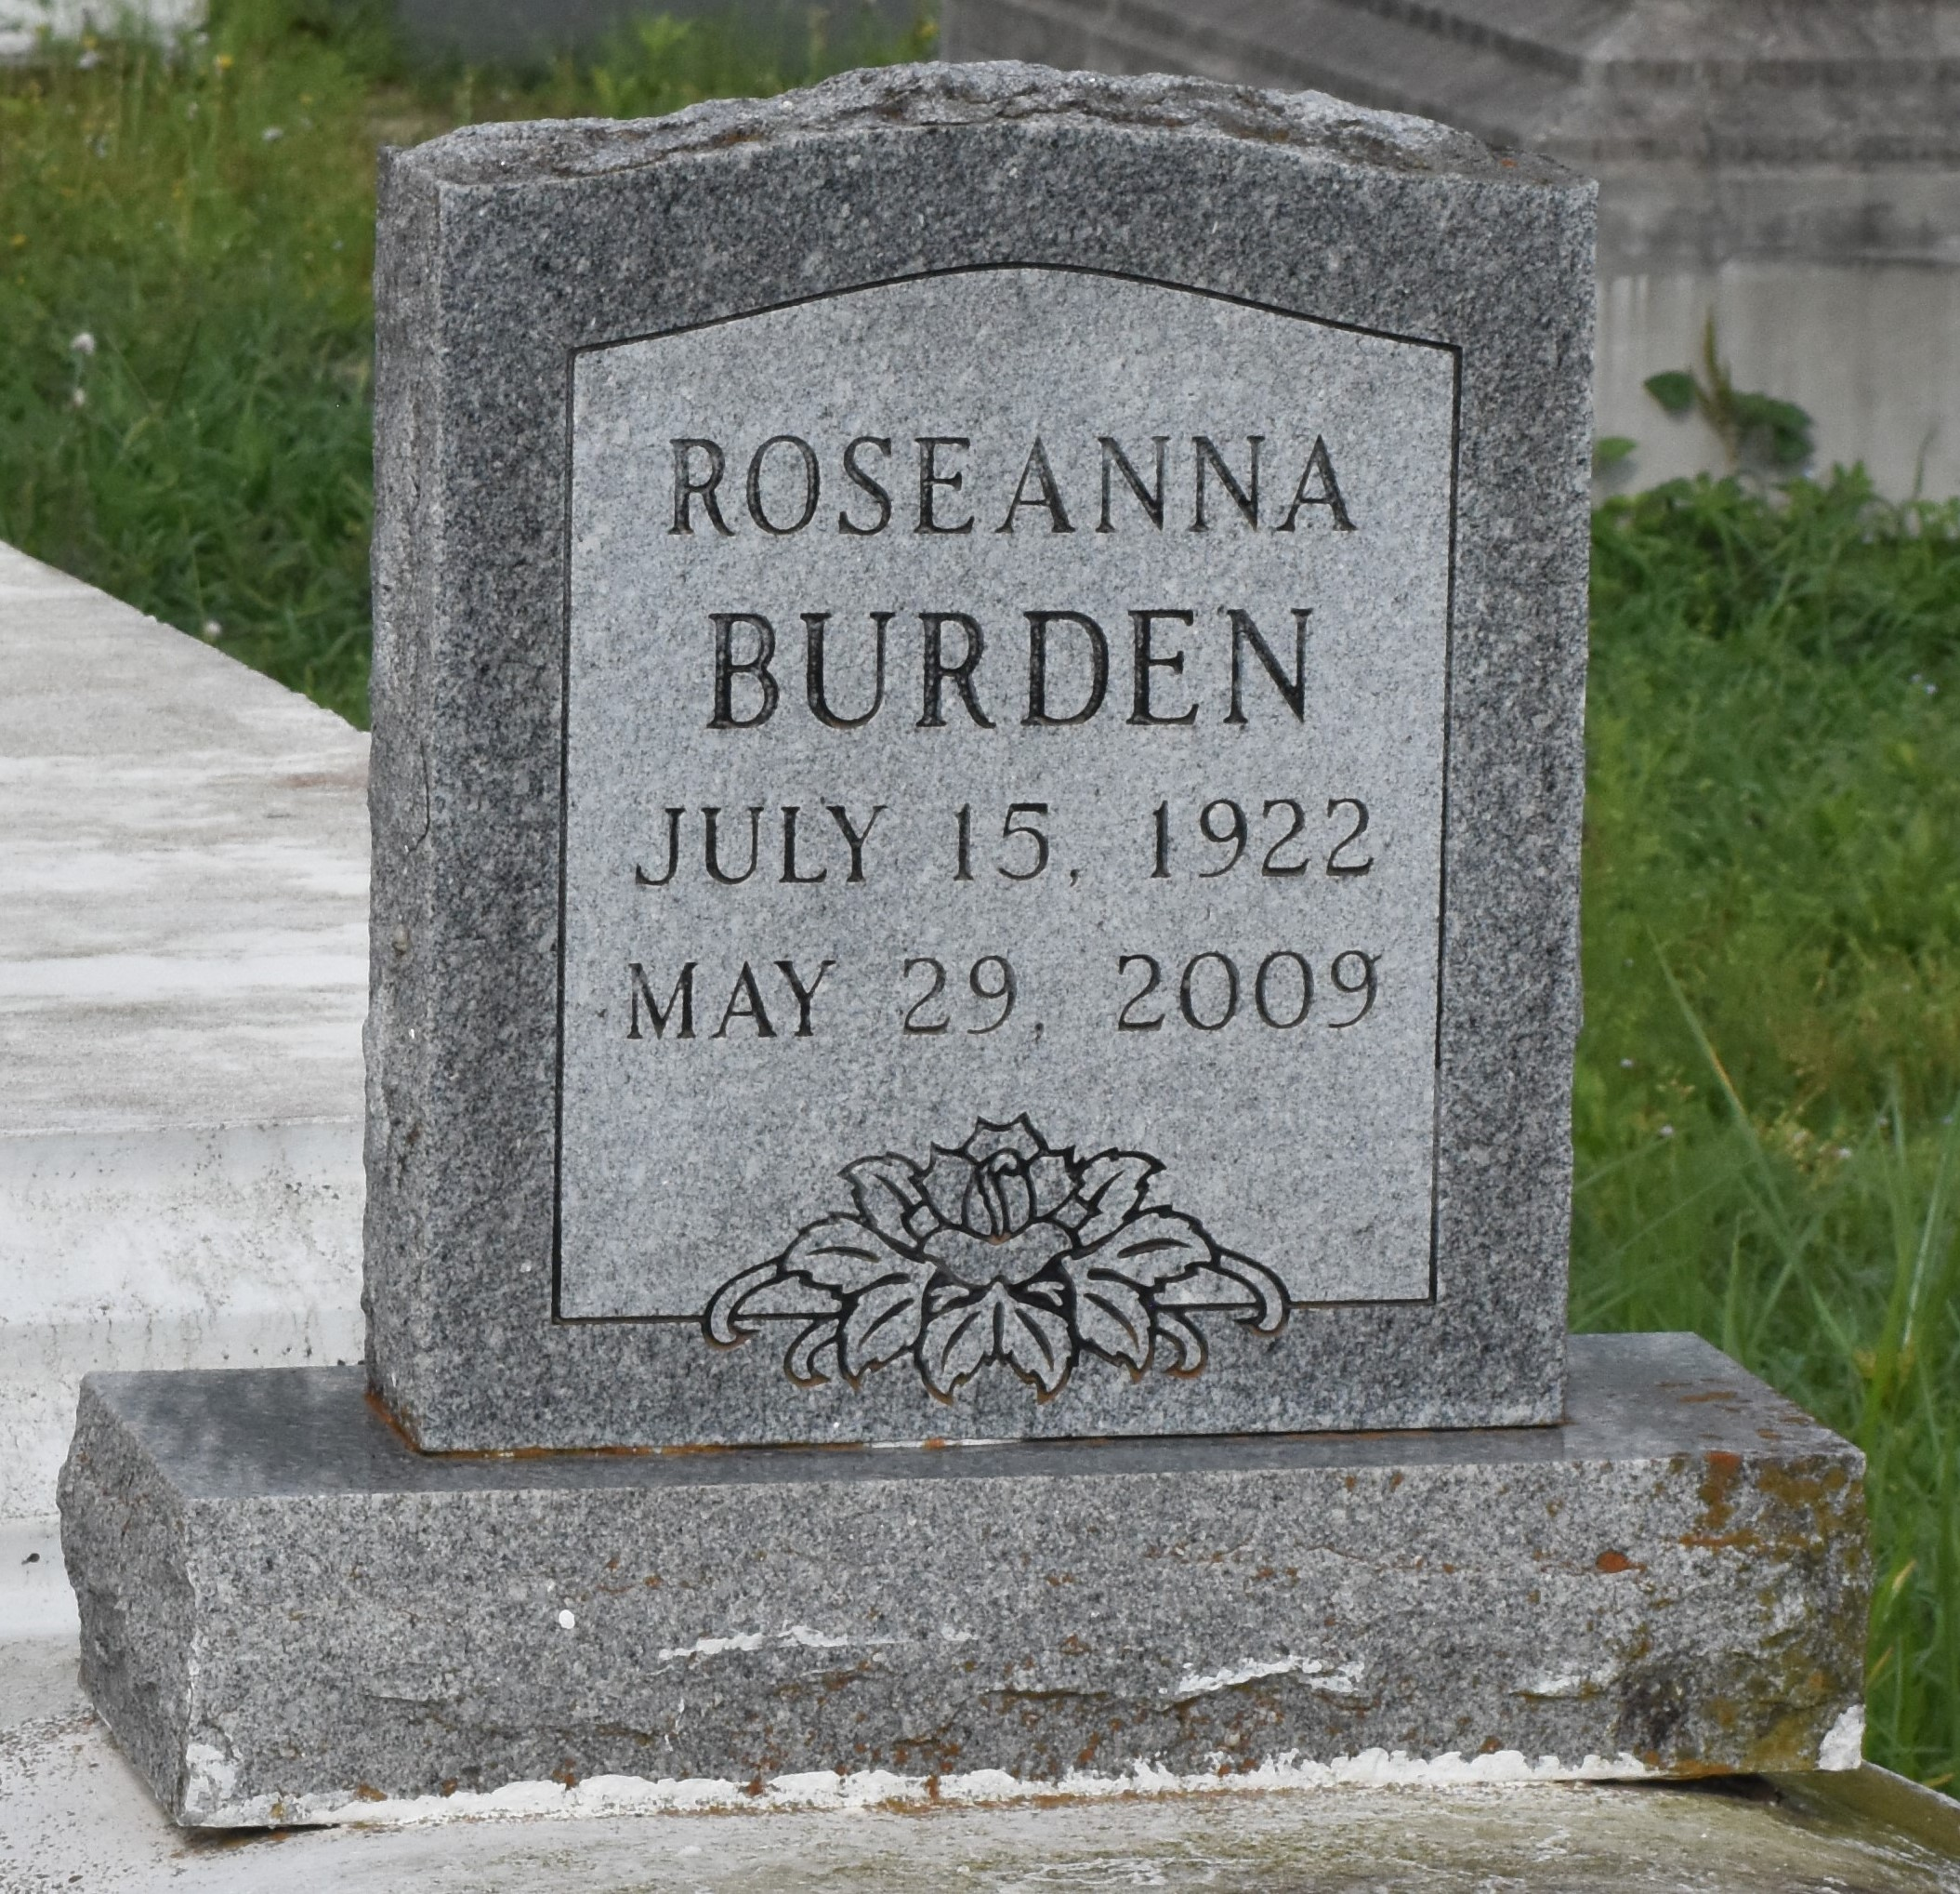

Roseanna Williams Burden at St. James Parish Hospital, Lutcher, LA on Friday, May 29, 2009 at 2:15 a.m. Daughter of the late Sullivan Williams and Theresa Shade Williams. Wife of the late James Burden. Mother of the late Ronald and Alex Burden. Sister of Joseph Williams, the late Shirley Traveler Weber, Annabelle Williams, Adam Cooper, Sr. and August Williams. Also survived by nieces including, Rosalind Langford; newphew, cousins, other relatives and friends. Age 86. Visiting at King David Baptist Church, King Avenue, Lutcher, LA, Friday, June 5, 2009 from 9:30 a.m. until Religious Services at 11:00 a.m. Interment in Antioch Cemetery, Paulina, LA. Brazier-Watson Funeral Home in charge of arrangements.
The Times-Picayune, New Orleans, Louisiana
June 4, 2009

