Everett Clyde Burns
September 28, 1961 – April 17, 2015

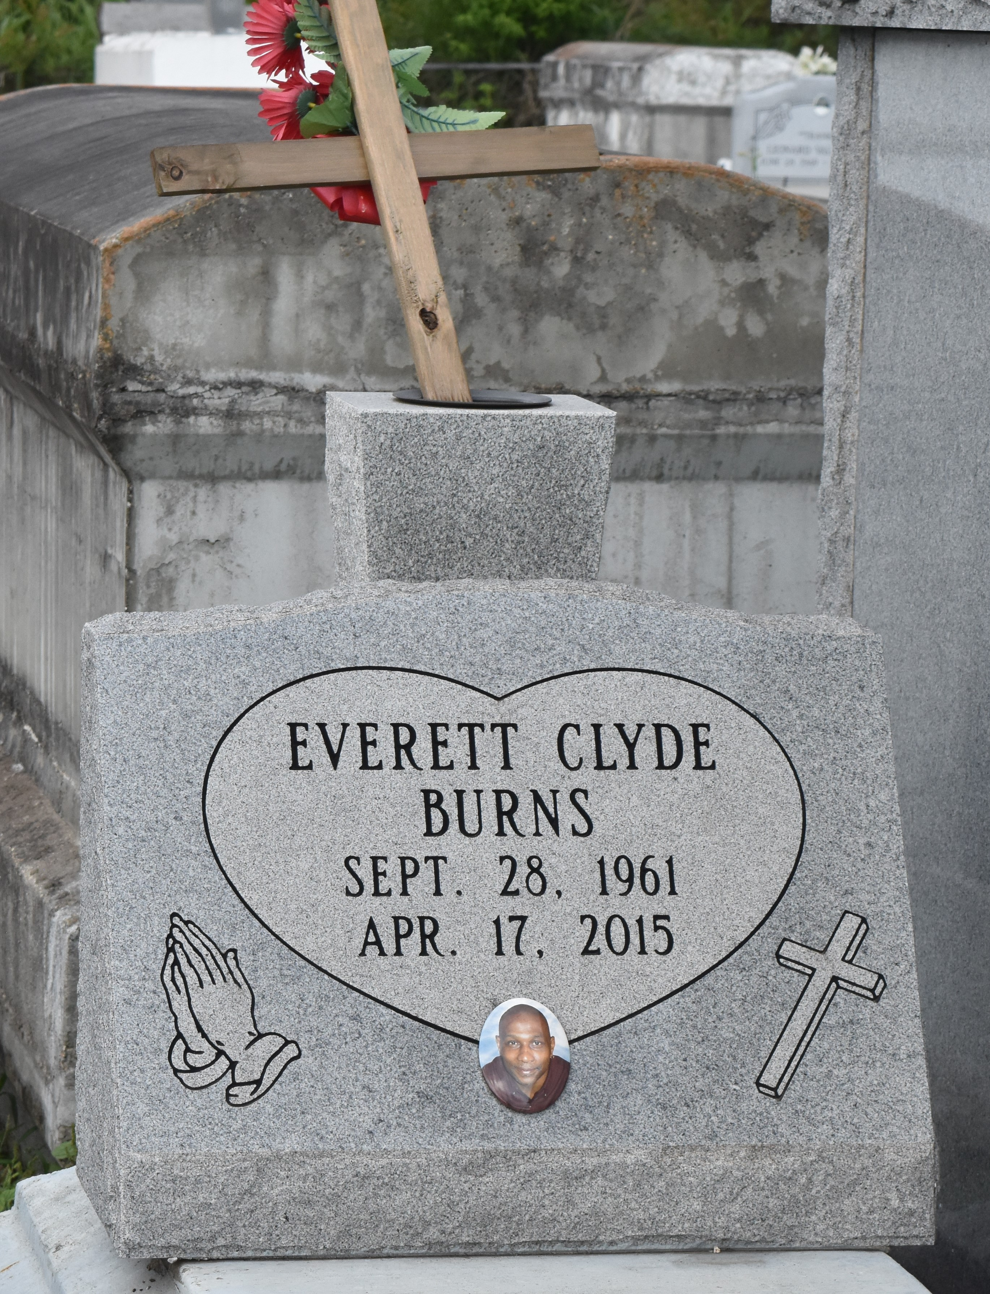

Everett Clyde Burns, age 53 years, departed this earthly life on Friday, April 17,2015 at Our Lady of the Lake Hospital of Baton Rouge, La. Beloved son of Willie Mae Burns and the Late John W. Burns Sr. Husband of Deidra Burns. Loving Father of Clydeshia and Clydria Burns, Everett Randell, Germeryl Lawrence and Sade Dennis.Also survived by 8 grandchildren, 8 sisters, 5 brothers, 1 aunt, 4 uncles, nieces, nephews other relatives and friends. A native and resident of Lutcher.
Pastors, Officers and Members of Greater Golden Grove Baptist Church, First Community Antioch Baptist Church of Lutcher, La. and all neighboring churches are invited to attend the homegoing celebration on Friday April 24, 2015 at 11:00 am at the First Community Antioch Baptist Church 10860 Hwy. 3125 Lutcher, La. Rev. Ferdinand Gaines Jr. Host Pastor/ Pastor Ulysses Jarrow officiating. Visitation will be at the First Community Antioch Baptist Church from 9:00 am until service time. Interment in Antioch Cemetary of Paulina, La. Bardell's Mortuary of Mt. Airy, La in charge. Information: 985-535-6837.
The Times-Picayune, New Orleans, Louisiana
Apr. 21 to Apr. 22, 2015

