Kathleen Burns
November 19, 1954 – June 19, 2016

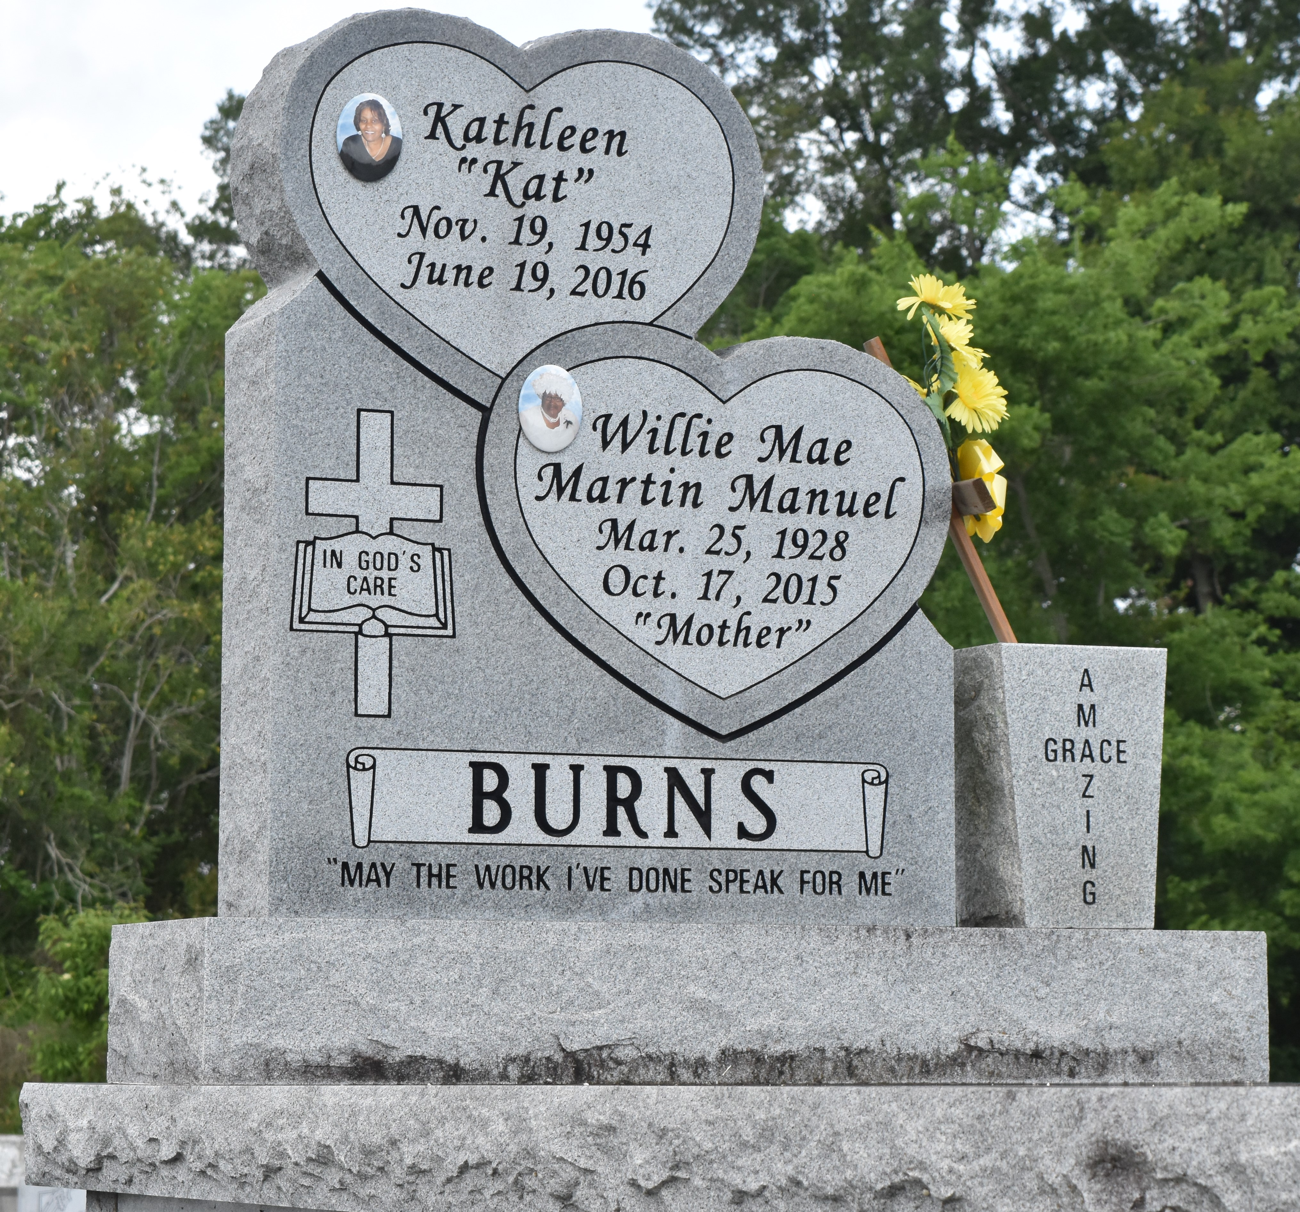

Kathleen "Kat" Burns at the age of 61 yrs. departed this earthly life on Sunday June 19, 2016 at St. James Hospital of Lutcher,La. Daughter of the late John Sr. and Willie Mae Burns. Beloved mother of Shalanda Williams (Alton), Shatisha Burns (Donald), Shanrick Burns, Kenitra and Kendall Belvin. Sister of Barry Manuel, John Jr., Frank, Michael and Adam Burns, Joyce Smith, Linda Hayes, Debra Hills, Loretta Joseph and Carolyn Cola. Niece of Morris Martin Sr. Also survived by 9 grandchildren Jaylin, Alton Jr., Doiron, Kaitlyn, Dayton, Alonzo, Kaiden, Liam and Sydney. Kathleen was preceded in death by her parents John W. Sr. and Willie Mae M. Burns; Brothers Alexander Manuel Jr. and Everett Burns; Sisters Sherry Robinson and Dorothy Harris, 4 uncles and 1 aunt. Also survived by a host of nieces, nephews other relatives and friends. "Kat" was a resident of Gramercy, La.
Relatives and friends of the family also Pastors, Officers and Members of First Community Antioch Baptist Church of Lutcher, La. Greater Golden Grove Baptist Church of Gramercy, La. all neighboring churches, Employees of East Jefferson General Hospital and St. James Parish Hospital are invited to attend the home going celebration on Saturday July 2,2016 at 11:00am at First Community Antioch Baptist Church 20860 Hwy. 3125 Lutcher, La., Host Pastor Rev. Ferdinand Gaines Jr., Pastor Jarrow officiating. Interment in Antioch Cemetery. Visitation will be from 9:00am until service time at First Community Baptist Church. Bardell's Mortuary in charge. Information:985-535-6837.
The New Orleans Advocate, Louisiana
Jun. 29 to Jul. 2, 2016

