Cordell J. Clayton
December 26, 1973 – January 9, 2001

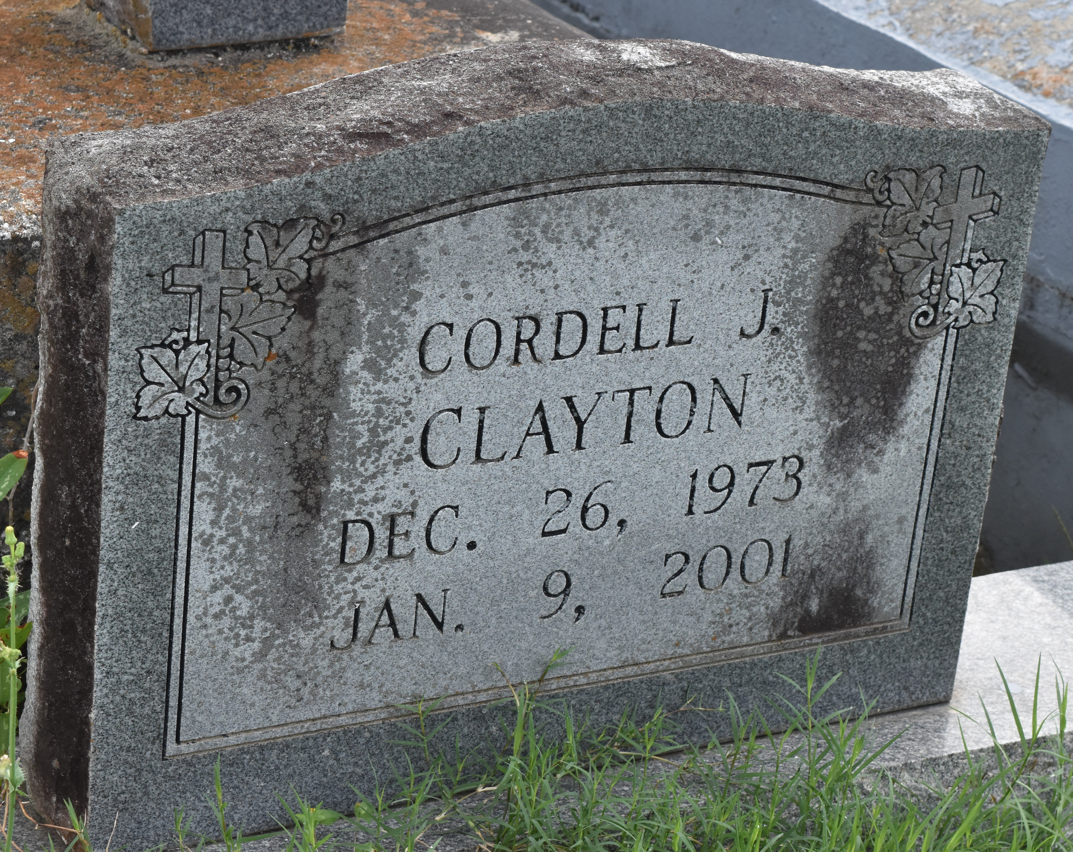

A native and resident of Paulina, he died at 1 a.m. Tuesday, Jan. 9, 2001, at St. James Parish Hospital, Lutcher. He was 27.
Visiting at Evergreen Baptist Church, Paulina, from 9:30 a.m. Saturday until religious services at 11 a.m., conducted by the Rev. Nolan Albert. Burial in Antioch Cemetery, Paulina.
Survived by his mother, Joyce Clayton Butler, Paulina; stepfather, Alfred Butler Jr., Paulina; three aunts, Janet Clayton, Elouise Turner and Ernestine Alexander; three uncles, Rodney, Floyd and Michael Clayton; grandparents, Berthella Nicholas and Ernest Clayton Sr.; cousins, other relatives and friends. Preceded in death by his father, Eric Nicholas; and maternal grandmother, Louizer Keys Clayton. Brazier-Watson Funeral Home in charge of arrangements.
Advocate, The (Baton Rouge, LA)
Friday, January 12, 2001

