Jerry Mae Clayton
June 12, 1954 – August 30, 2001

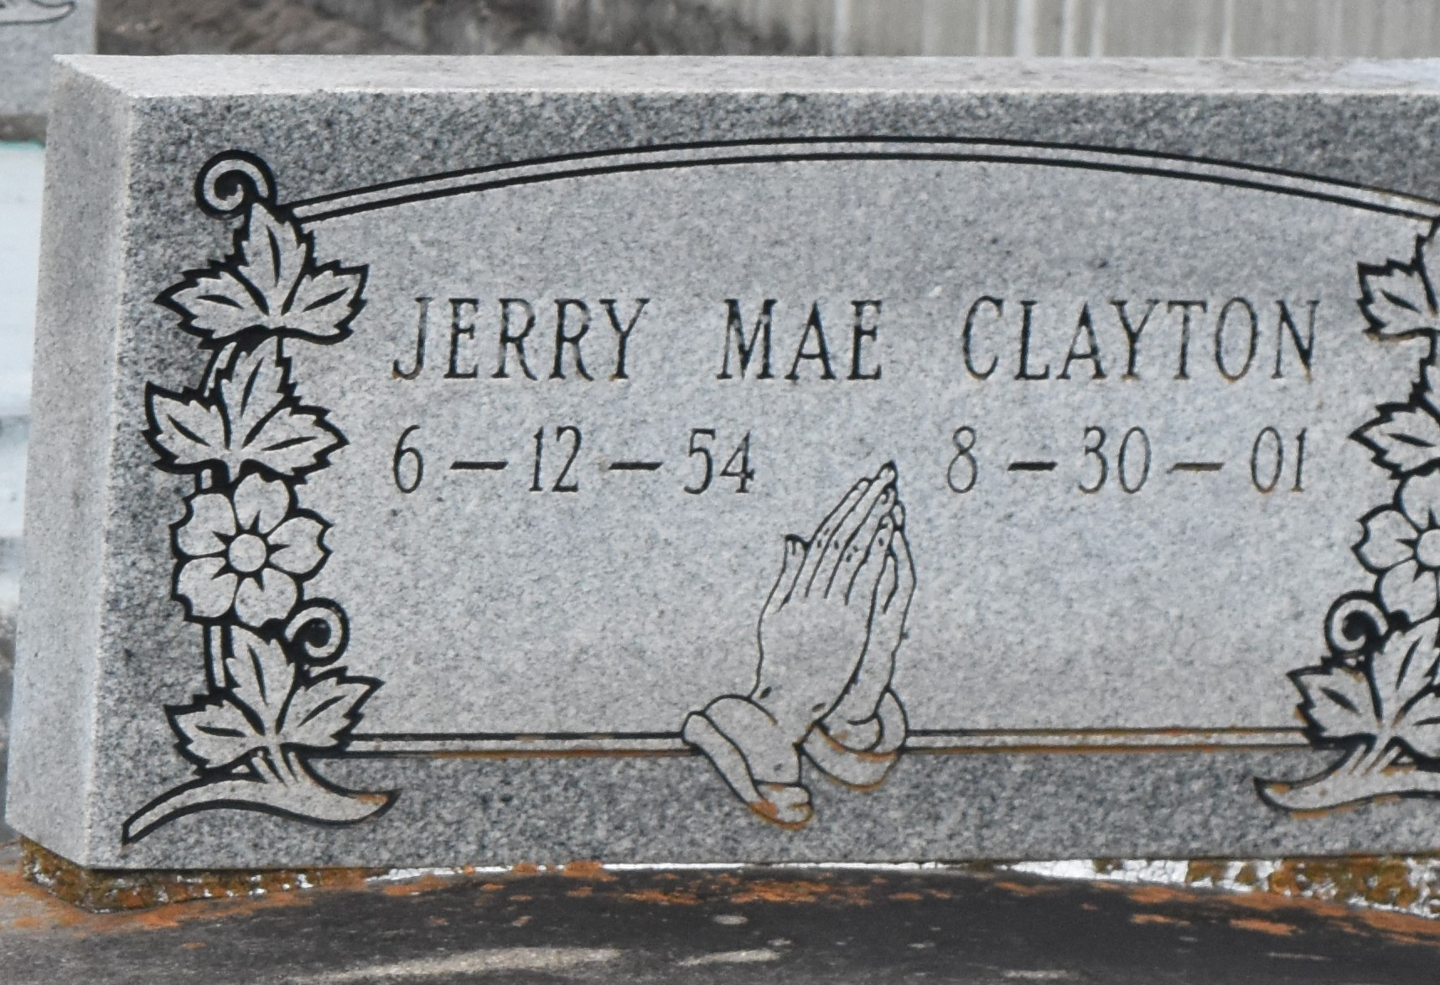

PAULINA - Jerry Mae Clayton, 47, a native of Dorseyville and resident of Paulina for 30 years, died Aug. 30. She was the wife of Rodney Clayton Sr. and mother of Dannisha, Dominique, Gabrielle and Rodney Clayton Jr. and Charlton Jackson. She is survived by two grandchildren.

She was a custodian for the St. James Parish school system.

Services are today at 11 a.m. at Evergreen Baptist Church, Paulina, with interment at Antioch Cemetery, Paulina. Visitation starts at 9 a.m.

LAGenWeb Louisiana Archives
Obits-St. John the Baptist Parish, LA
September 5, 2001

