Lorraine (Bradley) Clayton
April 27, 1934 – December 14, 2014

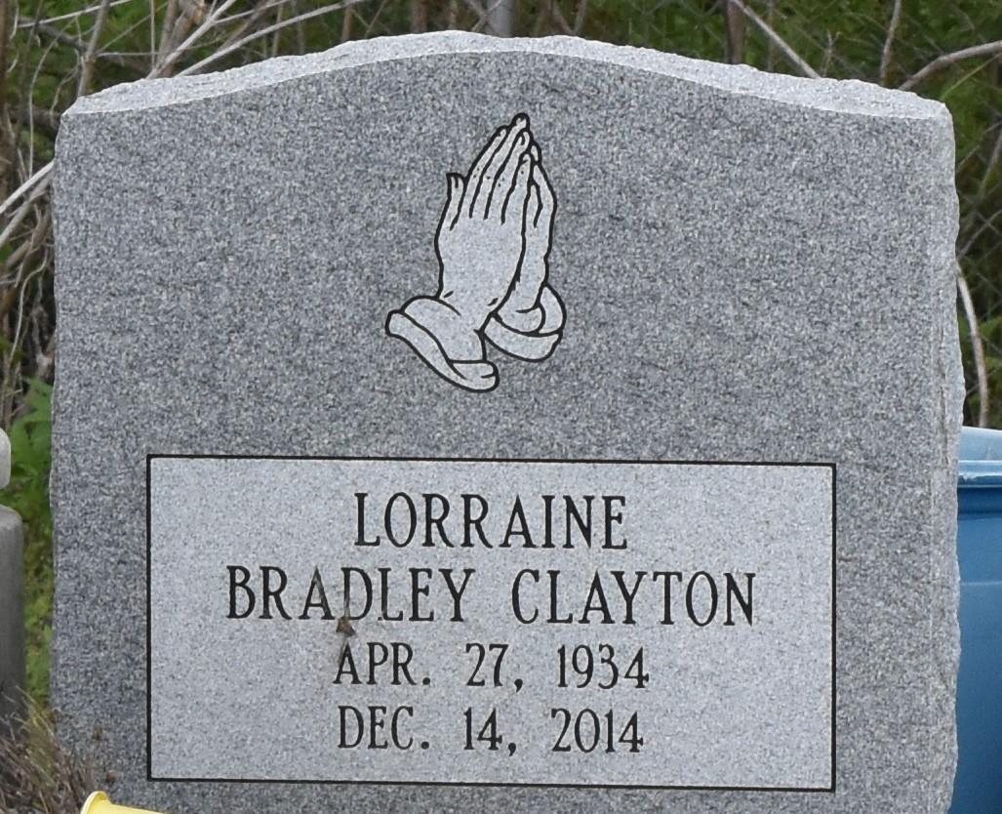

Lorraine Bradley Clayton, age 80 years, departed this earthly life and entered into eternal rest on Sunday December 14, 2014 at Ochsner Kenner Region Hospital in Kenner, La. Daughter of the late Robert and Alma Woods Bradley of Hazelhurst, Miss. Beloved wife of 62 years to John Clayton Sr. Loving mother of John W. Clayton Jr (Sylvia) of Reserve, La. Lonnie Clayton Sr. (Sheila), and Gregory Clayton of St. James, La. Sherone C. Smith (Derick), Ricky, Lorenzo and Leonard Clayton. Stepmother of Joyce Burgess (Frank) of Bartow, Fl. and the Late Tracy Clayton Sr. Sister of Mamie Davis of Gramercy, La and Yvonne William of Tulsa, OK. Also survived by 24 grandchildren, 22 great grandchildren, nieces, nephews, relatives and friends. A native of Fayette, Miss and a resident of Paulina, La.
Preceded in Death by her parents Robert and Alma Bradley; son Tracy Clayton Sr.; Grandson Corwin Clayton; Sibling Tommy C. Bradley, Mable Smith; Lillian Horton and Lozell Fishback.
Pastors, Officers and Members of Israelite Baptist Church of Lutcher, La, New Zion Christian Center of Gramercy, La and all neighboring churches are invited to attend the home-going celebration on Saturday December 20, 2014 at 10:00 am at New Zion Christian Center 216 W. Main St., Gramercy, La. where the Pastor is Emil Dean Mitchell, Pastor Kevin Frederick is officiating. Interment in Antioch Cemetery of Paulina. Visitation will be at New Zion Christian Center from 8:00 am until service time. Bardell's Mortuary of Mt. Airy, La in charge. Information: 985-535-6837.

The Times-Picayune, New Orleans, Louisian
Dec. 17 to Dec. 19, 2014

