Geneva (Kitt) Collier
May 27, 1913 – July 3, 2000

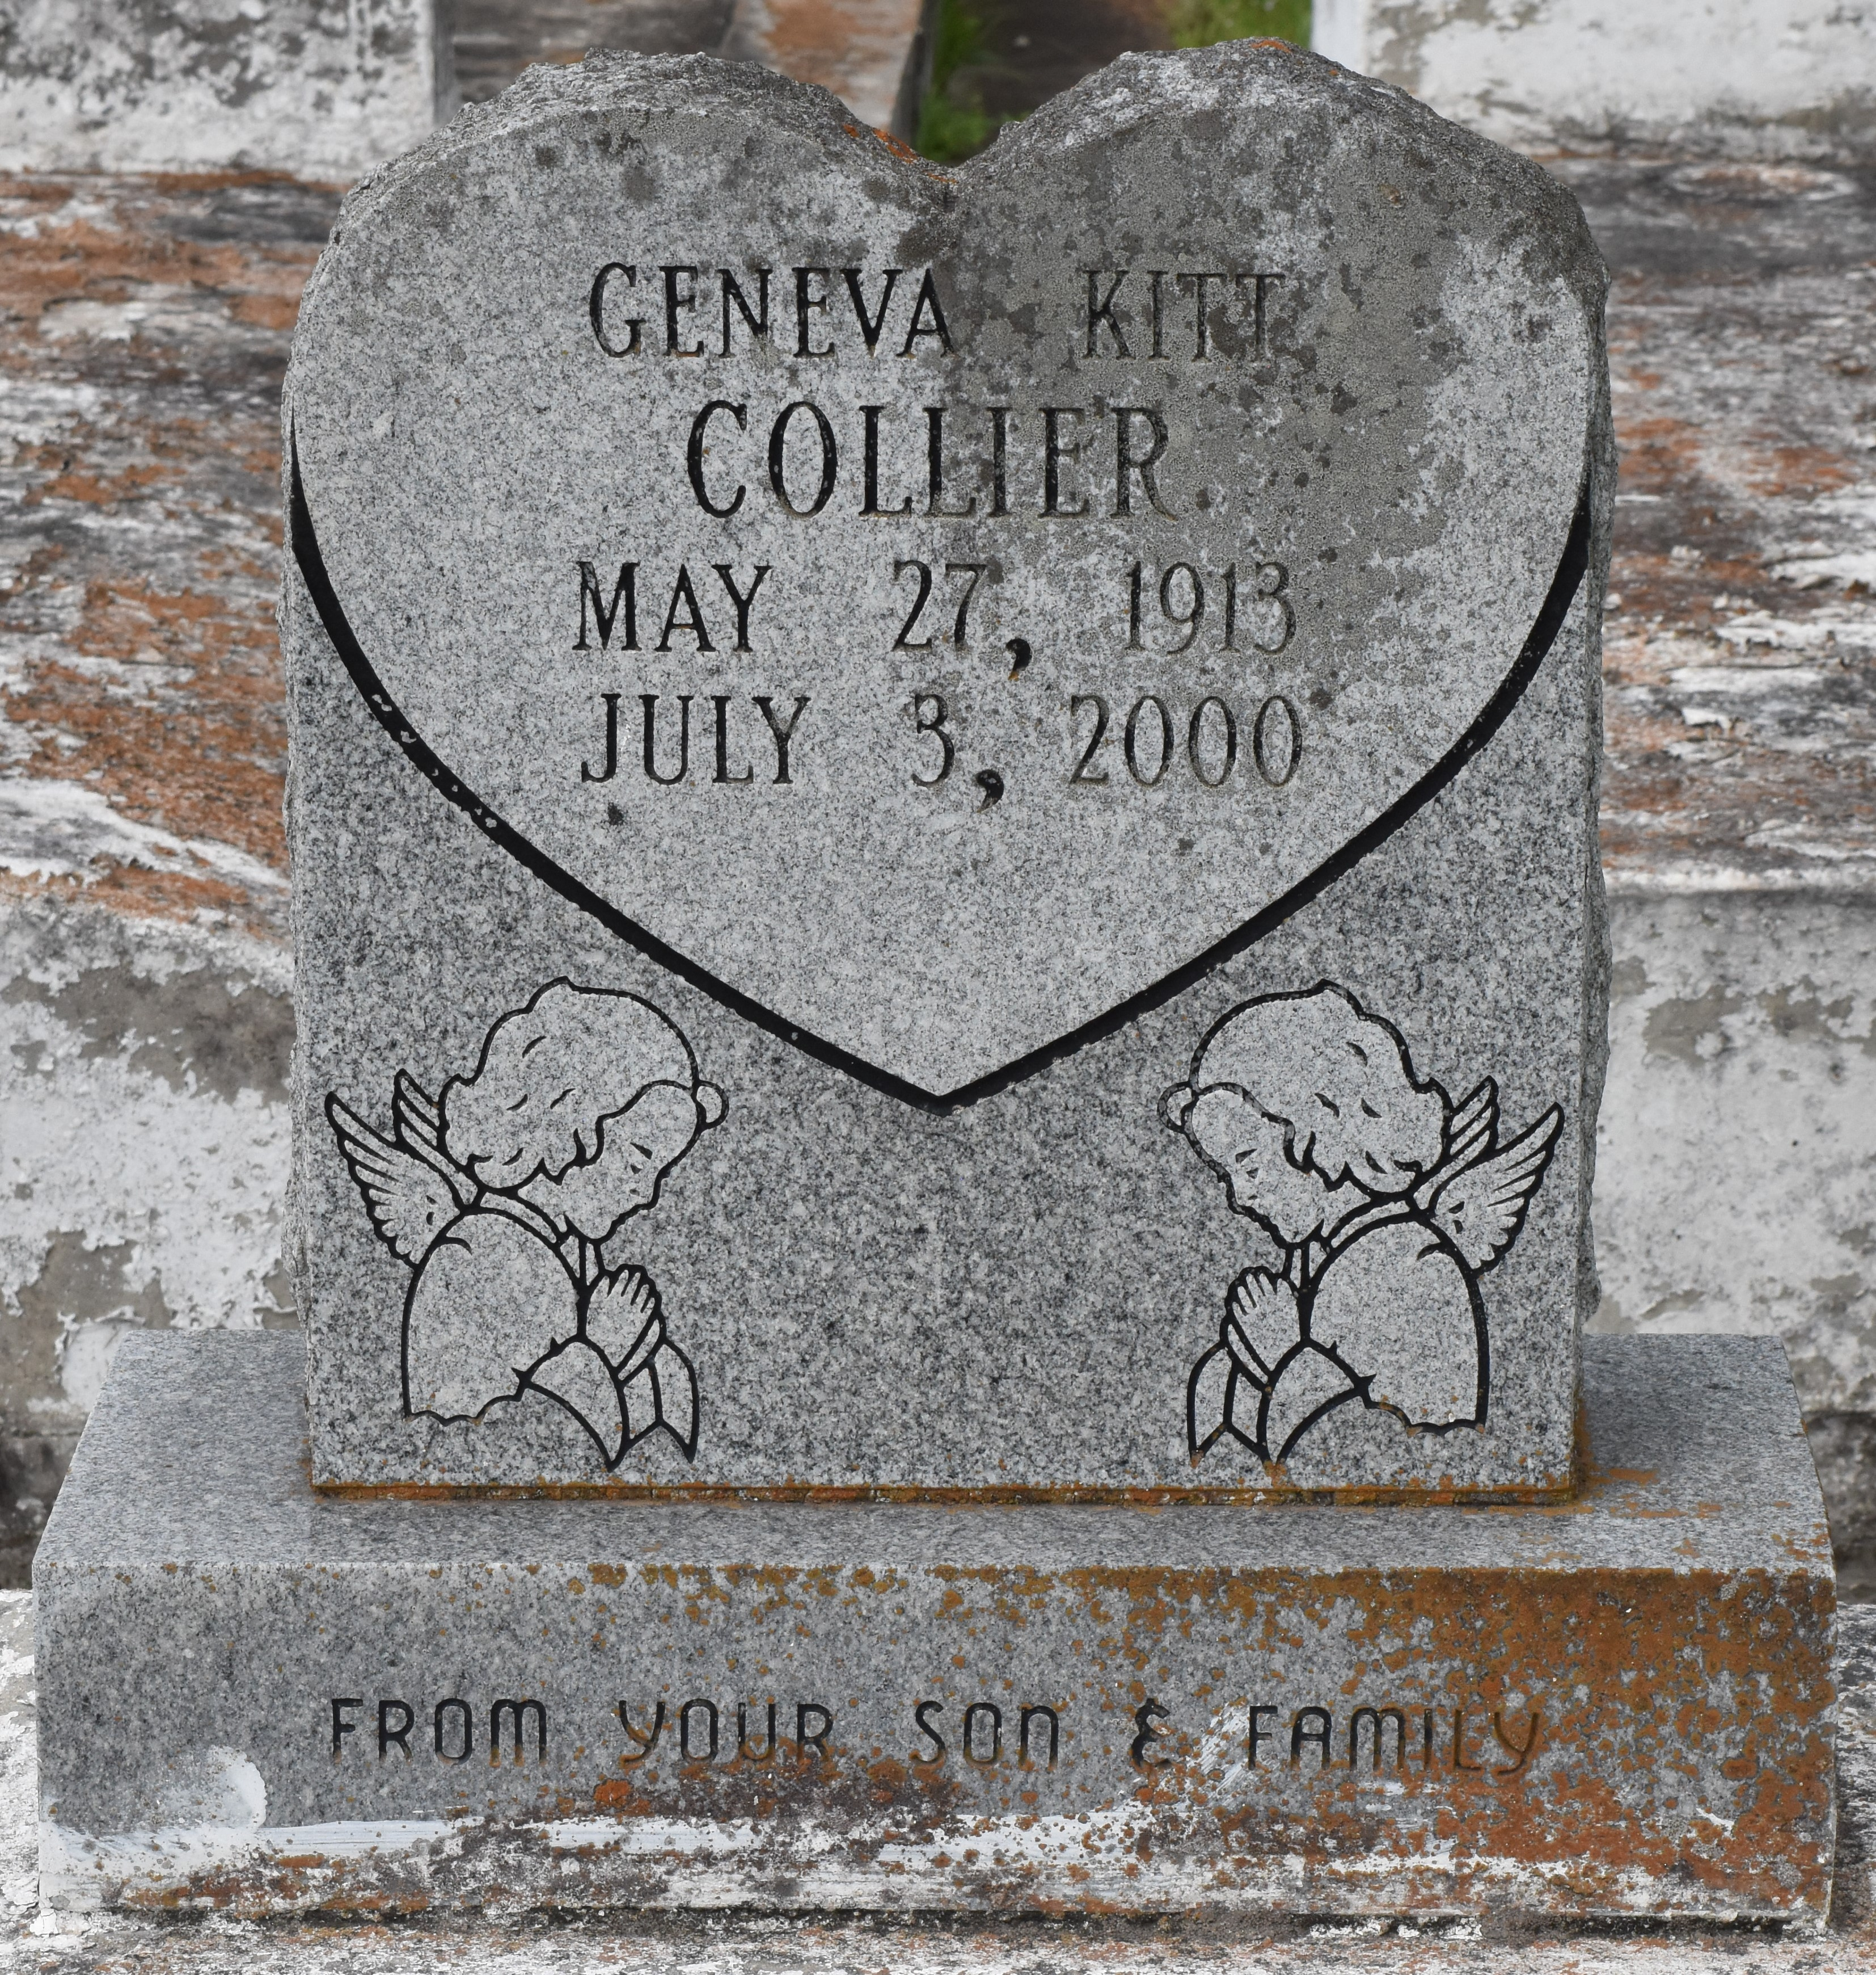

A native of Paulina and a resident of Gramercy, she died at 10 a.m. Monday, July 3, 2000, at St. James Hospital, Lutcher. She was 87.
Visiting at Golden Grove Baptist Church, Gramercy, from 9:30 a.m. until funeral services at 11 a.m. Tuesday, conducted by the Rev. Herbert Gordon. Burial in Antioch Cemetery, Paulina.
Survived by her son, Harold Collier, Chicago; two grandsons, Diron and Loren Collier, both of Chicago; a daughter-in-law, Beverly Clark Collier, Chicago; a niece, Viola Bashful; a nephew, Kevin Collins; her caregiver, Berthella Clark; and cousins, other relatives and friends.
Preceded in death by her parents, Victor Kitt Sr. and Carzeldia Lewis Kitt; her sister, Ethel Collins; and her brother, Victor Kitt Jr. Brazier-Watson Funeral Home in charge of arrangements.

Advocate, The (Baton Rouge, LA)
Monday, July 10, 2000

