Huey P. Collins
October 13, 1935 – January 7, 2002

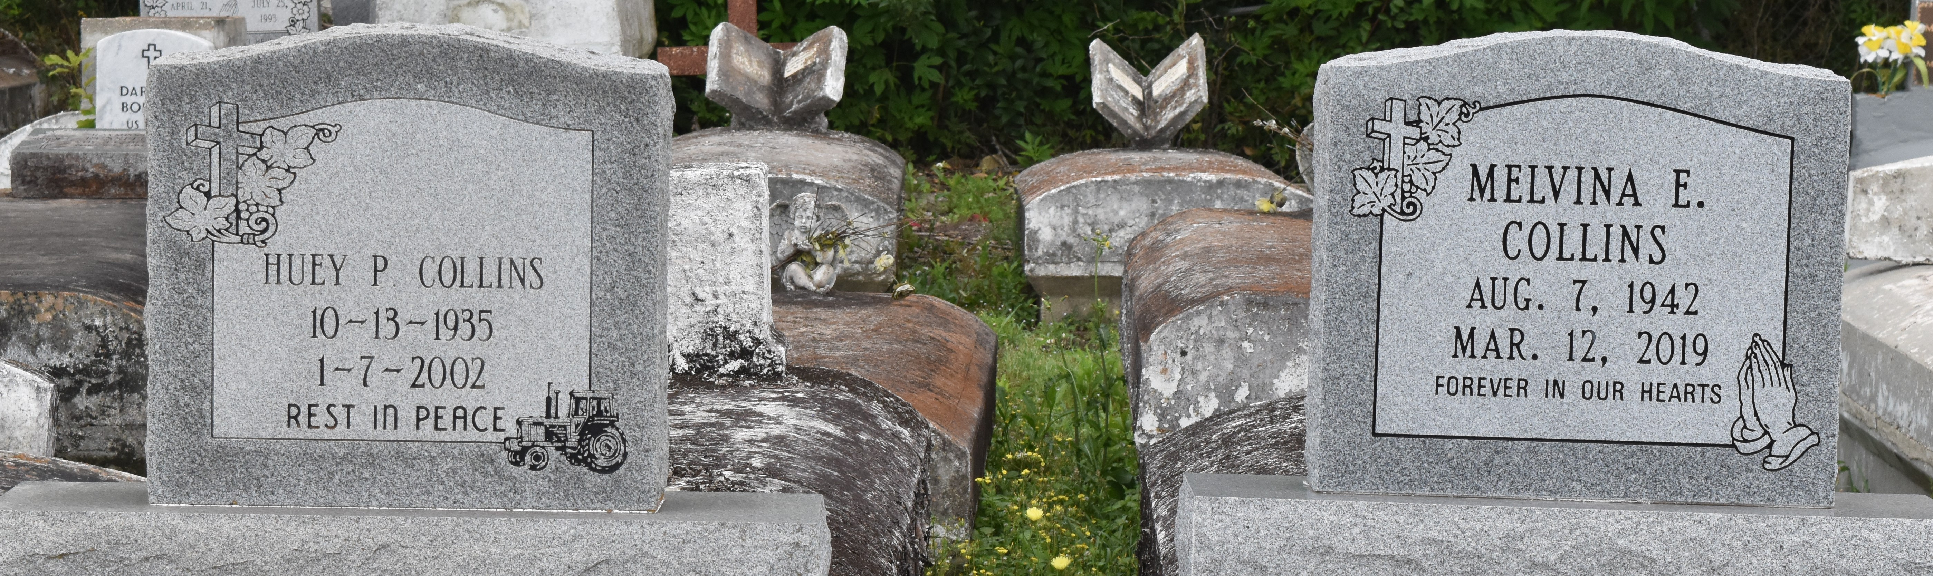
LUTCHER - Huey P. "Goolie" Collins, 66, a native of Paulina and resident of Lutcher, died Jan. 7. He was the husband of Melvina Johnson Collins and father of Tracey Bailey, Ramona Ezidore and Elesha, Tarasha and Mark Collins.
He was the son of Leroy Collins Sr. and the late Ethel McGee Collins and brother of Audrey McField, Vera Smith, Carol Detiege and Mary Ann, Gerald, Terrell and the late Leroy Collins Jr. He is also survived by nine grandchildren.
Services are today at noon at First Community Antioch Baptist Church, Lutcher, with interment at the church cemetery. Visitation starts at 10:30 a.m.

L'Observateur (La Place, LA)
Tuesday, January 15, 2002

