Melvina E. (Johnson) Collins
August 7, 1942 – March 12, 2019

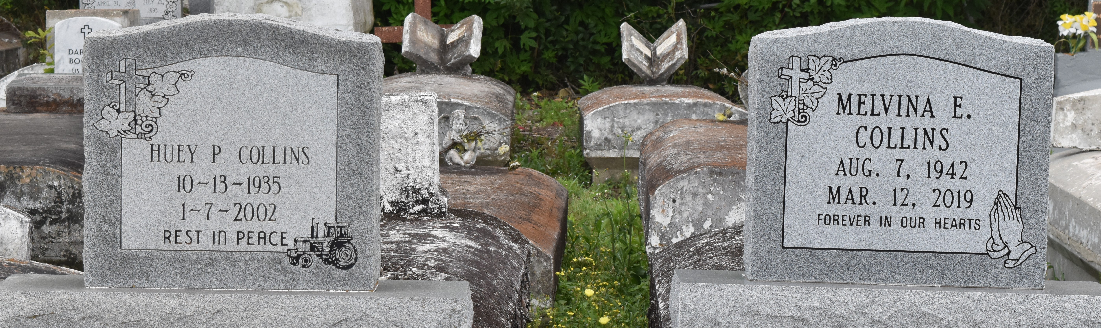

A native and resident of Lutcher. She passed away at her residence at 4:44 a.m, Tuesday, March 12 2019. She was 76.
Visiting at Greater King Triumph Baptist Church, Lionel Washington Street, Lutcher, Saturday, March 23, 2019 from 9:30 a.m. until religious services at 11:00 a.m. conducted by the Rev, Charlie Jones. Interment in Antioch Cemetery in Paulina.
Survived by her daughter; Elesha (Greg) Amos, Ramona Ezidore Tracey (Peter) Batiste and Tarasha Collins. Her son: Mark Collins. Sisters: Patricia Carr. Her brother: Morris (Doris) Bowser, Jr.,11 grandchildren, 18 great-grandchildren,. Sisters-in-law: Carolyn Bowser and Georgia Johnson and numerous nieces, nephews, cousins, other relatives and friends.
Preceded in death by her parents; Albert Johnson and Leola Brown. Her stepfather: Morris Bowser, Sr. Her husband: Huey Collins,. Sisters: Mary Albert and Carolyn Johnson. Brothers: Geron Bowser and Freddie Johnson, Sr. BRAZIER-WATSON FUNERAL HOME IN CHARGE OF ARRANGEMENTS. Visit us at www.brazierwatson.com to sign our guest book.
The Advocate, Baton Rouge, Louisiana
Mar. 21 to Mar. 23, 2019

