Mayolia (Long) Cooper
June 23, 1947 – November 11, 2014

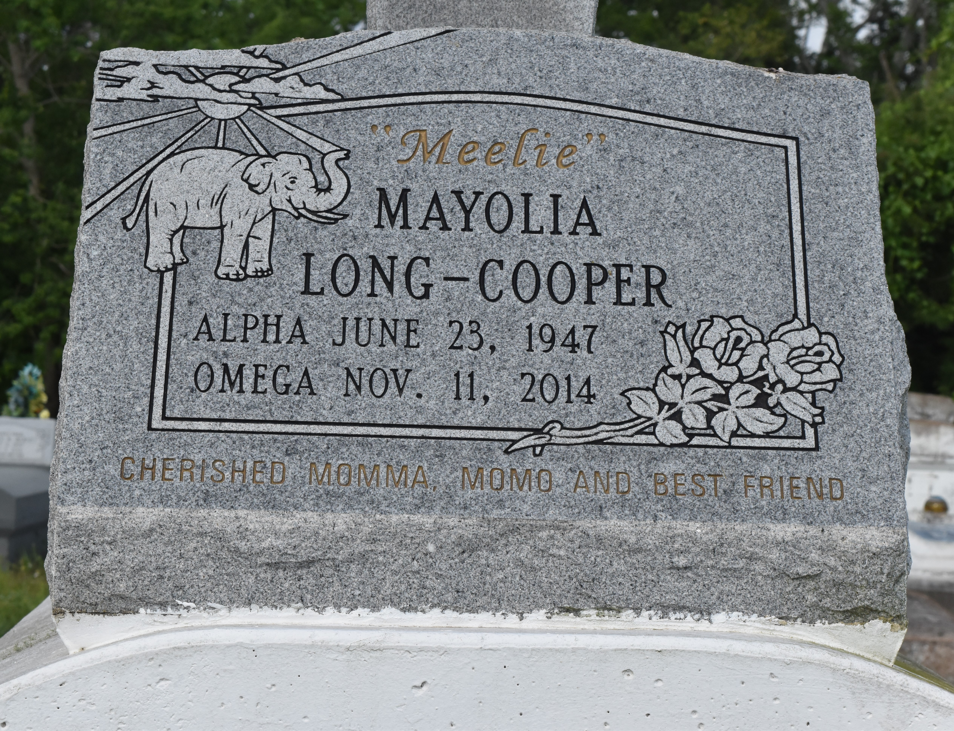

A NATIVE OF LUTCHER AND A RESIDENT OF GRAMERCY. SHE PASSED AWAY AT 1:38 P.M. ON TUESDAY, NOVEMBER 11, 2014 AT OCHSNER MEDICAL CENTER KENNER. SHE WAS 67.
VISITING (ONLY) AT FIRST COMMUNITY ANTIOCH BAPTIST CHURCH, HIGHWAY 3125, LUTCHER, SATURDAY, NOVEMBER 22, 2014 FROM 9:30 A.M. UNTIL RELIGIOUS SERVICES AT 11:00 A.M. CONDUCTED BY THE REV. FERDINAND GAINES, JR. INTERMENT IN ANTIOCH CEMETERY IN PAULINA.
SURVIVED BY THREE DAUGHTERS: LYTRESSA COOPER, ALVA VANESSAA COOPER AND WenQUEICE COOPER. A SON, ADAIR COOPER. SIX SISTERS AND THEIR SPOUSES: DIANNA(ROLAND) KELLER, WILMA SUE (GEORGE) WEBER, DEBORAH DUPERCLAY, DEIDRA (GARRETT) LONDON, CHERYL JACKSON AND JULLIETTE (DONALD RAY) WILLIAMS. FOUR BROTHERS AND THEIR SPOUSES: JOSEPH (PATRICIA) LONG, HUEY(BRENDA) LONG, SR., CRAIG (DONNA) LONG AND HONORAY WRIGHT. EIGHT GRANDCHILDREN, ONE GREAT GRANDAUGHTER, AUNTS, UNCLES, NIECES, NEPHEWS, COUSINS, GODCHILDREN, OTHER RELATIVES AND FRIENDS, INCLUDING JACQUELINE AUBERT AND MARY ANN PERKINS.
PRECEDED IN DEATH BY HER PARENTS, SAMPSON LONG, JR., AND ROSEMARY WALLACE, AND HER TWO SONS, CLYDE AND ADAM COOPER, III. BRAZIER-WATSON FUNERAL HOME IN CHARGE OF ARRANGEMENTS. Visit us at www.brazierwatson.com to sign our guest book.
Brazier-Watson Funeral Home, Donaldsonville, Louisiana

