Bobby “Tracy” Davis Sr.
August 3, 1937 – December 26, 2006

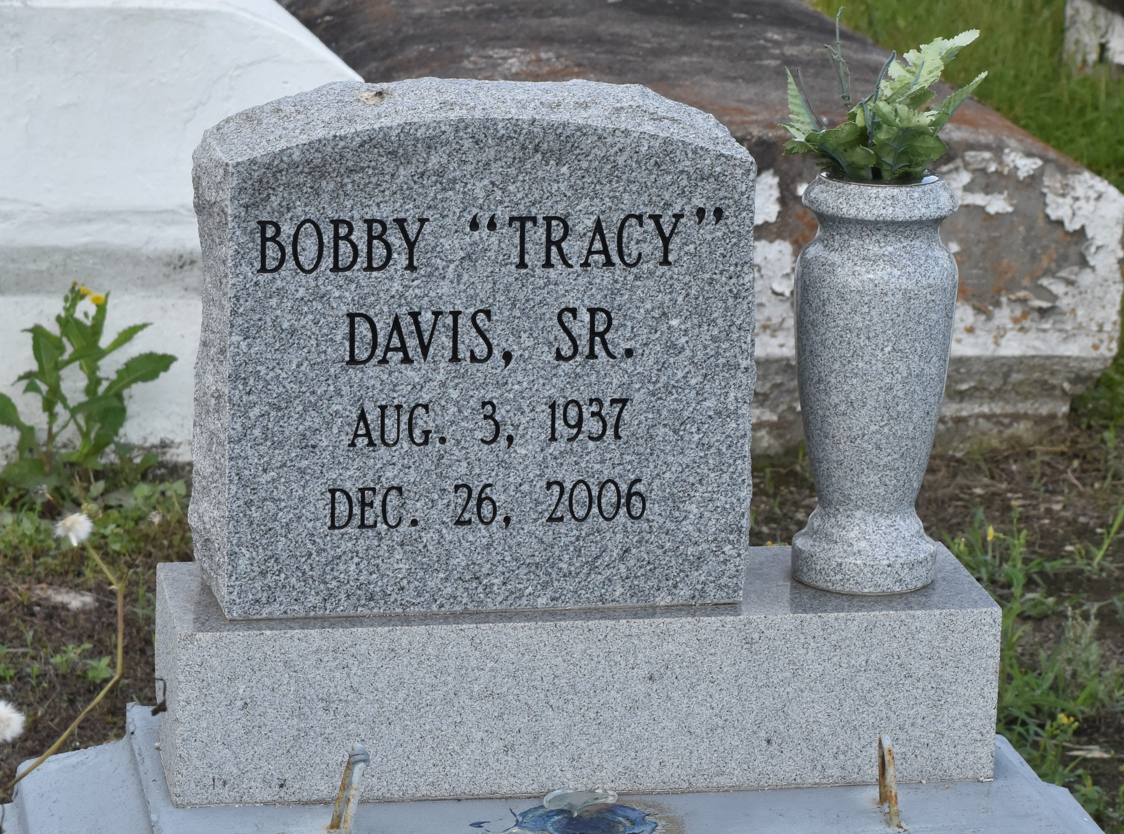

A resident of Gramercy, he died at 10:27 a.m. Tuesday, Dec. 26, 2006, at East Jefferson Hospital, Metairie. He was 69 and a native of Paulina. Visiting at King Triumph Baptist Church, Lionel Washington Street, Lutcher, on Tuesday, Jan. 2, 2007, from 9:30 a.m. until religious service at 11 a.m., conducted by the Rev. Reginald Joseph. Burial in Antioch Cemetery, Paulina. He is survived by four daughters, Stephanie Johnson, Terri Williams and Donna and Rhonda Davis; three sons, Craig, Rollin and Bobby Davis Jr.; two brothers, Robert and Alexander Davis Jr.; sister, Rebecca Hardy; 12 grandchildren, brothers-in-law, sisters-in-law, sons-in-law, daughters-in-law, cousins, nieces, nephews, other relatives, and friends, including Jacqueline Michaels. Preceded in death by his parents, Alexander Davis Sr. and Maude Washington Davis Barney; three brothers, Earl Davis and Lester and James Barney; and son, Zacharias Davis. Arrangements by Brazier-Watson Funeral Home, Donaldsonville.
The Advocate, Baton Rouge, Louisiana
Monday, January 1, 2007

