Gregory Davis Sr.
September 14, 1955 – November 22, 2018

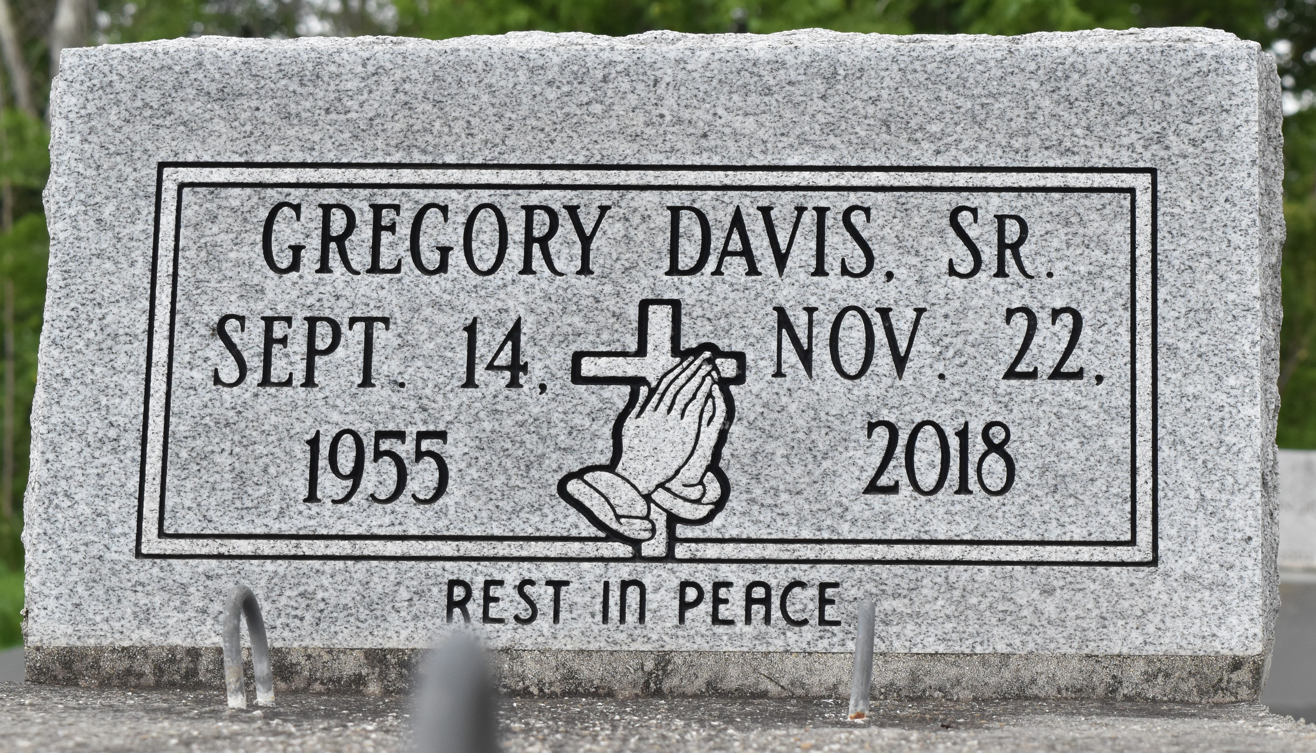
Gregory "Ground Hog" Davis Sr passed away on Thursday November 22, 2018 at the age of 63. Gregory leaves to cherish his memories his Mother Annie Mae Davis, wife, children, siblings, grandchildren, and a host of other relatives and friends. Relatives and friends are invited to attend the homegoing celebration on Friday, November 30, 2018 at 11:00 a.m. at Evergreen B.C., 3399 La Hwy 3125. Visitation at 9am until service time. Rev. Nolan Albert Officiating. Interment in Antioch Cemetery Paulina LA. Professional Services entrusted to the caring staff of Hobson Brown Funeral Home, 134 Daisy St., Garyville, LA 70051. 985-535-2516.

The New Orleans Advocate, Louisiana
Nov. 28 to Nov. 30, 2018

