Robert Carl Patrick Davis
May 26, 1952 – March 26, 2022

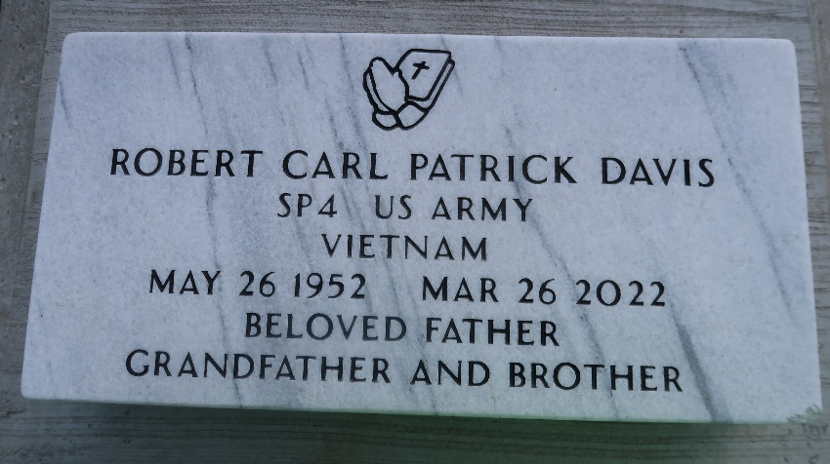

A native of Paulina, LA and resident of Lutcher, LA, Robert “Group” Davis passed away peacefully on March 26, 2022, at Legacy Nursing and Rehabilitation Home in Port Allen, LA. He was 69 years old.
He leaves to cherish his memories a daughter, Danyelle LaKeisha Bujol; two grandchildren, TiaJuan and Joshua Harrell of Houma, LA; five sisters, Dr. Bertha Williams, Rosemary Albert, and Felecia Smith of Lutcher, LA, Tilda Russell Gaines (Darrel) of Houston, Tx, and Regina Russell Chevalier (Joseph) of Lawrenceville, GA; three brothers, Amos Johnson, Sr. (Lynn) of Fairbanks, Alaska, Larry Davis of Houston, Tx, and Raymond Armont (Mary) of Bastrop, LA; three aunts, Dorothy R. Kirklin and Henrietta Russell of Paulina, LA, and Bertha Russell of Harvest, AL; one uncle, Louis Russell, Sr. of Paulina, LA; one Goddaughter, Dedra M. Wiliams of Lutcher, LA; and a host of nieces, nephews, other relatives and friends.
Robert was preceded in death by his mother, Albertha Davis Collins; father, Raymond Russell; brother, Ellis Albert; sister, Annebell Peterson; three brothers-in-law, Bishop Clarence Wiliams, Hebert Smith, and Aldrin Albert; nephew, Tyrone Williams; maternal grandparents, Annie and Charlie Davis; paternal grandparents, Ernest, Sr. and Louvenia Davis Russell; uncles, Ernest Russell, Jr., Royal Russell, Sr., Mack Russell, Sr., James Kirklin, Sr., and Bernard Keller; and aunts, Rosanna Russell Dupard and Gloria Russell Keller.
Services for Robert Davis will be held on Saturday, April 9, 2022, at First Community Antioch Baptist Church, 10860 LA-3125, Gramercy, LA 70052. Visitation will begin at 8am until the start of the religious service at 9am. Dr. Steven D. Beckham, Pastor officiating. Interment to follow at Antioch Cemetery in Paulina, LA. Final care and professional services entrusted to Treasures of Life Funeral Services, 315 E. Airline Hwy., Gramercy, LA 70052.

Treasures of Life Funeral Services, Gramercy, Louisiana

