Beatrice (Steward) DeVare
December 27, 1913 – January 2, 2003

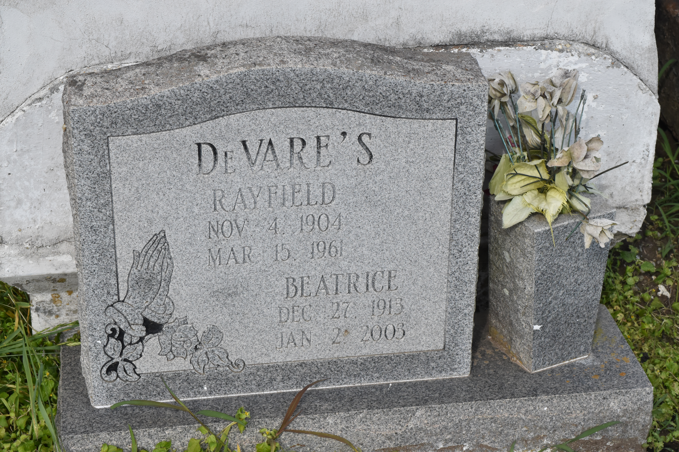

Beatrice S. Devare departed this life on Thursday, January 2, 2003 at River Parishes Hospital, Laplace, LA. Daughter of the late Clarence and Angelina Steward. Wife of the late Rayfield Devare. Mother of Lillie Mae Russell, Dave Devare, and Elouise Devare of Lutcher, LA., Rayfield (Betty) Devare of Reserve, LA., Beatrice (Joseph) Fluence of South Holland, IL., Alma (Alton) Brown of Gonzales, LA., Joyce and Ida Devare of Calumet, IL., and the late David and Evelyn Devare. Sister of the late Cecile Davis, Mable Vallery, and Mary Smith. Also survived by 15 Grandchildren, 30 Great-Grandchildren, 5 Great-Great-Grandchildren and a host of nieces, nephews, other relatives, and friends. She was a native and resident of Lutcher, LA. Age 89 years.
Relatives and friends, also pastors, officers and members of Mt. OIive Baptist Church and all neighboring churches are invited to attend the funeral services on Saturday, January 11, 2003 at 11:00 AM at Mt. Olive Baptist Church, Paulina, LA., Reverend Elmo Lee, Pastor, officiating. Interment in Antioch Cemetery, Paulina, LA. Visitation at HOBSON BROWN FUNERAL HOME, 134 DAISY STREET, GARYVILLE, LA., on Friday evening, January 10, 2003 from 5 PM until 7PM and on Saturday morning from 9 AM until funeral time. SERVICES ENTRUSTED TO HOBSON BROWN FUNERAL HOME

The Times-Picayune, New Orleans, Louisiana
January 10, 2003

