Betty Jane (Mason) Devare
March 10, 1940 – February 22, 2008

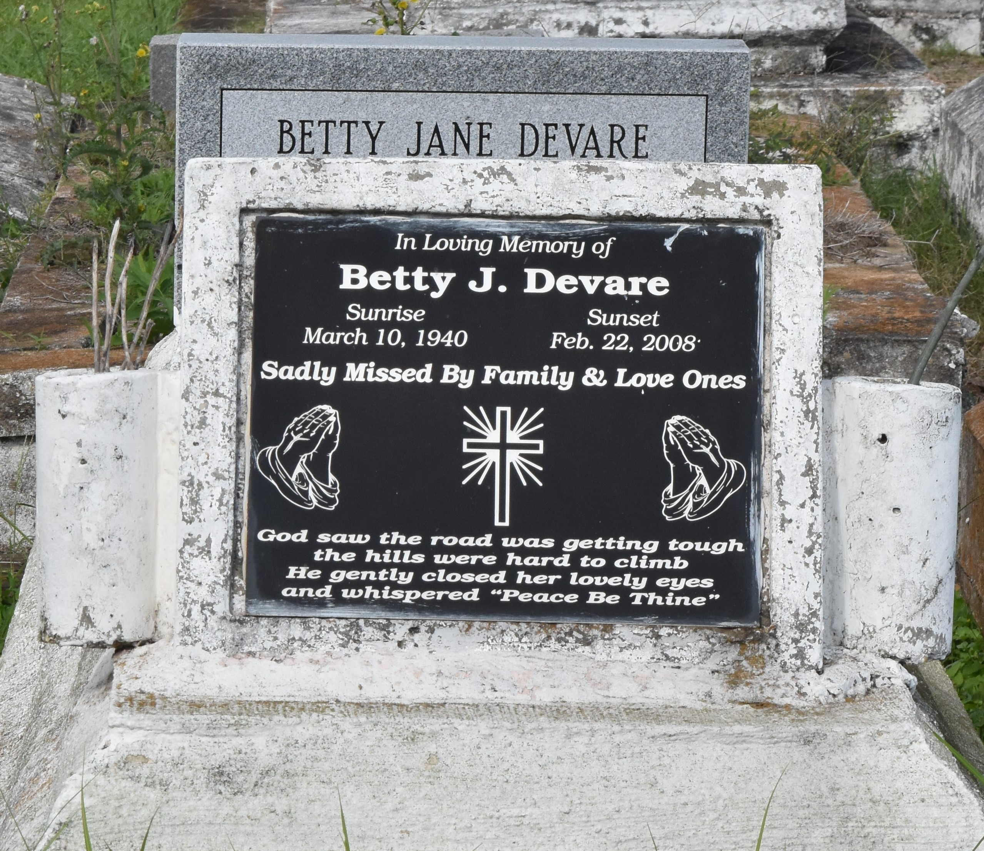

Betty Jane Mason Devare, Age 67, a Homemaker, passed away peacefully on Friday February 22, 2008 in Laplace, La., Daughter of the late Evalena Holly and the late Joseph Mason, and she was reared by the late Victor, and Dorothy Bright, Wife of Rayfield Devare Jr., Mother and Mother in law Deborah (Joseph) Weber, Tanya (Edwin) Williams, Gladys (Michael) Lumar, Jerome (Penny), Todd (Debra), Anthony (Prostheses Alfreda), Gregory (Lisa) Devare, Sister of Barbara, and Vanessa Mitchell, Diane Johnson, Ulysses, Geraldine, and Herman Bright, Naomi Davis, Dorothy Robertson, Sylvia James, Gwendolyn Juniors, Lori Ann Reid, Mary Lee Nelson, Jason, Cleophas, Alvin, and Leroy Mason, also survived by a host of grandchildren, and Great grandchildren, Sisters and Brothers in law, and a host of nieces, nephews, Cousins other relatives and friends. A native and resident of Reserve, La.
Pastor Officers and members of Greater New Plymouth B.C. and all neighboring churches are invited to attend the Funeral Service on Wednesday February 27, 2008 at 11:00a.m. From the above named church 110 N W 13th St. Reserve, La.., Rev. David Carter, Pastor Officiating, and Interment in Antioch Cem. Paulina La., Visitation at the Church from 9:00a.m. Until Service time. Service Entrusted to Hobson Brown Funeral Home Garyville, La.

The Times-Picayune, New Orleans, Louisiana
February 26, 2008

