David DeVare
1941 – April 1, 2000

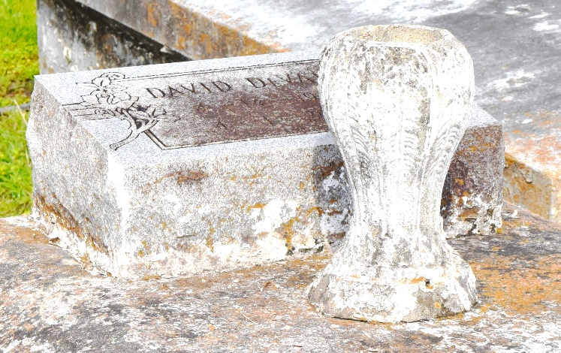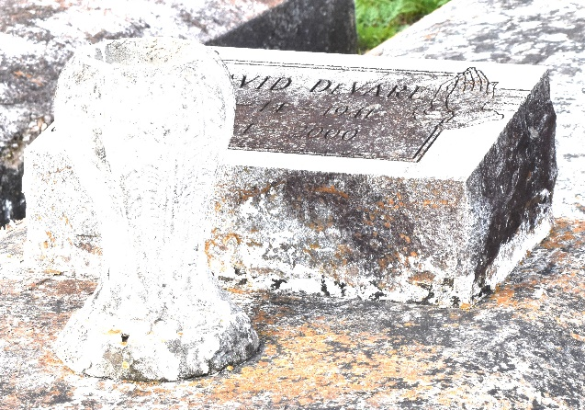

David "Fun" Devare, 58, native of Hester, and resident of Lutcher, died April 1, 2000.
He was the husband of Theresa Devare.
He was the son of Beatrice Devare and the late Rayfield Devare Sr., and brother of Lillie Mae Russell, Beatrice Fluence, Alma Brown and Elouise, Ida Mae, Joyce, Rayfield Jr., Dave and the late Evelyn Devare.
Services are today at 11 a.m. at Mount Olive Baptist Church, Paulina, with interment at Antioch Cemetery, Paulina. Visitation begins at 9:30 a.m.
Unknown source

