Rayfield Devare
May 15, 1936 – June 4, 2019

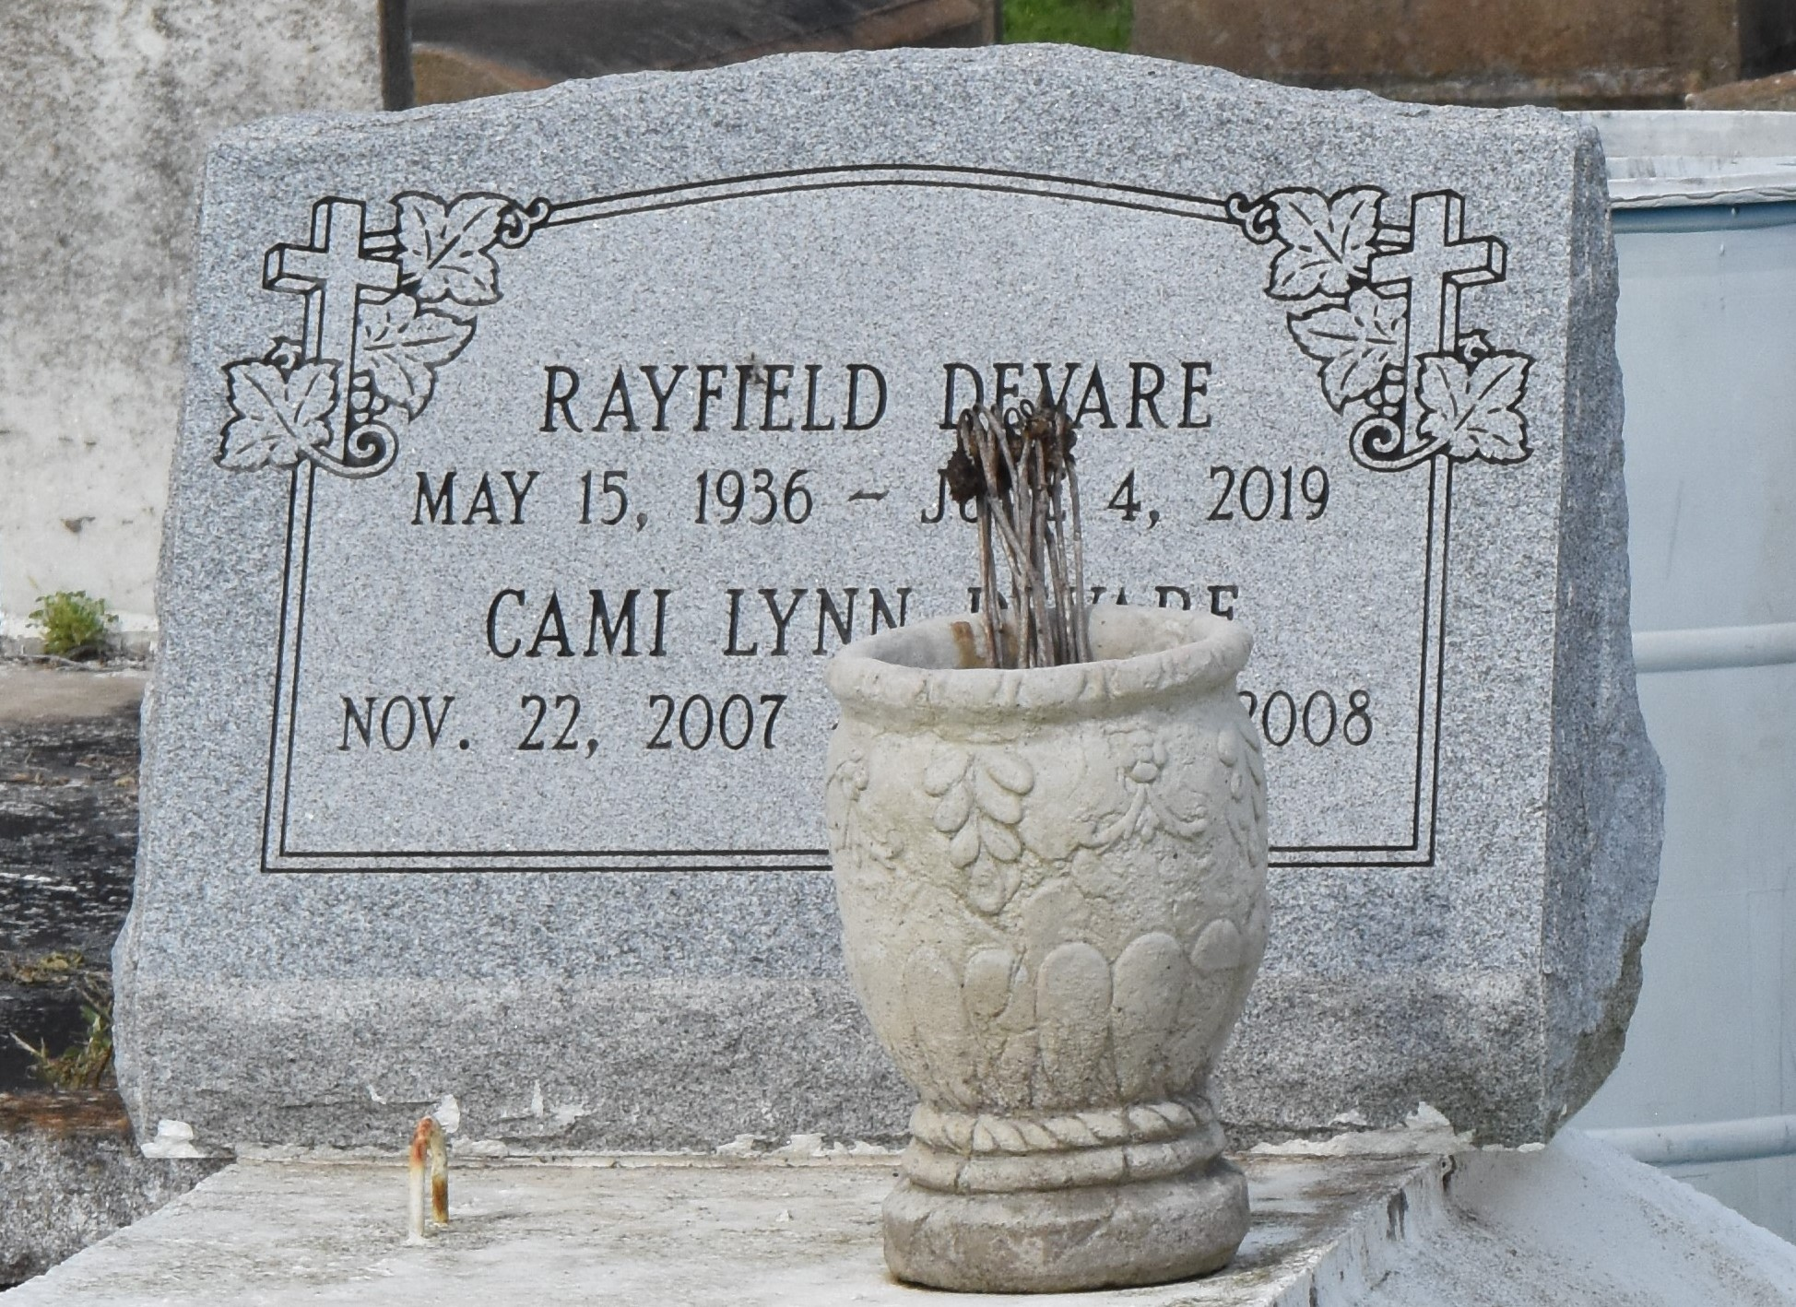

Rayfield "Bud" Devare Jr, transitioned on June 4, 2019 at Ochsner (Main Campus), husband of the late Betty Jane Mason Devare, Father of Deborah Weber, Tinya Williams, Gladys Lumar, Anthony, Gregory Sr., Todd and Jerome Devare. Mr. Bud is also survived by grand and great grandchildren, 5 sisters, 1 brother and a host of nieces, nephew, relatives and friends. Celebration service will be held on June 15, 2019 at Plymouth Rock B.C. 110 NW13th St. Reserve, LA, at 10:00 am. Viewing from 9:00 am until service time. (ONLY). Rev. David B. Carter Pastor, officiating. Internment Antioch Cemetery, Paulina, LA. Professional Services entrusted to the caring staff Hobson Brown Funeral Home, 134 Daisy St., Garyville, La 70051. 985-535-2516.

The New Orleans Advocate, Louisiana
Jun. 13 to Jun. 15, 2019

