Audrey Mae (Beckett) Duhone
February 2, 1942 – February 18, 2009

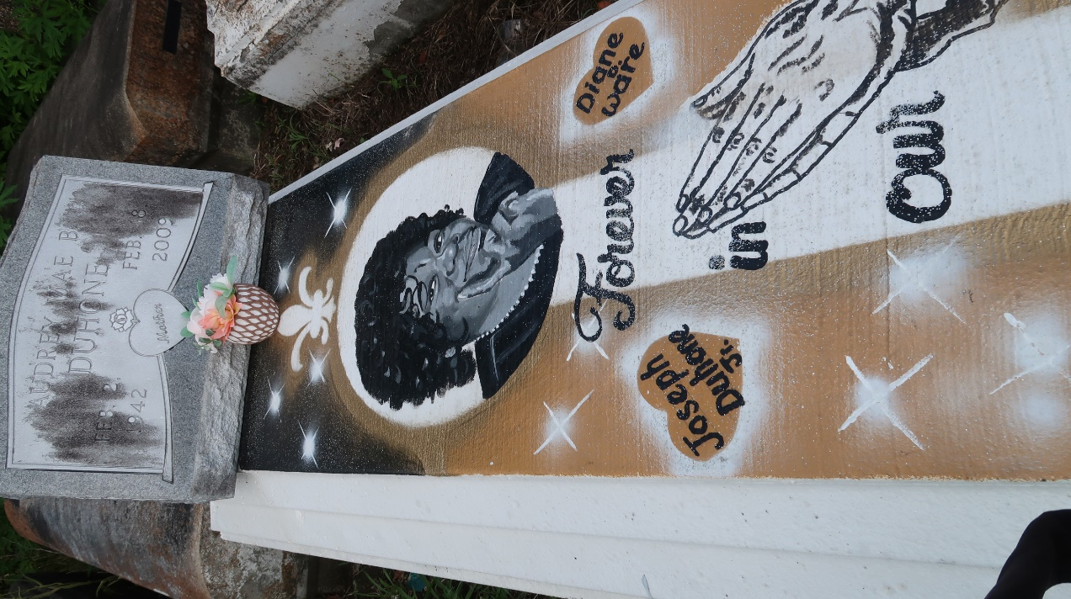

Audrey Beckett Duhone at her daughter's residence in Gramercy, LA, at 3:00 P.M., Wednesday, February 18, 2009. Daughter of the late Wilmer Beckett, Sr., and Bernice Davis Beckett. Wife of the late Joseph Duhone, Sr. Mother and mother-in-law of Grace and Severa Joseph, Diane and Frank Ware, Cynthia and Lawrence Williams, Joseph Duhone, Jr., Diazhun McKinley, Tequilla and Nancy Duhon and the late Shirley Duhone. Sister of Anna Lee, Besty and Sterling Beckett and the late Alice, Celestine, August, Lawrence, and Wilmer Beckett, Jr., Edward Givens and Charley Davis, Jr. Also survived by 21 grandchildren, 27 great-grandchildren, aunts, uncles, nieces, nephews, cousins, other relatives and friends. Age 67.
Visiting at St. Joe Baptist Church, Alexander Street, Lutcher, LA, Saturday, February 28, 2009 from 10:00 A.M. until Religious Services at 11:00 A.M., conducted by Bishop Clarence Williams, Sr. Interment in Antioch Cemetery in Paulina, LA. Brazier-Watson Funeral Home in charge of arrangements.

The Times-Picayune, New Orleans, Louisiana
Feb. 27, 2009

