James Anthony Duhone
December 16, 1979 – February 6, 2003

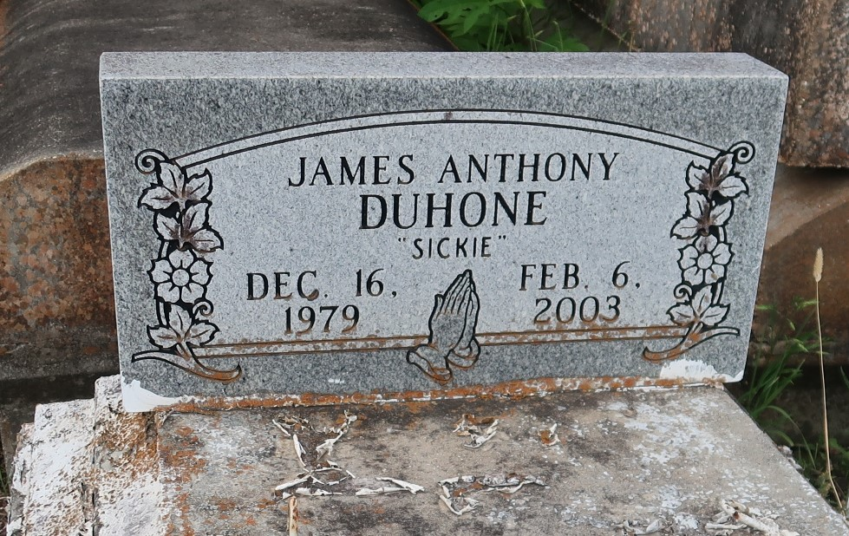

James Anthony (Lil-James) Duhon at Medical Center of Louisiana at New Orleans, at 12:30 PM Thursday, February 6, 2003. Son of Cynthia Duhon Williams of Lutcher, LA and James Johnson, Jr. of Laplace, LA. Husband of Shemika Sullivan Duhon of Laplace, LA. Step-Son of Lawrence Williams, Sr. and Mary K. Johnson. Father of Charles Lucas of Convent, LA. Brother of Eric Duhon and Lawrence and Courtney Williams, all of Lutcher, LA. Step-Brother of Michael Beckless and James Johnson, III. Grandson of Audrey Mae and Joseph Duhon, Sr., Richard, Jr. and Brenda Mitchell. Son-in-law of Judy Sullivan and Lionel Mason. Also survived by a number of nieces, nephews, cousins, aunts, uncles, other relatives and friends. Age 23 years.
Visiting at First Community Antioch Baptist Church, Highway 3125, Lutcher, LA., Thursday, February 13, 2003 from 9:30 AM until Religious Services at 11:00 AM conducted by the Rev. Gary Bolden: Rev. Ferdinand Gaines, Pastor. Interment in Antioch Cemetery, Paulina, LA. BRAZIER-WATSON FUNERAL HOME IN CHARGE OF ARRANGEMENTS.

The Times-Picayune, New Orleans, Louisiana
Feb. 12, 2003

