Mickquill Anthony Duhone
1956 – September 24, 2014

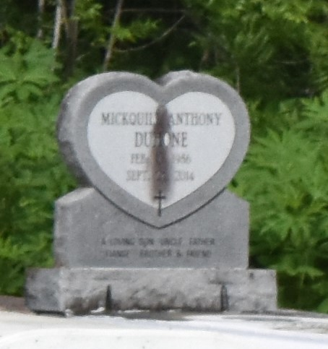

Mickquill Anthony "Mikey" Duhone, age 28 years, departed this earthly life on Wednesday September 24, 2014 at St. James Parish Hospital of Lutcher, La. Beloved son of Diane Duhone Ware, Betty Lee Taylor and Stepson of Travis Nelson. Loving father of Tyler Joseph and the late Mikez Martin, stepfather of Ta'Jah Albert, Brother Tequille, Shenika and Dorlano Duhone, and Robert Taylor. A devoted friend of Mytia Joseph. Grandson of Brenda Mitchell and the late Audrey and Joseph Duhone Sr.; Annie and Willie Taylor and Richard Mitchell Sr. Also survived by a host of aunts, uncles, nieces, nephews and other relatives and friends. A native and resident of Lutcher, La.
Relatives and friends of the family also Pastors, Officers and Members of Greater King Triumph B.C. of Lutcher, La. and all neighboring churches are invited to attend the home going celebration on Saturday October 4, 2014 at 11:00am at Greater King Triumph Baptist Church 2572 Lionel Washington St. Lutcher, La. Rev. Charlie Jones Sr. officiating. Visitation will be at the above name church from 9:00 am until service time. Interment in Antioch Cemetery of Paulina, La. Bardell's Mortuary of Mt. Airy, La. in charge. Information: 985-535-6837.

The Times-Picayune, New Orleans, Louisiana
Oct. 2 to Oct. 3, 2014

