Elaine (Jones) Dyer
April 30, 1951 – August 25, 2015

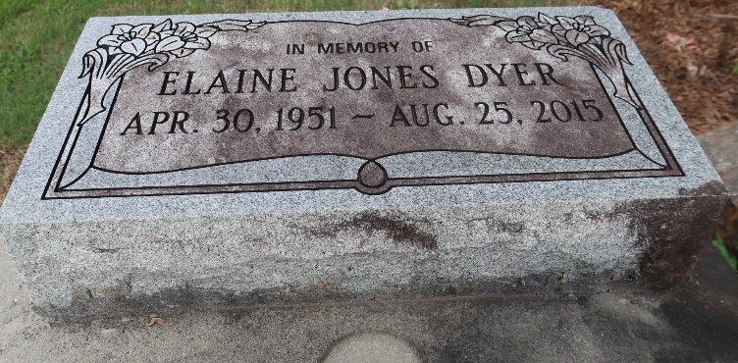

Elaine Jones Dyer, on August 25, 2015 God whispered Elaine's name and He gently embraced her to prepare for the journey to be with Him in the city that's set on a hill, with lights that would lead the way to her eternal resting place.
Wife of the late Harold Dyer, daughter of the late Harold Jones Jr. and Ida Bourgeois Jones Russell. Mother of Dartez Dyer. Step-daughter of Louis Russell, Sr. Sister of Dianne Bolton (Darryle), Harold, Jerry, Vernon (Edna), Norman (Terri), Louis Russell Jr. (Velma). Late Larry Jones, sister in-law Oneata Jones, godmother of Aleta Doherty and Nakia Williams, a host of other relatives and friends. Special friends, Beverly, Linda and Lucy. A native of Paulina, LA and a former resident of Baton Rouge, LA and Houston, TX.
Pastors, officers and members of the First Community Antioch Baptist Church, Greater Divine Missionary Baptist Church and neighboring churches are invited to attend the funeral services on Saturday, September 5, 2015 at 10:00AM from the First Community Antioch Baptist Church, 10860 Hwy 3125, Gramercy, LA. Visitation at the church after 9:00AM. Interment Antioch Cemetery, Paulina, LA. Treasures of Life, Center for Life Funeral Services entrusted to her care. 315 E. Airline Hwy, Gramercy, LA 70052. 225.258.4039.
The New Orleans Advocate (LA)
Sep. 3 to Sep. 5, 2015

