Alexander Ezidore
May 20, 1915 – October 10, 2007

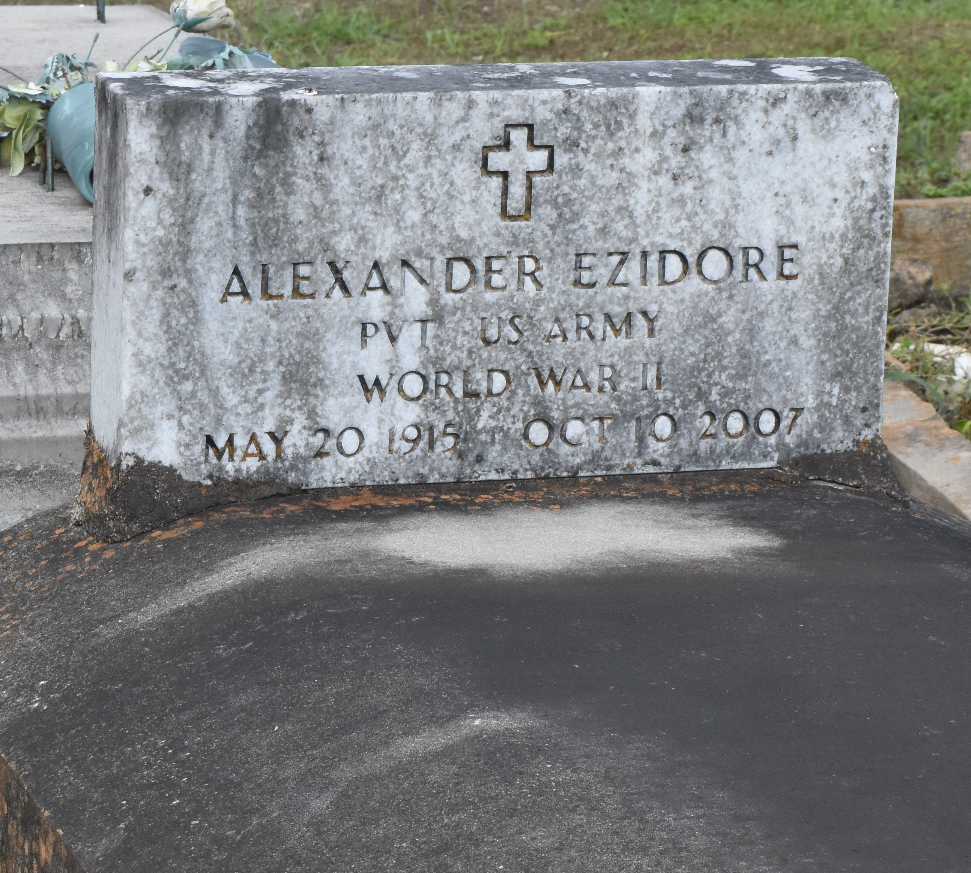

A native and resident of Paulina, he died at 4 p.m. Wednesday, Oct. 10, 2007, at his daughter's home in Algiers. He was 92.
Visiting at Israelite Baptist Church, Lutcher, on Wednesday, Oct. 17, from 9:30 a.m. until religious service at 11 a.m., conducted by the Rev. Kevin Fredricks. Burial in Antioch Cemetery, Paulina.
Survived by his daughter and her husband, Eunice and Robert Anthony; four sons and two daughters-in-law, Larry and Joyce Fluence, Gary and Marva Fluence, Nathan Fluence and Alexander Ezidore Jr.; sister, Artemise Williams; 15 grandchildren, 12 great-grandchildren, numerous nieces, nephews, cousins, other relatives and friends. Preceded in death by his parents, Sidney Ezidore and Annie Minor Ezidore; sister, Julia Jasmin; and two brothers, Manuel and Pompey Ezidore Sr. Arrangements by Brazier-Watson Funeral Home, Donaldsonville.
The Advocate, Baton Rouge, Louisiana
October 16, 2007

