Stella (Joseph) French
December 21, 1940 – October 28, 2010

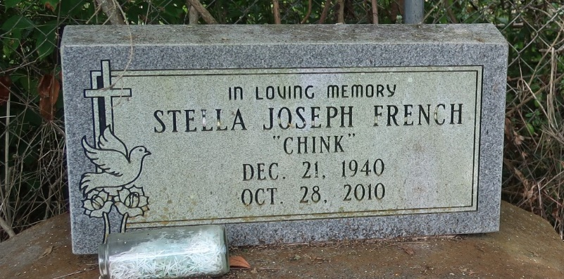

Stella Joseph "Chink" French at Women's Hospital, Baton Rouge, LA, at 3:20 p.m., Thursday, October 28, 2010. Wife of Charles French, Jr. Daughter of the late Ernest Joseph, Sr. and Ethel Starks Joseph. Mother of Rechelle Eskridge and husband, Calvin Jr., Msg. Kevin C. French and wife, SFC. Linda French, SSgt. Dwayne S. French and wife, Rhonda, Sgt. Cornell D. French and wife, Florida, and SFC. Clarence French. Sister of Jacqueline J. Bause and husband, Adam, Sr., Ernest Joseph, Jr. and wife, Madeline, Andrew Joseph and wife, Lena Mae, the late Dorothy, Joinell and Jackie Joseph. Sister-in-law of Patricia Joseph. Also survived by five grandchildren, nieces, nephews, cousins, other relatives and friends. She was a member of Mt. Olive Baptist Church, Paulina, LA, Rev. Oscar Nelson, Pastor.
Visiting at Frist Community Antioch B.C., Highway 3125, Lutcher, LA, Rev. Ferdinand Gaines, Jr., Pastor from 11:30 a.m. until Religious Services at 1:00 p.m. Interment in Antioch Cemetery, Paulina, LA. BRAZIER-WATSON FUNERAL HOME in charge of arrangements
Times-Picayune, New Orleans, Louisiana
Nov. 5, 2010

