Allen Henry Jr.
March 31, 1960 – April 9, 2010

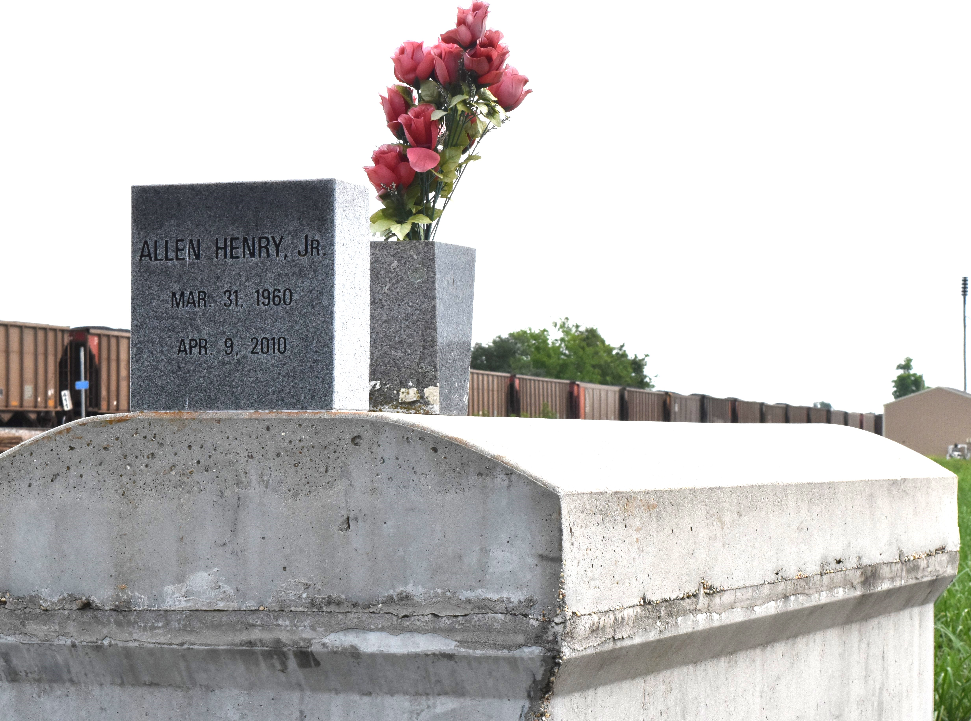

A native and resident of Paulina, he died at home at 10:30 a.m. Friday, April 9, 2010. He was 50. Visiting at Greater Evergreen Baptist Church, La. 44, Paulina, on Saturday, April 17, from 9:30 a.m. until religious service at 11 a.m., conducted by the Rev. Nolan Albert. Interment in Antioch Cemetery in Paulina. Survived by his parents, Allen Henry Sr. and Jersey Taylor Henry; a sister, Debra Harrison; two brothers and their spouses, Gerald and Patricia and Carl and Sherita Henry; aunts, Shirley Fluence, Ida Russell, Annabell Joseph and Emma Lee Clark; uncle, Louis Russell Sr.; nieces, nephews, cousins, other relatives and friends. He was preceded in death by his maternal grandparents, Tim and Violet Taylor; paternal grandparents, Alma Lee Finley; and uncle, Johnny Clayton. Arrangements by Brazier-Watson Funeral Home, Donaldsonville.
The Advocate, Baton Rouge, Louisiana
April 16, 2010

