Debra Jean (Manuel) Hill
November 7, 1953 – August 30, 2019

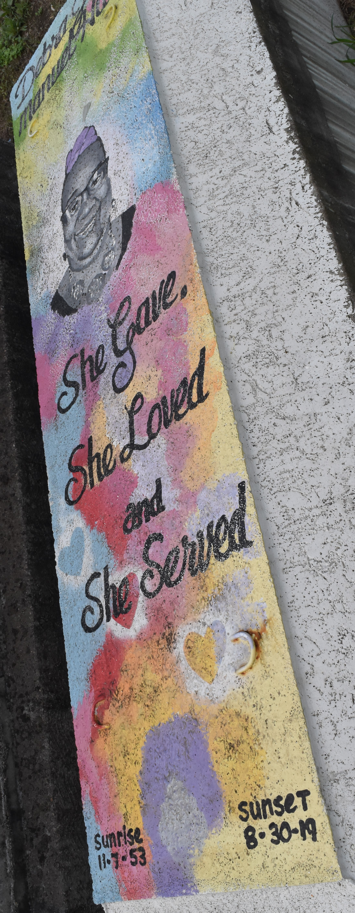

Debra Jean Manuel Hill was born on November 7, 1953 at Charity Hospital in New Orleans to Alexander Manuel Sr. and Willie Mae Martin. In 1969, she accepted Christ and was baptized at the Greater Mt. Zion Missionary Baptist Church by the late Rev. Howard in Chicago, IL. She graduated in 1971 from Hyde Park High School in Chicago, IL. Debra worked most of her life as a Dietician. She was a very devoted usher and always willing to help in whatever way she could. She took great pride in being a Mother, grand, and great-grandmother to all her babies.
She is survived by her 4 children; Twanya, Shaveen, Tanjanita Hill, and Ronda (Walter) Hansley. 5 brothers; Barry (Earlean) Manuel, John Jr., Frank (Cassandra), Michael (Debra), Adam Burns. 4 sisters, Loretta Joseph, Linda Hayes, Joyce Smith, and Carolyn Cola. 17 grandchildren, 7 great-grandchildren, god-children, Jason Webster, Damon Jenkins, and Sincir "Sam" Porter and a host of nieces, nephews, cousins, and friends.
She is preceded in death by her parents, Alexander Manuel Sr. and Willie Mae Burns, and step-father; John W. Burns Sr.; brothers; Alexander Manuel Jr. and Everett Burns; sisters, Kathleen Burns, Dorothy Harris, and Sherry Robinson, and her god-parents Elijah Scott and Margaret Cooper.
Funeral services will be held Saturday, September 7, 2019 at Greater King Triumph Baptist Church 2572 Lionel Washington St. Lutcher, LA 70071. Pastor Charlie Jones, Sr. officiant. Visitation 9:00 am followed by service at 11:00 am. Interment Antioch Cemetery, Paulina, LA. Bardell's Mortuary entrusted with her final care.
The Advocate, Baton Rouge, Louisiana
Sep. 5 to Sep. 7, 2019

