Dave Howard Jr.
February 16, 1925 – March 10, 2005

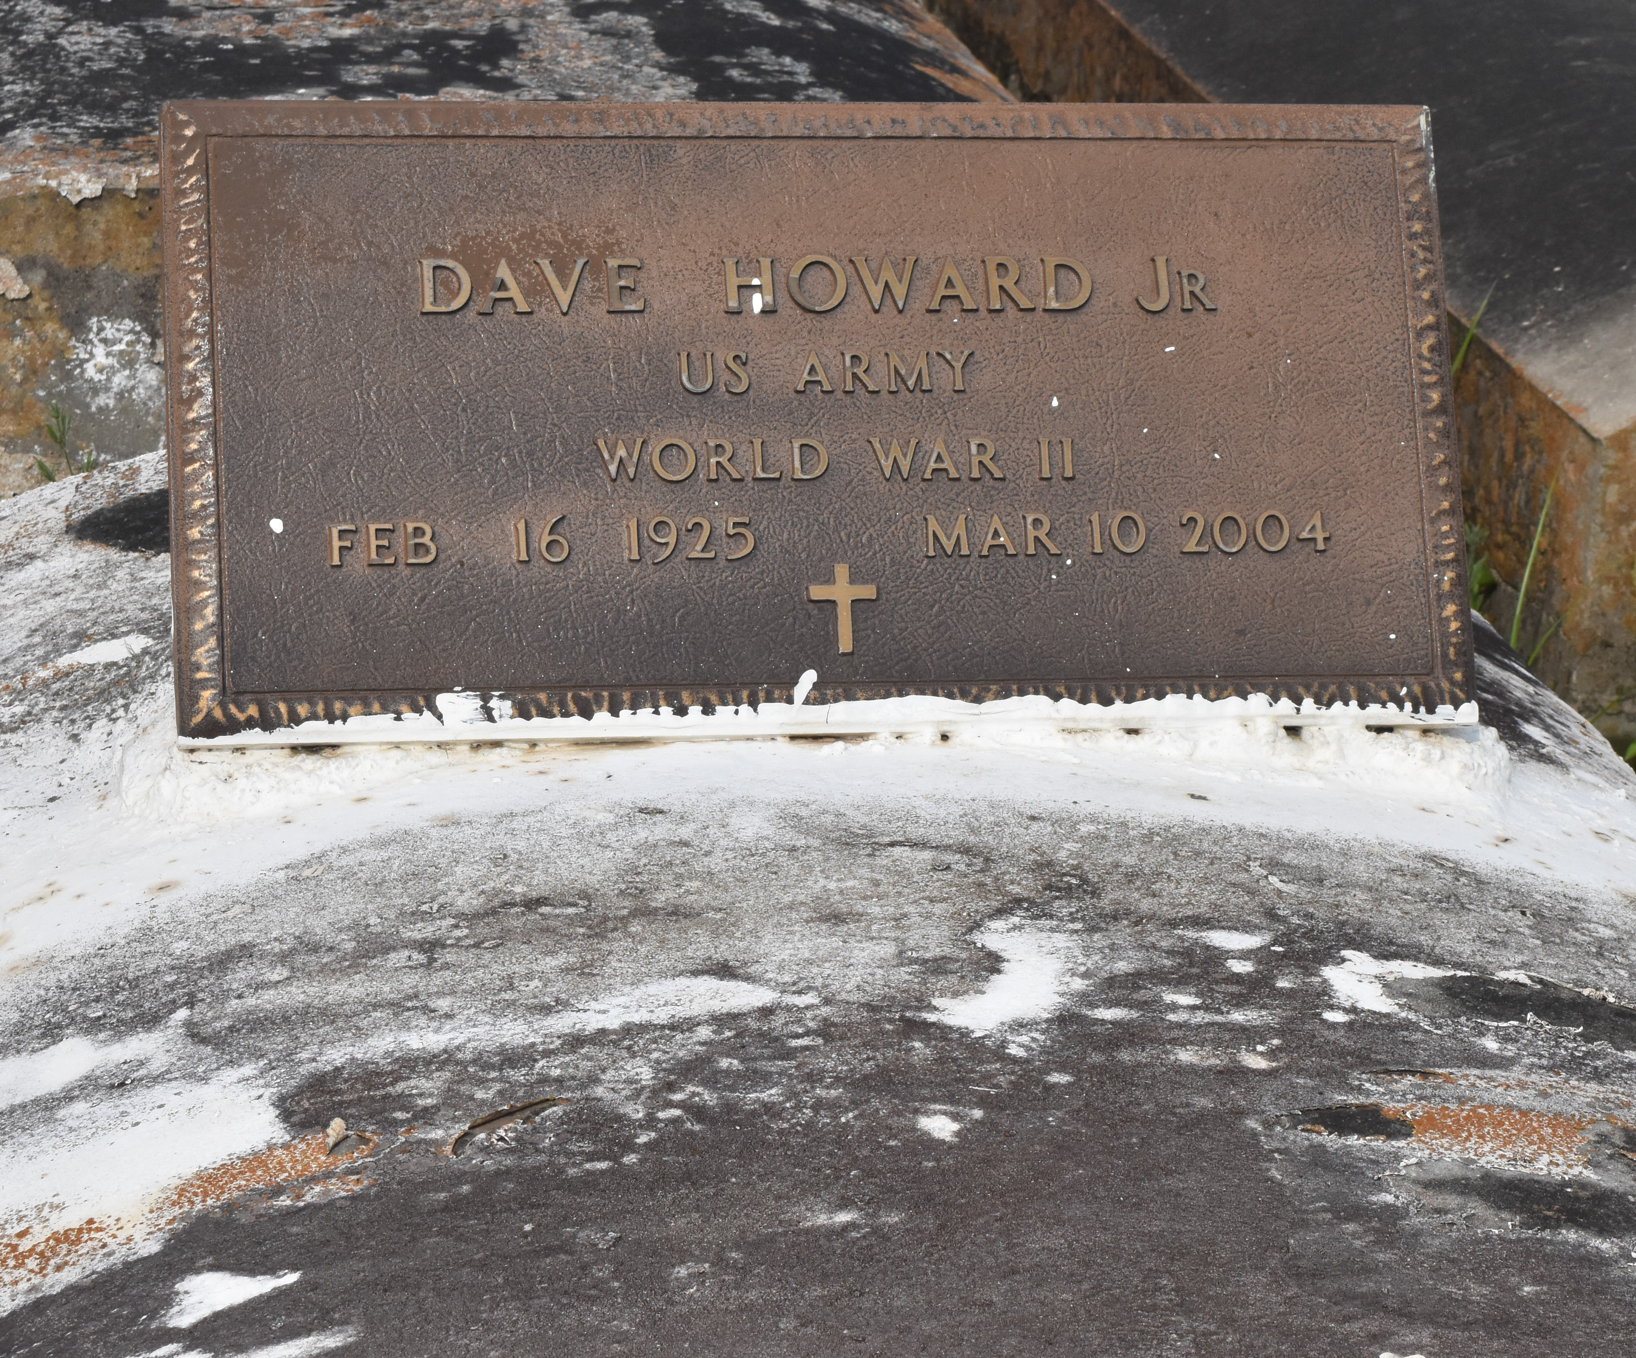
Dave Howard, Jr. on Wednesday, March 10, 2004 @ 9:50am. A funeral service will be held on Tuesday, March 16, 2004 at Mt. Olive Baptist Church in Paulina, LA at 11:00am. Visitation will begin at 9:00am until funeral time. Burial will be in Antioch Cemetery in Paulina, LA. Arrangements by D.W. Rhodes Funeral Home, 3933 Washington Ave. Please visit our website at www.rhodesfuneral.com to sign guest book.

The Times-Picayune, New Orleans, Louisiana
March 15, 2004

