Alfred L. Jackson
January 4, 1940 – October 21, 2009

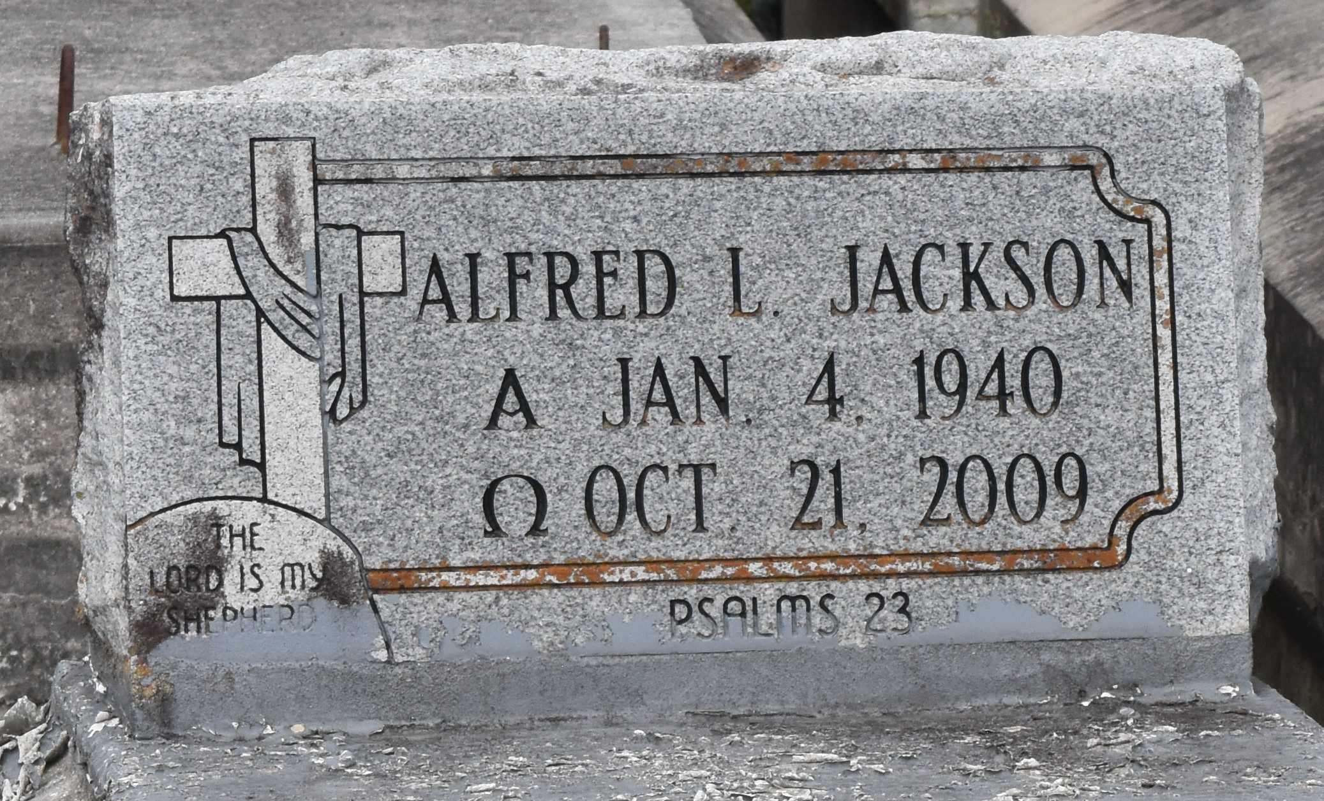

A native and resident of Lutcher, he died at 1:18 p.m. Wednesday, Oct. 21, 2009, at St. James Parish Hospital, Lutcher. He was 69. Visiting at Israelite Baptist Church, Lutcher, Thursday, Oct. 29, from 9:30 a.m. until religious service from 11 a.m. to noon, conducted by the Rev. Kevin Fredricks. Interment in Antioch Cemetery, Paulina. Survived by his wife, Rosemary Wallace Jackson; three daughters, Juliette and spouse Donald Williams, Cheryl Jackson and Mayola Long Cooper; two sons and their spouses, Huey Sr. and Brenda Long and Joseph and Patricia Long; sister, Sylvia and spouse James Cushenberry; brother, Sterling and spouse Elise Jackson; 18 grandchildren; 25 great-grandchildren; nieces and nephews, including his caregiver, Nathaniel Blue; cousins, other relatives and friends. Preceded in death by his parents, Howard and Clintene Jackson; two sisters, Shirley Jackson and Annabelle Blue; four brothers, Allen Jackson and James, William and Eddie Johnson. Arrangements by Brazier-Watson Funeral Home.
The Advocate, Baton Rouge, Louisiana
October 28, 2009

