Clara (Williams) Jackson
July 26, 1911 – August 11, 2007

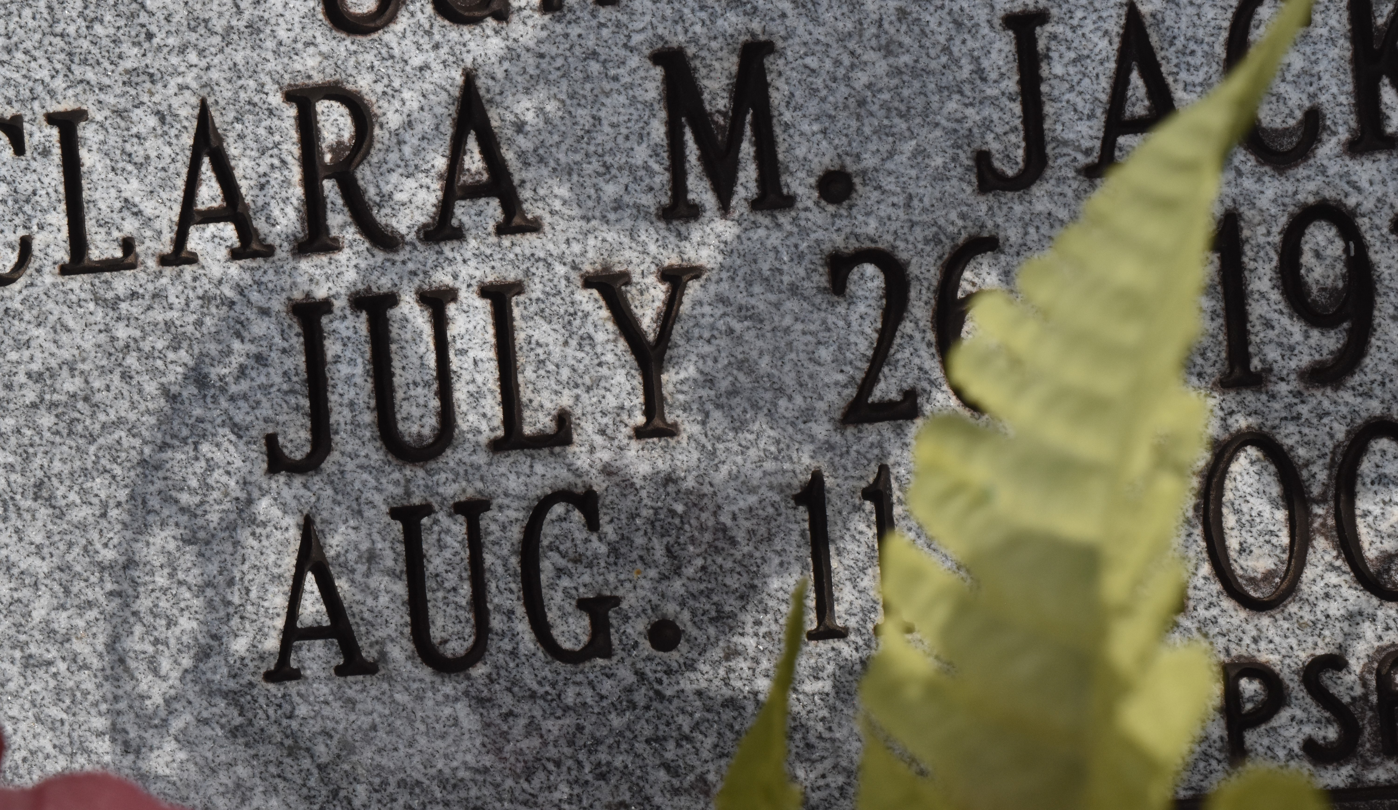

A native of New Orleans and a resident of Gramercy, she died at her home on Saturday, Aug. 11, 2007, at the age of 96.
Visiting at First Community Baptist Church, Lutcher, on Friday, Aug. 17, from 5 p.m. until 9 p.m. with religious service at 7 p.m., conducted by the Rev. Ferdinand Gaines Jr. Dismissal service on Saturday at 10 a.m. with interment in the church cemetery.
She is survived by four daughters, Geraldine Watson, Alma Sparks, Pauline Hayden and Emma Jenkins; two sons, the Rev. Louis and wife Lisa Watson and James Watson; 23 grandchildren and numerous nieces, nephews, cousins, other relatives and friends. She was preceded in death by her parents, Arthur Williams and Alice Henderson Williams; her husband, Wilmer Jackson; and a brother, Arthur Williams. Brazier-Watson Funeral Home is in charge of arrangements.
The Advocate (Baton Rouge, LA)
August 17, 2007

