Karen Ann Jackson
January 11, 1967 – January 7, 2014

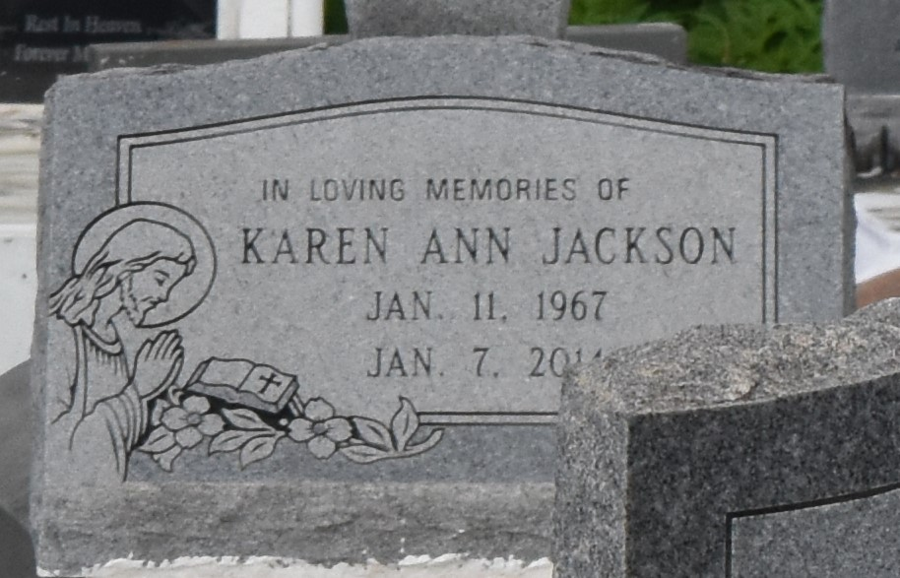

Karen "Shorty" Jackson at the age of 46 yrs, departed this earthly life on Tuesday, January 7, 2014, at St. James Hospital of Lutcher, LA. A devoted friend of Curtis Taylor. Daughter of the late Floyd and Dotsy Boudreaux-Jackson.
Loving mother of Keshonda Brown (Thorne), Cody Gant (Charles), Darren, Cornell, Kawonda, and Darrinesha Jackson. Sister of Shelia Ruffin, Floyd Jr., Cynthia, Kenneth, Darnell, and Sherman Jackson. Also survived by 8 aunts, 10 uncles, 5 grandchildren, a host of nieces, nephews, other relatives, and friends. A native and resident of Gramercy, LA.
Relatives and friends of the family, also pastors, officers, and members of the New Zion Full Gospel Church of Gramercy, LA and all neighboring churches are invited to attend the funeral service on Saturday, January 18, 2014, at 11:00am at New Zion Full Gospel Church, 216 W. Main St., Gramercy, LA. Elder Emil D. Mitchell officiating. Interment in Antioch Cemetery of Paulina, LA. Visitation will be from 9:00am until service time.

The Times-Picayune, New Orleans, Louisiana
Jan. 16 to Jan. 17, 2014

