Rose Mae (Wallace) Jackson
November 26, 1929 – December 6, 2009

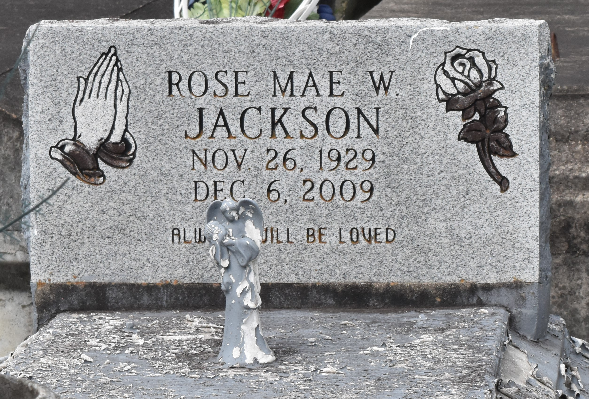

Rose Mae Wallace "Pon" Jackson at 6:25 a.m., Sunday, December 6, 2009 at River Parishes Hospital in LaPlace, LA. She was 80. Survived by three daughters: Mayola Cooper, Jullieth (Donald) Williams and Cheryl Jackson; two sons: Joe L. (Patricia) Long, and Huey Sr., (Brenda) Long; a brother and his wife, James Sr. and Gloria Wallace; an uncle, Peter Wallace; 17 grandchildren, 27 great-grandchildren, nieces, nephews, cousins, other relatives and friends. Preceded in death by her husband, Alfred Jackson; her parents: Chris Wallace and Rosie Jones Wallace. Visiting at Israelita Baptist Church, Lutcher, LA, Saturday, December 12, 2009 from 9:30 a.m. until Religious Service at 11:00 a.m. Conducted by the Rev. Kevin Fredricks. Interment in Antioch B.C. Cemetery, Paulina, LA. BRAZIER-WATSON FUNERAL HOME in charge of arrangements.

The Times-Picayune, New Orleans, Louisiana
December 11, 2009

