Willie Mae (Riley) Jackson
March 3, 1941 – January 12, 2021

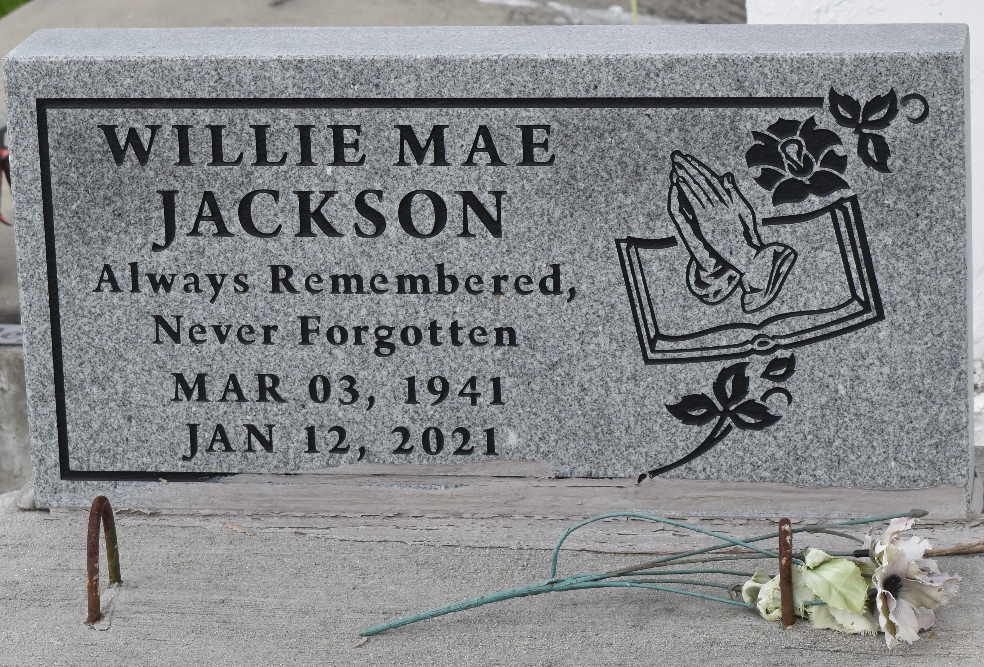

On Tuesday, January 12, 2021, Sister Willie Mae Riley Jackson was called on to glory. A very loving, kind hearted person. She leaves behind exceptionally treasurable memories with everyone that she may have come in contact with.
Daughter of the late Mary Emma Riley and Thomas Foster Sr. and her stepfather Jim Alexander Sr. she was the oldest to eight children. She was the wife of the late James Jackson, Mother of Pamela Lebray (Maurice), Stanley Jackson, Sr. (Tammy), and the late Deborah Ann Burl, and James Sharnell Jackson. Sister of Carolyn Morris, Mary Williams, Jim Alexander, Geraldine and Charles Riley, Sr. and the late Barbara Ann Farlough, and Freddie Alexander. Willie Mae is also survived by 12 grandchildren, 22 great grandchildren, stepbrothers and sisters, brothers in laws, sisters in laws, nieces, nephews, other relatives and friends. She was also preceded in death by her grandson Lydell Laron Alexander.
Celebration Service will take place on Saturday, January 23, 2021 at 10:00 am St. John Missionary B.C. 287 daffodil St. Mt. Airy, La. Rev. Gary Bolden Pastor, Minister Stanley Jackson, Sr Officiating. Visitation at 8:00 am until service time. Interment in Antioch Cemetery Paulina, LA. Due to CDC (Covid-19) restrictions seating is limited. Mask and social distancing are required. Professional Services entrusted to the Caring Staff of Hobson Brown Funeral Home 134 Daisy St. Garyville, La 70051 985-535-2516.

The Times-Picayune, New Orleans, Louisiana
Jan. 22 to Jan. 23, 2021

