Larry James
December 20, 194? - September 5, 2019

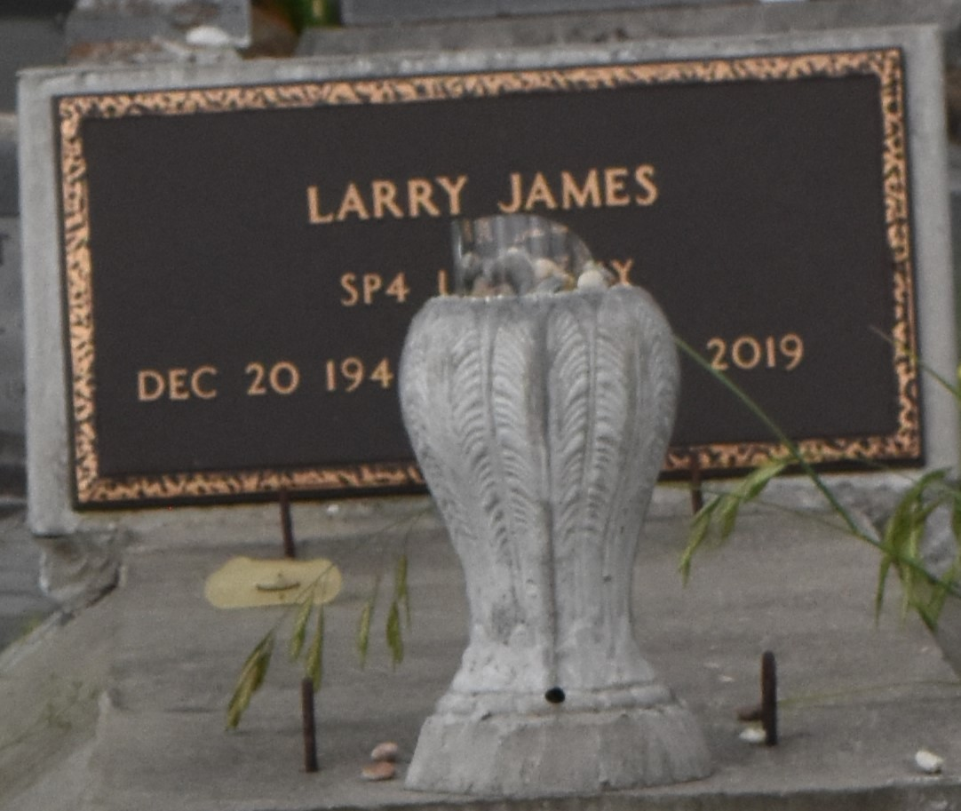

Larry (Seafood Man) James transitioned on Thursday, September 5, 2019. Husband of Stella James. Larry is also survived by a host of family and friends.
Funeral service will be held on Saturday, September 14, 2019 at First Community Church, 10860 LA Hwy 3125, Gramercy, LA at 11 am. Viewing is at 10 am. Rev. Ferdinand Gaines, Officiating. Interment: Church Cemetery. Professional Services entrusted to the caring staff of Hobson Brown Funeral Home, 134 Daisy St, Garyville, LA 70051. 985-535-2516.
The Times-Picayune (New Orleans, LA)
Sep. 12 to Sep. 14, 2019

