Donald Johnson
November 21, 1951 – November 22, 2003

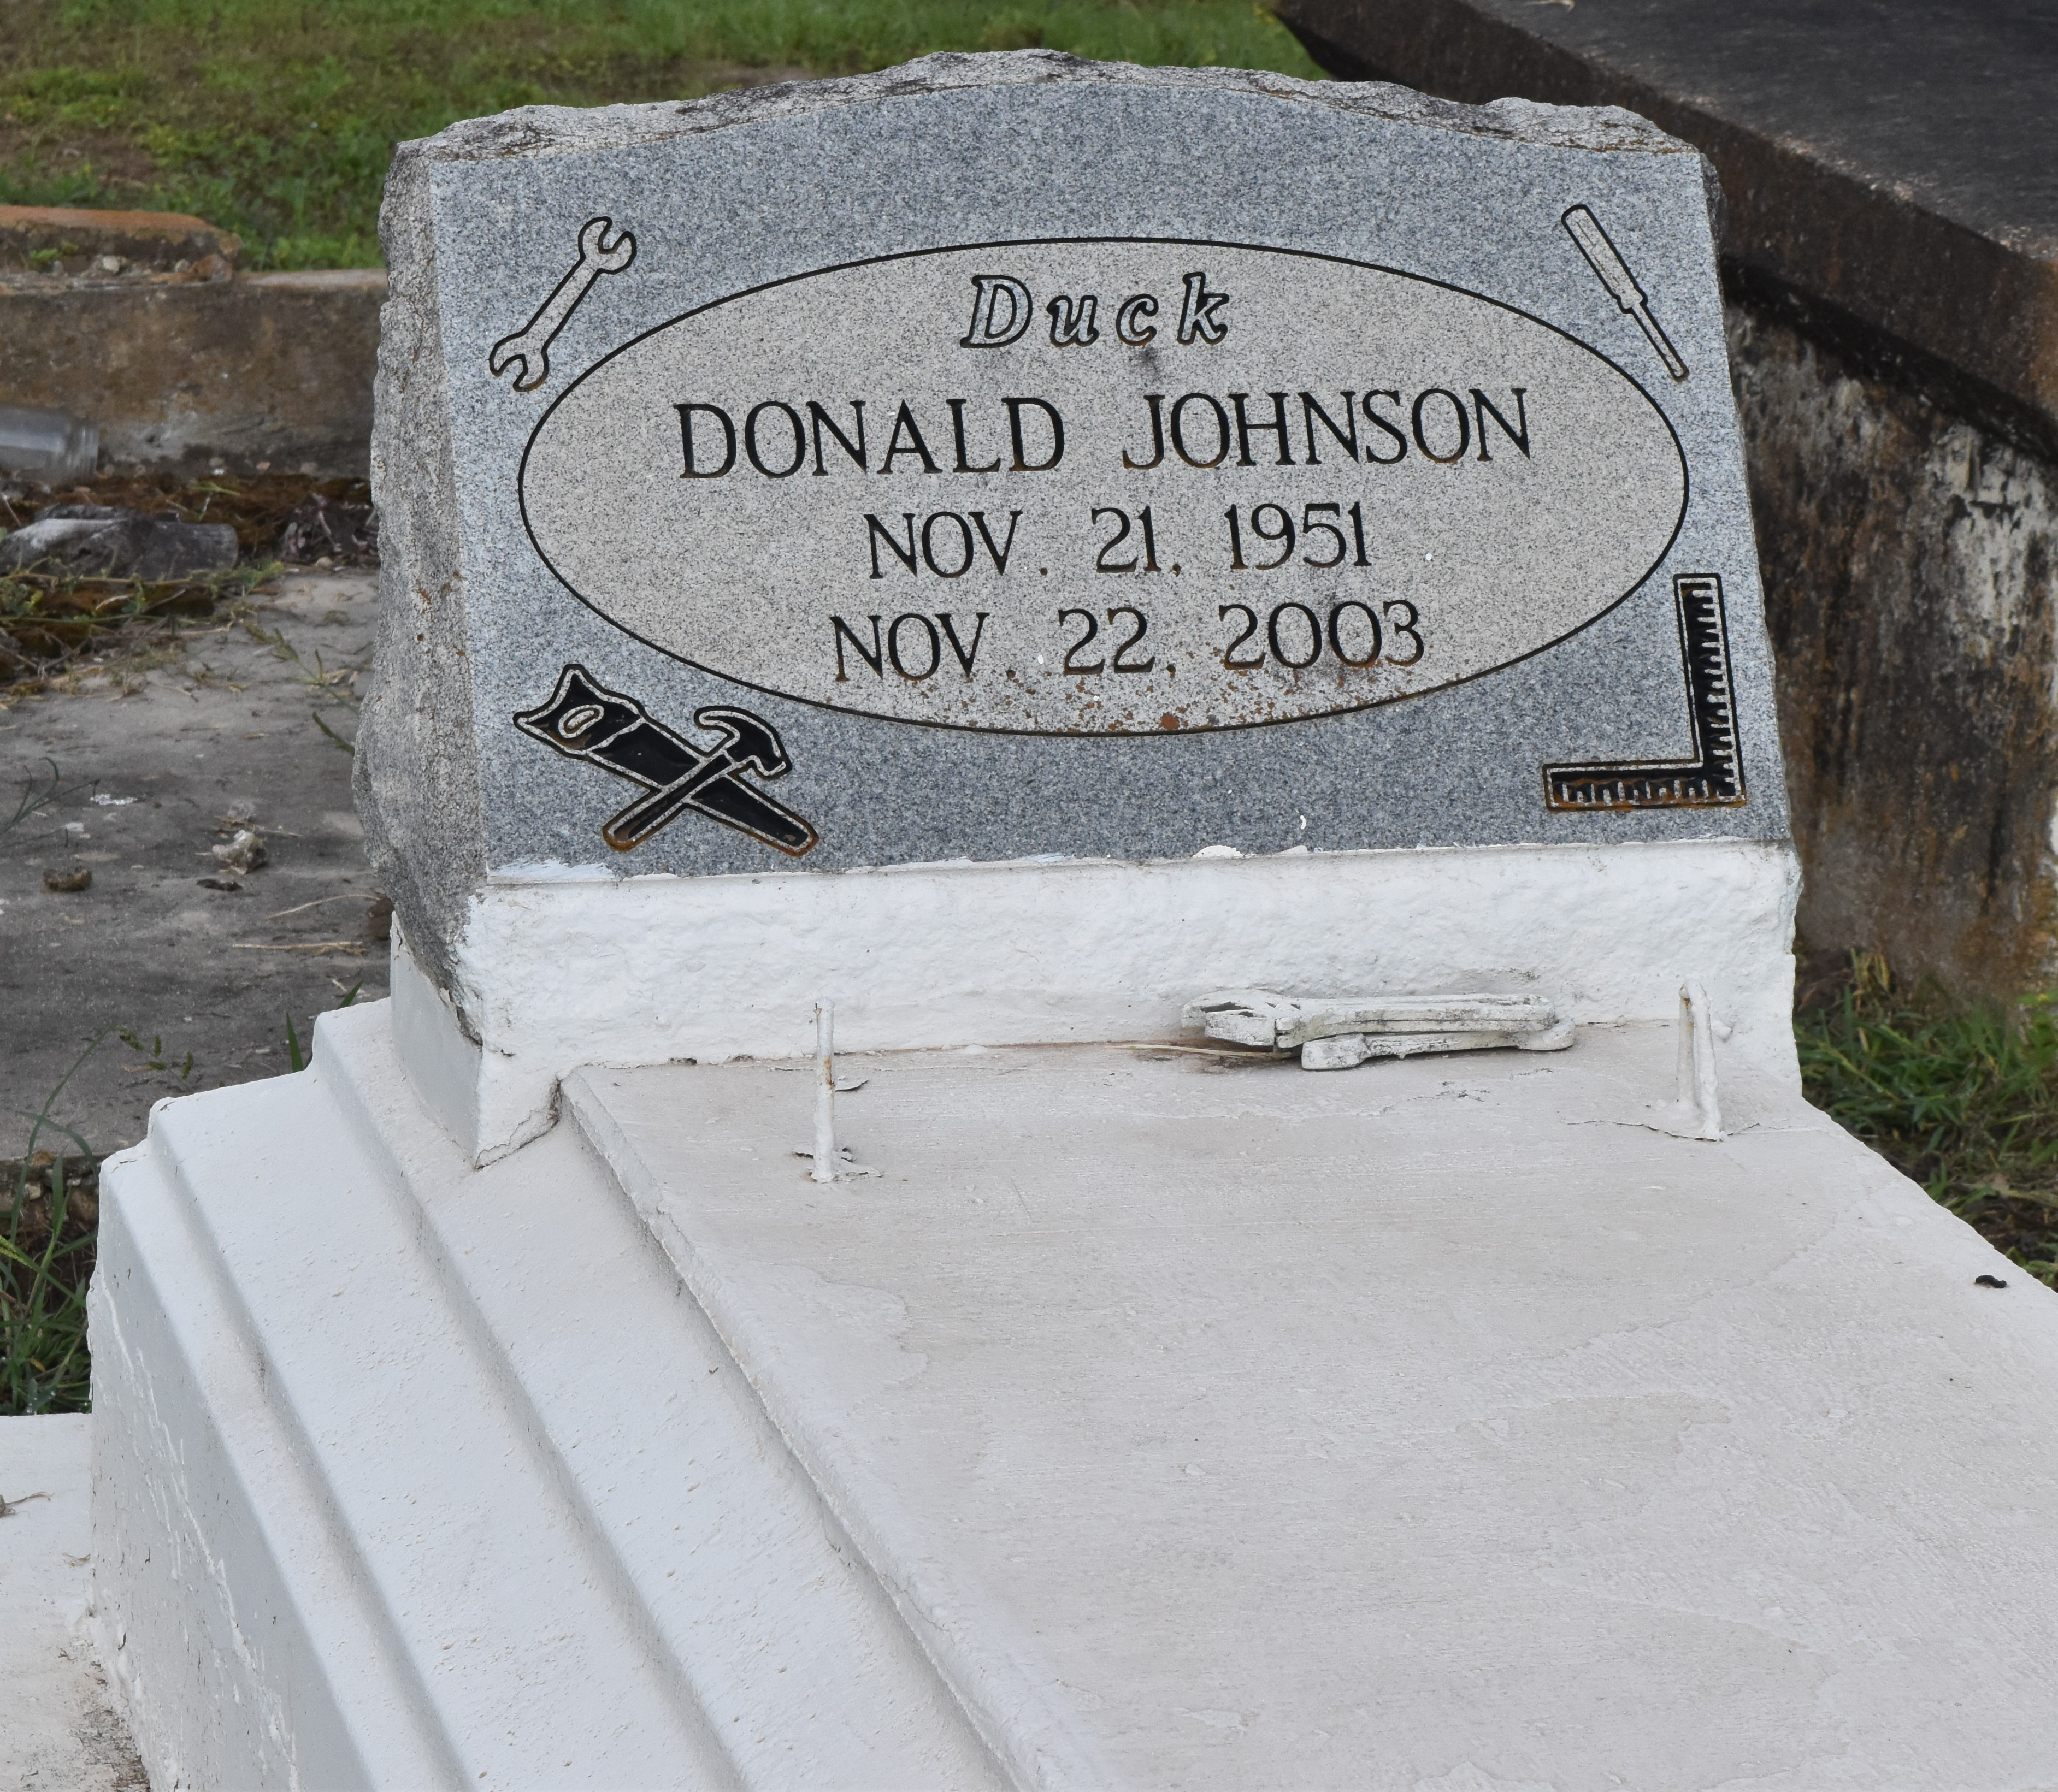

Donald ""Duck'' Johnson departed this earthly life and entered into eternal rest on Saturday, November 22, 2003 at River Parish Medical Center of Laplace, LA.
Son of the late Enola and Rev. Dennis Johnson, Jr. Beloved father/ father-in-law of Janelle/Romell Johnson and Delacy/Jermaine Lewis, Sr. of Lutcher, LA. Loving brother of Ronald Johnson, Sr., Faye J. Farlough of Laplace, LA, Dennis Johnson of Gramercy, LA, Hattie J. La'Day, Denese J. Washington and Herman Stafford of Lutcher, LA. Nephew of Marjie Jackson of Ponchatoula, LA and Aldrich Seals of Hammond, LA. A devoted friend of Wagon Boudreaux and Mack. Also survived by 4 grandchildren , a host of nieces, nephews, other relatives and friends.
Relatives and friends of the family, also pastors, officers and members of First Community-Antioch Baptist Church, Israelite Baptist Church, St. Joe Baptist Church, all of Lutcher, LA., St. John Missionary Baptist Church of Mt. Airy, LA, all neighboring churches and employees of River Parish Vault are invited to attend the funeral services on Friday, November 28, 2003 at 11:00 A.M. at the First Community-Antioch Baprist Church, 10860 Hwy. 3125 Lutcher, LA. Rev. Ferdinand Gaines, Jr. officiating. Interment in Antioch Cemetery, Paulina, LA. Visitation will be at the Church from 9:00 A.M. until service time. Bardell's Mortuary of Mt. Airy in charge. Information: 985-535-6837.
The Times-Picayune (New Orleans, LA)
November 27, 2003

